PAYROLL NOTIFICATION FORM
ILLNESS BENEFIT - CLASS A EMPLOYEES
OCCUPATIONAL INJURY BENEFIT - CLASS A & D EMPLOYEES

Since 1 January 2018 the Department of Social Protection (DSP) ceased issuing Illness and Occupational Injury Benefit notifications to employers (see HSE HR Circular 005/2018) https://www.hse.ie/eng/staff/resources/hr-circulars/hr-circular-005-2018-re-changes-to-payment-of-hse-sick-pay-and-occ-injury-benefit-by-deasp.pdf.

Since 1 January 2018 all HSE employees are required to provide notification to the HSE of the amount of Illness Benefit/Occupational Injury Benefit they are eligible to receive from DSP during periods of medically certified absences.
DSP has advised that this information is available online to recipients or directly from its Store St. Dublin 1 office.

Illness Benefit/Injury Benefit Address & Enquiries Section at the following contact details:
Áras Mhic Dhiarmada, Store Street, Dublin 1
Telephone: (01) 704 3300
LoCall: 1890 928 400
If calling from outside the Republic of Ireland please call +353 1 704 3300
Emails to IllnessBenefit@welfare.ie
Or
Department of Social Protection website: Log on to www.welfare.ie or www.mywelfare.ie

QUALIFYING EMPLOYEES : Please provide the following information on this form directly to your local Time Returning/Payroll/HR Area at site/location level as soon as possible to ensure your payroll is processed correctly and to avoid payroll overpayments and underpayments. Your line manager will provide the relevant contact details that apply in your area.

In addition, please note that you are required to submit a copy of your DSP Notification Statement when it is received. This statement will be used to verify the amount of DSP benefit which should be deducted from your salary. This statement can be requested online (see further information below). Statements of all payments issued by the Department are in the first instance provided by DSP directly to the employee or can also be requested on MyWelfare.ie.

You can also contact the Central Payroll Department with any queries – see contact details below.

The following information must be provided by:-
- Employees on Class A PRSI in receipt of Illness Benefit and
- Employees on Class A and Class D in receipt of Occupational Injury Benefit

Payroll Group/Area: ____________ Employee No: _____________ Name: ___________________________
Work Location/County: ________________________________
Type of benefit claimed (please circle as appropriate): Illness Benefit Occupational Injury Benefit

Date illness commenced: _______________________
Date claim commenced: _______________________

Total amount of Benefit payable per week: _____________

Payment Breakdown: Number of Dependants Value of Benefit
Personal: __________________ €_____________
Adult Dependant: __________________ €_____________
Child Dependant: __________________ €_____________

Employee Signature ____________________________________ Date _______________________

As an initial step, please return this form to your local Time/Payroll office at site/location level without delay to facilitate payroll calculations in a timely manner and to avoid salary over/underpayments and/or adjustments insofar as is reasonably practicable.
The information required on the form can be provided by email to local Time Returning/Payroll/HR Area at site/location level where it is not possible to return the form.
All eligible employees receive a DSP Statement for benefit automatically.
Note: Please submit a copy of the DSP Notification Statement when it is received from DSP, so that the amount of benefit payable can be verified and balanced.
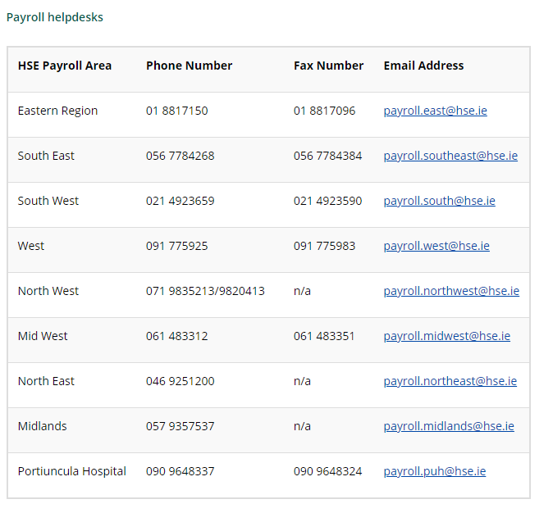
Easy language to understand Illness Benefit and Occupational Injury Benefit from Citizens Information

https://www.citizensinformation.ie/en/social_welfare/social_welfare_payments/disability_and_illness/disability_benefit.html
https://www.citizensinformation.ie/en/social_welfare/social_welfare_payments/disability_and_illness/injury_benefit.html

DSP STATEMENTS FOR PAYROLL NOTIFICATION

ILLNESS BENEFIT - CLASS A EMPLOYEES

OCCUPATIONAL INJURY BENEFIT - CLASS A & D EMPLOYEES

A copy of the statement from DSP should be forwarded to the local Time Returning/Payroll/HR Area at site/location level when it is received for verification purposes.

The DSP information below will assist employees to obtain Statements from DSP on payments received.
All employees in receipt of Illness Benefit may request an Illness Benefit statement on-line.
An online statement request facility is not available for Injury Benefit but requests for these statements can be made via email to IllnessBenefit@welfare.ie. Injury Benefit statements can also be requested direct from the Injury Benefit section (contact details above)

Statements of all payments issued by the DSP can also be requested on MyWelfare.ie.
Click on ‘Statements, Refunds and Calculators’
Click on ‘Payment statement’ to request a Statement of all Payments received

