Making sense of rapid, emergent change Delivering good change practices is critical right now to benefit from the rapid pace of change and innovation in response to COVID-19. Disruption is a positive force for change that needs personal and team agility to make sense of it. COVID-19 is part of our on-going reality. Working together to give effect to a just and resilient recovery is a shared responsibility.
This template and supporting infographics are aligned to the Health Services Change Framework and are intended to support individuals and teams adapt and act in a rapidly changing environment. Access the full Reflect Recover Renew infographics: click here https://www.hse.ie/changeguide/covid19-team-resources

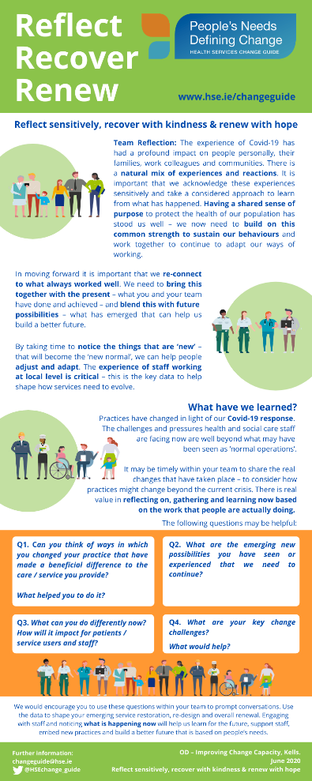
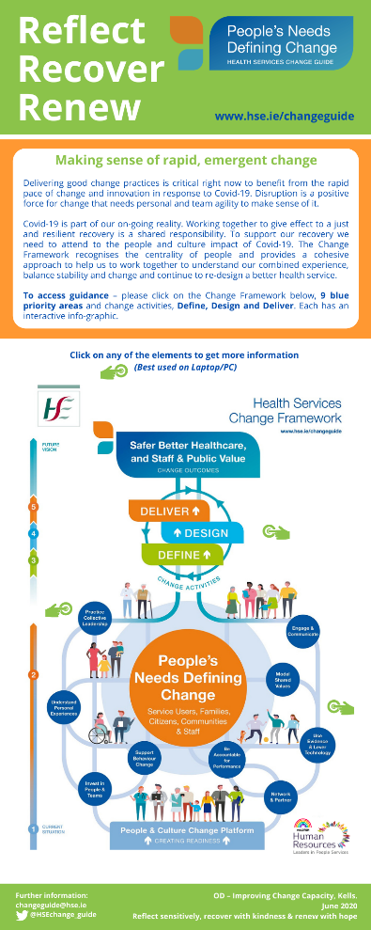
Purpose
Reflect Recover Renew supports teams to consider what has changed and what we have learned from our COVID-19 experiences. The template and infographics will support you as team leader to self-facilitate a session in order to:
- Take time with your colleagues to pause and reflect
- Consider the learning and make sense of your experiences
- Identify what individual and team supports are needed
- Plan for how services can be resumed or redesigned
- Consider how new practices can be implemented
- Build on new relationships to sustain improvements

How to use it?
Use this template and associated infographics to support personal and team reflection and meaningful conversations.
- Agree how you will facilitate the team conversation using the prompt questions below.
- Think about how best to create a reflective/learning culture – a safe place to share insights, concerns and hopes based on your experiences of COVID-19.
- Identify who will coordinate the learning efforts – think of ways to make it easy to gather and share insights given the pressures on staff.
- Agree what information you want to collect – use the questions below as a starting point.
- Identify how you will come together to share and act on the learning – ‘on the go’, team huddles, learning sessions.
- Agree how you will share the learning with senior managers and put an action plan in place.
Team Reflection Questions: Learning from COVID-19
Name of service/team: Date:
Question | Response | Improvement Actions
1a. Can you think of ways in which you changed your practice* that improved the care and service you provide?
*New roles, working relationships, skills, technology, work practices, working in different locations etc.
1b. What helped you to do it?
2a. What are the emerging possibilities you have seen or experienced that we need to continue?
2b. What actions do you need to take to support these possibilities?
3a. What can you as a team do differently now?
3b. How will these changes impact for patients/services users and for staff?
4a. What are your key change challenges?

4b. What would help to address these challenges?

Reflect Recover Renew – infographics
Now that you have gathered the data from your team reflection you can access the helpful infographics and tools from the Change Guide. As a team leader take some time to read through the guidance set out in the Reflect Recover Renew infographics (see samples overleaf) considering the following questions:
- What resonates with you and connects with your team reflections?
- Are there actions you can take to progress the guidance provided?

Access Reflect Recover Renew and Health Services Change Guide resources – see details below.

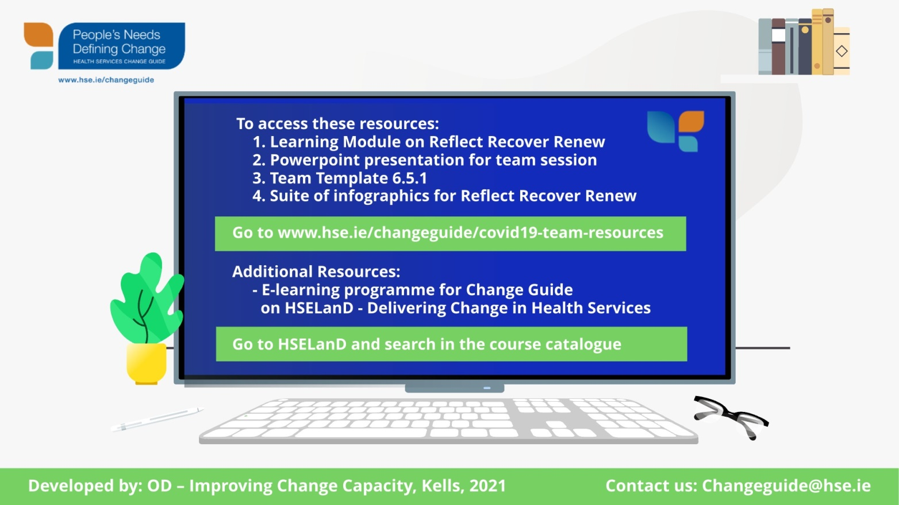
To access the live version of each infographic please visit https://www.hse.ie/eng/staff/resources/changeguide/covid19-team-resources/

