**Candidate Information Pack**

**Consultant Anaesthesiologist**

37 hours Cavan General Hospital

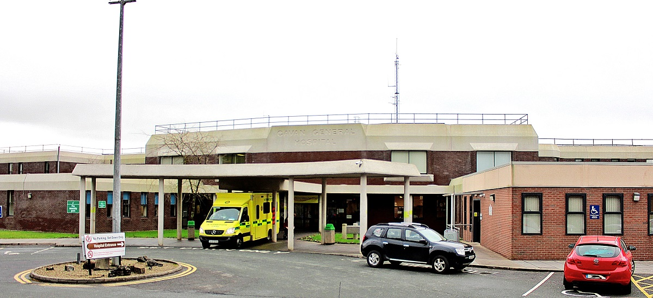

|  |  |
| --- | --- |
| **Job Title:** | Consultant Anaesthesiologist |
| **Closing date for applications:** | **Monday, 7th April, 2025@ 12 noon** |
| **Contract duration:** | Permanent |
| **Contract Type:** | Public Only Consultant Contract 2023 |
| **Hours per week:** | 37 hours Cavan General Hospital |
| **Contact Details:** | [ConsultantHR@beaumont.ie](mailto:ConsultantHR@beaumont.ie) – for application queries.  Enquiries relating specifically to this post or informal visits should be directed to Dr Val Gough, Clinical Director, Cavan/Monaghan Hospital, [val.gough@hse.ie](mailto:val.gough@hse.ie) |



**RSCI Hospital Group Profile**



The HSE has created six new health regions. Each region is responsible for providing both hospital and community care for the people in that area. Bringing community health services and hospitals together means we can take a more patient-centred approach to healthcare.

HSE Dublin and North East provides health and social care to North Dublin, Louth, Meath, Monaghan and most areas of Cavan.

HSE Dublin and North East Region includes the following hospitals;

* Beaumont Hospital
* Cavan General Hospital
* Connolly Hospital
* Louth County Hospital
* Monaghan General Hospital
* Mater Misericordiae University Hospital
* National Orthopaedic Hospital Cappagh
* Our Lady’s Hospital Navan
* Our Lady of Lourdes Hospital
* Rotunda Hospital

**Cavan Monaghan Hospital**

Cavan Monaghan Hospital is a bi-located site providing services to the population of both counties and its catchment area extends to counties Meath, Longford and Leitrim. It has a total of 421 beds with 286 of these representing acute in-patient beds. All acute inpatient services are based in Cavan Monaghan Hospital; there were approximately 17,000 acute admissions in 2018. Monaghan Hospital's primary role includes the continuing care for medically discharged patients requiring inpatient step-down and rehabilitation care.

Cavan Monaghan Hospital is a teaching hospital with links to the Royal College of Surgeons, Royal College of Physicians and the Dundalk Institute of Technology. Both sites are actively engaged with HIQA (Health Information & Quality Authority) in meeting their standards to ensure they continually strive to provide a high quality service.

Cavan Monaghan Hospital has an Emergency Department, an Acute Medical Admissions Unit, 5 General Medical wards, 1 General Surgery ward, a maternity ward, a paediatric ward, an ICU, a SCBU, and a CCU. It also has 4 operating theatres, a renal dialysis unit, a surgical day ward, an endoscopy / bronchoscopy unit, a haematology / oncology day ward, and an interventional radiology unit. Orthopaedic, vascular, urological and neurological services are provided by visiting consultants with sessional commitments. The hospital provides services for the care of paediatric and adult patients with cystic fibrosis; the paediatric ward has recently been extended and refurbished to include the provision of 2 high specifications, neutral pressure isolation rooms. It is anticipated that an outpatient antimicrobial therapy service will be launched in 2020 following the recruitment of an OPAT co-ordinator.

**ANAESTHESIOLOGY SERVICES**

Currently anaesthesiology delivers emergency and elective services for general adult and paediatric surgery, obstetrics, gynaecology, a regional paediatric and special needs GA dental service, psychiatry ECT and critical care both formally in ICU and as outreach across the hospital.

Perioperative medicine includes an established general preoperative assessment and an obstetric anaesthesiology clinic. Approximately 50% of the 1300 maternity patients per year have anaesthesiology input – 33% LSCS and 40% Epidural rates.

The Emergency Dept. is highly dependent on Anaesthesiology’s attendance for many of its high priority patients.

This post permits a further freedom in deployment aspiring to the “2+2” model at least during an extended day for obstetrics and critical care. It will also contribute to reinstating the running of two elective theatres and a daytime emergency theatre per day.

To expand on Anaesthesiology services on the Cavan Hospital site and provide services to Monaghan Hospital, this post will promote approximation to dedicated support for obstetric and critical care responses.

Current consultant clinical commitments are spread evenly across all activity on a 5 week cycle. Each is expected to participate equally in all areas as an independent practitioner.

This model implies competence across all sub-speciality areas especially obstetric anaesthesiology, Critical Care, paediatric anaesthesiology.

Each day includes elective and emergency theatre cover to include caesarean sections, and an ICU handover with ICU activity covering any outreach to ED and the wards.

The ICU consultant will also cover the Labour ward and any out-of-theatre anaesthesia activity in CCU, radiology and endoscopy. Tuesday also includes an anaesthesiology- obstetric clinic for complicated cases.

Thursday also includes an anaesthesiology day-of-surgery-admission clinic for those referred from the nurse led clinics.

**Population Details:**

• 120,000 Cavan &Monaghan.

• Regional 395,000 Cavan, Monaghan Louth & Meath.

**Useful Links**

|  |  |
| --- | --- |
| **Our website:** | <https://www.hse.ie/eng/services/list/3/acutehospitals/hospitals/cavanmonaghan/cavan-monaghan-hospital.html> |

**Job Description and Responsibilities**

Standard Duties and Responsibilities for all Consultant posts are as per Section 4 and Section 10 of the POCC23:

The Employee is hereby employed as a consultant. The Employee will be clinically independent in relation to decisions on the diagnosis, treatment and care of individual patients. This clinical independence derives from the specific relationship between the patient and the Employee. In that relationship, the patient places trust in the consultant who is personally involved in the patient’s care to make clinical decisions in the patient’s best interests and to take continuing responsibility for the consequences of that consultant’s decisions.

The Employee acknowledges that they are subject to statutory and regulatory requirements and corporate policies and procedures including those adopted for implementation by the national clinical programmes.

The Employee has a substantial and direct involvement in the medical diagnosis, treatment and delivery of care to patients.

The Employee may discharge their responsibilities through:

1. a direct professional relationship with the patient;
2. shared responsibility with other consultants who contribute significantly to patient management; and
3. (subject to the following paragraph of this clause) delegation of aspects of the patient’s care to other appropriate members of staff.

The Employee will only delegate responsibility to other doctors or staff members where the delegation is consistent with the continued provision of an appropriate level of diagnosis, treatment and care to the patient in respect of the relevant episode of care. Notwithstanding any such delegation, the Employee will retain a continuing overall responsibility for the care of the patient.

The determination of the range, volume and type of services to be provided and responsibility for the provision of same within available resources rests with the Employer. Services not provided because of a resource limit are the responsibility of the Employer and not the Employee.

The Employee will generally work as part of a consultant team. The primary purpose of consultant teams is to ensure consultant-provided services to patients on a continuing basis. In effect this requires that the Employee will provide diagnosis, treatment and care to patients who are under the care of other consultants on their consultant team and vice versa. This may include discharge and further treatment arrangements, as appropriate.

The membership of the Employee’s consultant team will be determined by the Employer in the context of the local working environment. The team may be defined at specialty/sub-speciality level or under a more broadly based categorisation, such as “general medicine” or “general surgery”.

The work of the Employee will be determined by reference to the Clinical Directorate Service Plan that applies from time to time. The principles underpinning the preparation of the Clinical Directorate Service Plan are set out in Appendix 3 of the POCC23.

The initial scope of this post is as set out in the letter of approval. The main duties of the Employee’s position (as of the Commencement Date) are set out in the job description attached at Appendix 2 of the POCC23. The scope and duties of the post may be changed by the Clinical Director from time to time provided the Clinical Director consults the Employee before making any such change.

In addition to or instead of their normal duties, the Employee may be required to undertake other duties as may be assigned to them provided such other duties are consistent with

* + - 1. the role of a consultant having regard to the letter of approval and the duties set out at Appendix 1 and Appendix 2 of the POCC23 respectively and
      2. the Employee’s clinical speciality (as recognised in their registration on the Specialist Division or the Register of Dental Specialist).

Any other duties that are assigned further to the preceding paragraph will be discussed between the Employee and their Clinical Director/Executive Clinical Director/line manager and will be incorporated into the Employee’s work plan.

The Employee is required to cooperate with the delivery of national clinical programmes, national health strategies and nationally agreed models of care. If any of these materially change the terms and conditions of this contract, the same will be subject to negotiation. Such cooperation will not impinge on the clinical independence set out in clause 4 of the POCC23.

Other operational, strategic, developmental, clinical, administrative and other duties that will apply to the post.

**Additional:**

* The post holder will be part of the Consultant Anaesthesiologists team at Cavan &Monaghan Hospital.
* The post holder will take part in Clinical Audit and other Health Care Initiatives.
* To ensure that duties and functions are undertaken in a manner that minimises delays for patients and possible disruption of services.
* To provide, as appropriate consultation in the Consultants area of designated expertise in respect of patient of other Consultants at their request.
* To supervise and be responsible for diagnosis, treatment and care provided by NCHDs treating patients under the Consultants care.
* In conjunction with his/her Colleagues to contribute to the development of Anaesthesiology in Cavan and Monaghan Hospital

**The above Job Description is not intended to be a comprehensive list of all duties involved and consequently, the post holder may be required to perform other duties as appropriate to the post which may be assigned to him/her from time to time and to contribute to the development of the post while in office.**