

**Candidate Information Pack**

**Consultant Neuropathologist**

Beaumont Hospital / RCSI

*April 2019*

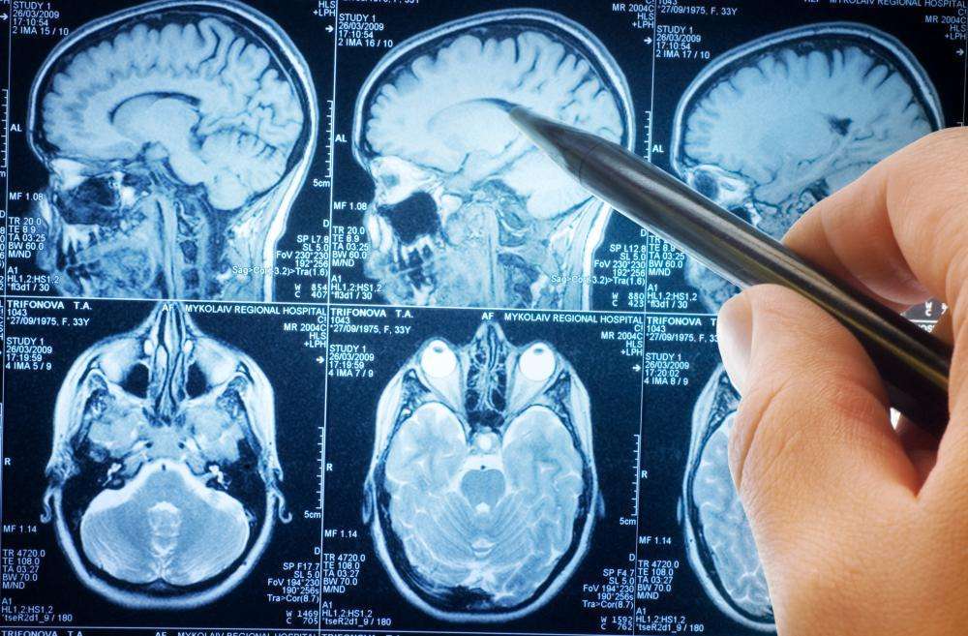

|  |  |
| --- | --- |
| **Job Title:** | Consultant Neuropathologist |
| **Closing date for applications:** | 12 noon, Friday 24th January 2025 |
| **Contract duration:** | Permanent |
| **Contract Type:** | Public Only Consultant Contract 2023 |
| **Hours per week:** | Beaumont Hospital ( 35.5 hours per week) and RCSI ( 3.5 hours per week) |
| **Contact Details:** | [ConsultantHR@beaumont.ie](mailto:ConsultantHR@beaumont.ie) – for application queries.  Enquiries relating specifically to this post should be directed to:  Prof Patrick Thornton, Clinical Director, Beaumont Hospital, email: [patrickthornton@beaumont.ie](mailto:patrickthornton@beaumont.ie) or Prof Francesca Brett, Consultant Neuropathologist, Beaumont Hospital, email [francescabrett@beaumont.ie](mailto:francescabrett@beaumont.ie) |

**Beaumont Hospital Profile**

Beaumont Hospital, incorporating St. Joseph’s Raheny, is a large academic teaching hospital 5km north of Dublin City centre. It is a Level 4 hospital within the HSE Dublin and North East Region, which includes Mater Misericordiae University Hospital, Connolly Hospital, Rotunda Hospital, Cavan / Monaghan Hospitals, Our Lady of Lourdes Hospital, Our Lady’s Hospital Navan and the National Orthopaedic Hospital Cappagh with its academic partners The Royal College of Surgeons in Ireland University of Medicine & Health Sciences and Dublin City University.

Beaumont Hospital provides emergency and acute care services across 54 medical specialties to a local community of some 290,000 people. In addition, it is a designated Cancer Centre and the regional treatment centre for Ear, Nose & Throat, and Gastroenterology, the national referral centre for Neurosurgery and Neurology, Renal Transplantation, the National Poisons Information Centre, Cochlear Implantation and Mechanical Thrombectomy. The Hospital has been designated as the European Stroke Organisation (ESO) Stroke Centre in addition to the National Centre for Skull Based Cancer Services.

With a workforce of approximately 4,500 staff and a combined bed complement of 1058 (IP & DC) beds, Beaumont Hospital is the principal teaching hospital for the Royal College of Surgeons in Ireland. It also enjoys close links with Dublin City University, especially in the area of nurse training, and with other academic institutions in respect of training and research.

The St. Joseph's Hospital Raheny site provides both medical and surgical inpatient care, day-care, outpatient, outpatient physiotherapy, radiology services, Care of the Elderly Rehabilitation and a 100 bedded Raheny Community Nursing Unit.

**Tradition**

Beaumont Hospital opened in 1987, following the closure and merger of the Charitable Infirmary, Jervis Street and the Richmond Hospital. Both hospitals had a long and proud tradition of advancing patient care and a strong association with pioneers in medicine, such as Sir Dominic Corrigan. This tradition of excellence in patient care and clinical research is at the core of our ethos.

**Leadership**

Beaumont Hospital plays a leading role in the transformation process in the Irish health services, including establishment of a number of clinical directorates, the development of formal academic and service development links with sister hospitals as part of an academic and regional network. It looks forward to continuing to strengthen its national and international role in provision of quality health care, innovation and patient management.

**Neuropathology Service**

The Neuropathology Department is a consultant-lead service providing a service not only to Beaumont Hospital but also to hospitals in the greater Dublin area. Additionally referrals are received from hospitals roughly north of a line from Waterford to Limerick. Referrals south of this imaginary line are referred to Cork University Hospital. In addition to providing a diagnostic service to these hospitals the neuropathologists are required to attend MDM, grand rounds and other conferences at hospitals in the Dublin area to discuss cases.

Neuroscience specialities account for the bulk of the work coming through the department. These also account for the more complex and time consuming investigations including intraoperative frozen sections, tumours, muscle and nerve biopsies.

All autopsies on patients under the Neurology and Neurosurgery services in Beaumont Hospital are carried out by the Neuropathologists and this on occasion requires attendance at the coroner’s court for inquest. Attendance at the Central Criminal Court is required on an infrequent basis.

The National CJD surveillance centre (dealing with all suspect CJD cases in the Republic), the National Brain Bank (dealing with cases of atypical dementia, motor neuron disease, movement disorders and other atypical neurological illnesses in the Republic) and the National Brain Tumour Biobank (dealing with adult tumours) are all located on the Beaumont Hospital /RCSI campus site and overseen by Neuropathology.

Neuroscience centre at Beaumont Hospital is a tertiary referral centre for Neurosurgery.

1. Neurosurgical biopsies –All adult and paediatric neurosurgical biopsies are received by the Beaumont Hospital Neuropathology Laboratory and are reported by consultant Neuropathologists in Beaumont Hospital – The majority require intraoperative smear / frozen section analysis. All tumour cases are subsequently reviewed weekly in Beaumont for adults and in CHI at Crumlin for paediatric cases. With the exception of paediatric cases, the Consultant Neuropathologists in their capacity as reporting pathologist present their own cases at the adult neuro-oncology meetings when possible.
2. Epilepsy resections for non-tumour lesions are performed both in Beaumont Hospital and CHI at Temple Street.
3. Muscle biopsies are received not only from Beaumont Hospital but from all the hospitals in the Dublin area and north of the imaginary line from Waterford to Limerick.
4. Nerve biopsies are received not only from Beaumont Hospital but from all the hospitals in Dublin and north of the imaginary line from Waterford to Limerick.
5. CSF cytology again is received not only from Beaumont but also referred from other hospitals both in Dublin and in the country.
6. Electron Microscopy is performed on selected cases.
7. Post mortem examinations are carried out on both ‘in house (consented hospital cases)’ and coroner’s cases.
8. Brain referrals are received not only to the Brain Bank and as part of CJD surveillance but also from the forensic services and from other hospitals.
9. Molecular analysis is an integral part of the work load since the revised WHO Classification of CNS Tumours 2016. Beaumont Hospital is the national referral centre for all diagnostic molecular tests in the Republic of Ireland.
10. Western blot analysis is carried out on all suspected CJD cases both biopsy and autopsy. This has obviated the need for extensive pre-treatment in cases referred with suspected CJD, where an alternate diagnosis is subsequently made.

**Useful Links**

|  |  |
| --- | --- |
| **Our website:** | <http://www.beaumont.ie> |
| **Management:** | <http://www.beaumont.ie/index.jsp?p=108&n=115> |
| **Senior executives:** | <http://www.beaumont.ie/index.jsp?p=115&n=303> |
| **Corporate reports:** | <http://www.beaumont.ie/index.jsp?p=108&n=387> |

**Job Description and Responsibilities**

**Consultant Neuropathologist**

The successful candidate will fulfil the role of Consultant Neuropathologist at Beaumont Hospital with duties including:

* To practice as Consultant Neuropathologist at Beaumont Hospital.
* The appointee will be required to participate in a consultant rota for the provision of Neuropathology services.
* Perform specialised diagnostic pathology work as required in accordance with the schedule approved by the Consultant Appointments Unit, the Department of Laboratory Medicine in Beaumont Hospital and the provision of expertise as required.
* To work in close collaboration with all staff charged with responsibility for the delivery of Neuropathology services.
* Provide consultation service if so requested.
* To participate in development of and undertake all duties and functions pertinent to the practice of neuropathology as set out within the Clinical Directorate Service Plan and in line with policies as specified by the Hospital Board.
* To ensure that duties and functions are undertaken in a manner that minimises delays for patients and possible disruption of services.
* To work within the framework of Beaumont plan and /or levels of service (volume, types etc.) as determined by Beaumont Hospital.
* To participate in teaching at the RCSI group – both undergraduate and postgraduate
* To formally review the execution of the Clinical Directorate Service Plan with the Clinical Director / Employer periodically. The Clinical Directorate Service Plan shall be reviewed periodically at the request of the Consultant or Clinical Director / Employer. The Consultant may initially seek internal review of the determinations of the Clinical Director regarding the Service Plan.
* To participate in the development and operation of the Clinical Directorate structure and in such management or representative structures as are in place or being developed. The Consultant shall receive training and support to enable him/her to participate fully in such structures.
* To provide, as appropriate, consultation in the Consultant’s area of designated expertise in respect of patients of other Consultants at their request.
* To ensure in consultation with the Clinical Director that appropriate medical cover is available at all times having due regard to the implementation of the European Working Time Directive as it relates to doctors in training.
* To participate as a right and obligation in selection processes for non-Consultant Hospital Doctors and other staff as appropriate. The Employer will provide training as required. The Employer shall ensure that a Consultant representative of the relevant specialty / sub-specialty is involved in the selection process.
* To participate in clinical audit and proactive risk management and facilitate production of all data/information required for same in accordance with regulatory, statutory and corporate policies and procedures.
* To participate in and facilitate production of all data/information required to validate delivery of duties and functions and inform planning and management of service delivery.

Standard Duties and Responsibilities for all Consultant posts are as per Section 4 & Section 10 of the Public Only Consultant’s Contract 2023.

1. To participate in development of and undertake all duties and functions pertinent to the Consultant’s area of competence, as set out within the Clinical Directorate Service Plan and in line with policies as specified by the Employer.
2. To ensure that duties and functions are undertaken in a manner that minimises delays for patients and possible disruption of services.
3. To work within the framework of the hospital / agency’s service plan and/or levels of service (volume, types etc.) as determined by the Employer. Service planning for individual clinical services will be progressed through the Clinical Directorate structure or other arrangements as apply.
4. To co-operate with the expeditious implementation of the Disciplinary Procedure (attached at Appendix II).
5. To formally review the execution of the Clinical Directorate Service Plan with the Clinical Director / Employer periodically. The Clinical Directorate Service Plan shall be reviewed periodically at the request of the Consultant or Clinical Director / Employer. The Consultant may initially seek internal review of the determinations of the Clinical Director regarding the Service Plan.
6. To participate in the development and operation of the Clinical Directorate structure and in such management or representative structures as are in place or being developed. The Consultant shall receive training and support to enable him/her to participate fully in such structures.
7. To provide, as appropriate, consultation in the Consultant’s area of designated expertise in respect of patients of other Consultants at their request.
8. To ensure in consultation with the Clinical Director that appropriate medical cover is available at all times having due regard to the implementation of the European Working Time Directive as it relates to doctors in training.
9. To supervise and be responsible for diagnosis, treatment and care provided by non-Consultant Hospital Doctors (NCHDs) treating patients under the Consultant’s care.
10. To participate as a right and obligation in selection processes for non-Consultant Hospital Doctors and other staff as appropriate. The Employer will provide training as required. The Employer shall ensure that a Consultant representative of the relevant specialty / sub-specialty is involved in the selection process.
11. To participate in clinical audit and proactive risk management and facilitate production of all data/information required for same in accordance with regulatory, statutory and corporate policies and procedures.
12. To participate in and facilitate production of all data/information required to validate delivery of duties and functions and inform planning and management of service delivery.

The above is not intended to be a comprehensive list of all duties involved and consequently, the post holder may be required to perform other duties as appropriate to the post which may be assigned to him/her from time to time and to contribute to the development of the post while in office.