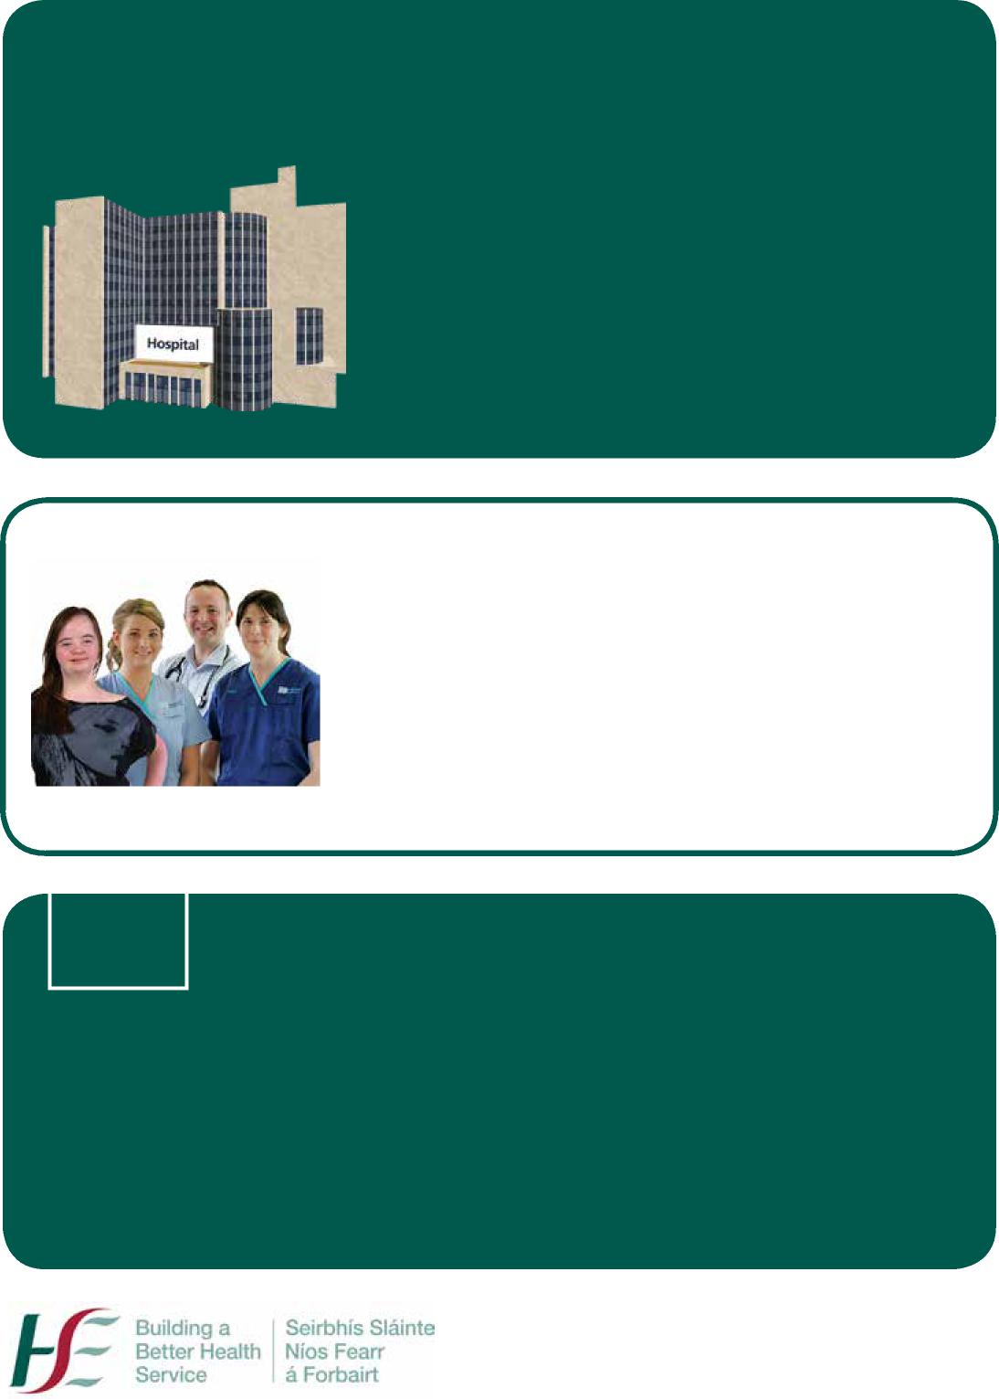
For people with an intellectual disability in contact with a healthcare setting
Your Health Passport will help to let healthcare staff know all about your abilities and needs.
This will help them give you better care when you are in a healthcare setting.
Please ensure that your information is up to date.
To staff:
Please read this Health Passport and make reasonable adjustments before you undertake any assessment, examination, treatment or care.
Try to make this passport easily available to all staff involved in care.
HSE Health Passport

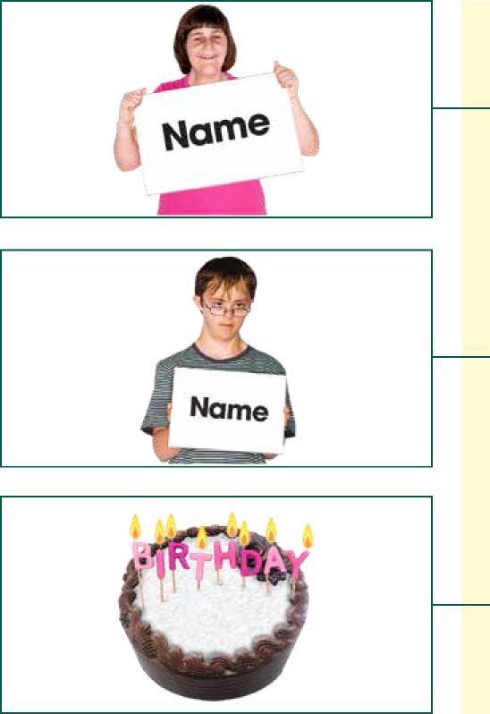
My name is
I like to be called
My birthday is (date of birth)

I live at

All about me

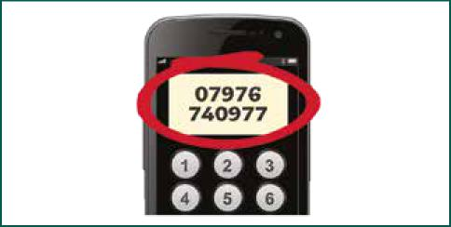
My telephone number is

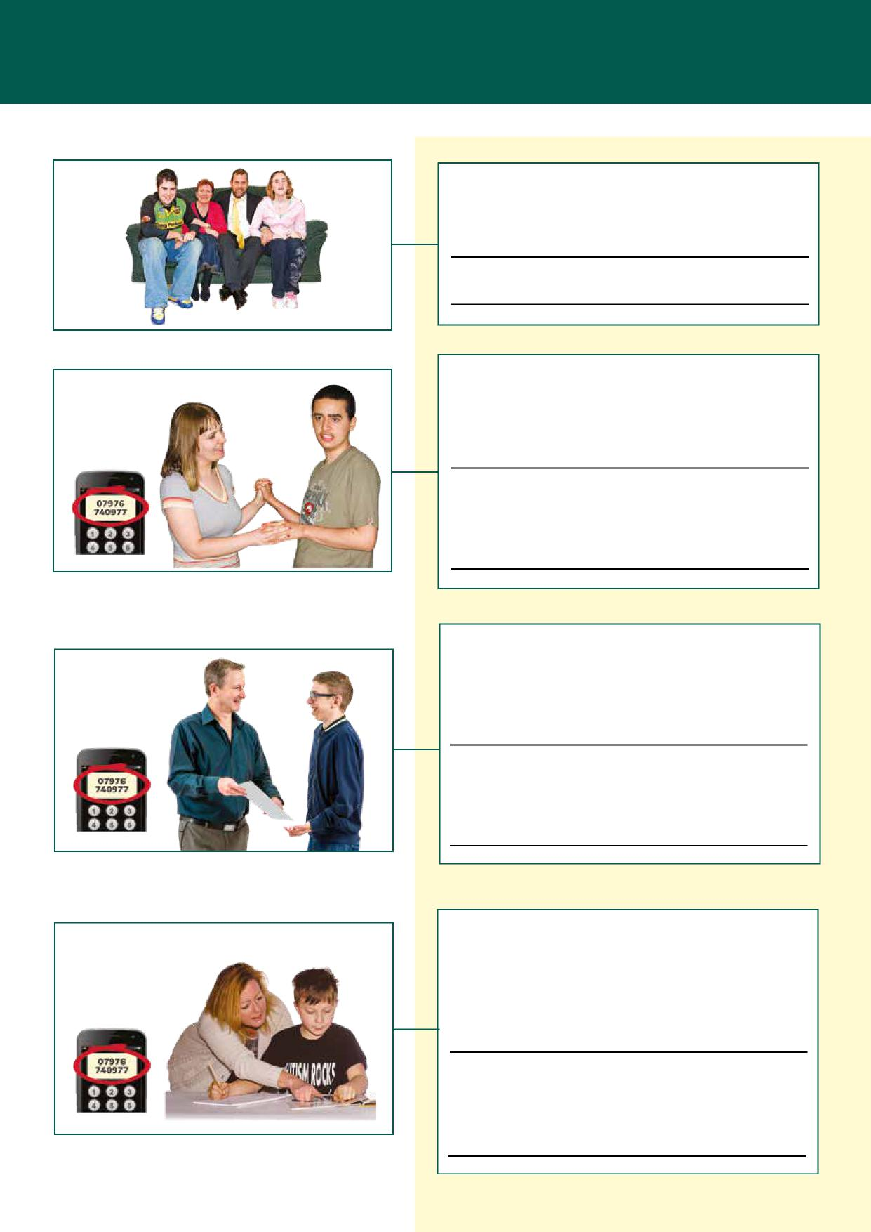
I live with
My main carer is Name
Telephone number
My keyworker is Name
Telephone number
Parental responsibility
(for children under 18 years of age)
Name
Telephone number

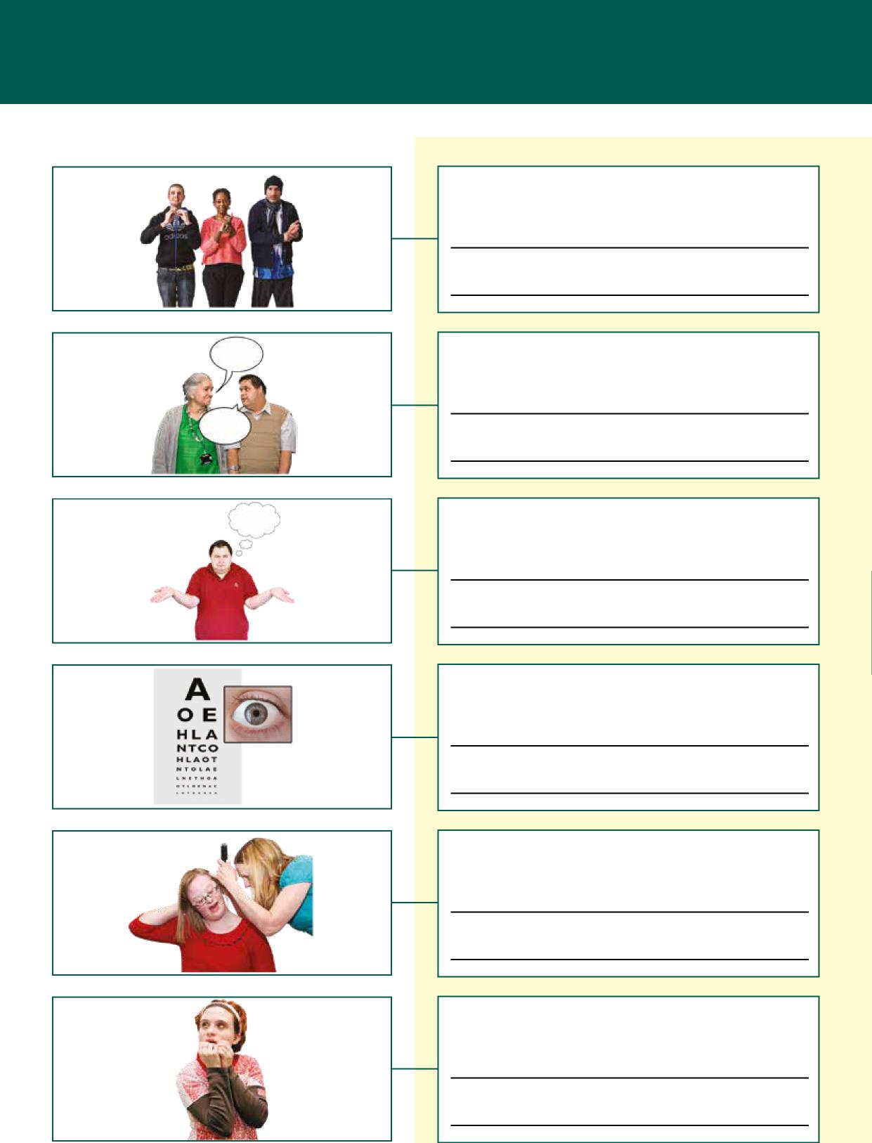
Communication
My hearing
What I do if I am afraid or worried
Support I need to make decisions
My eyesight
I communicate by
How best to communicate with me

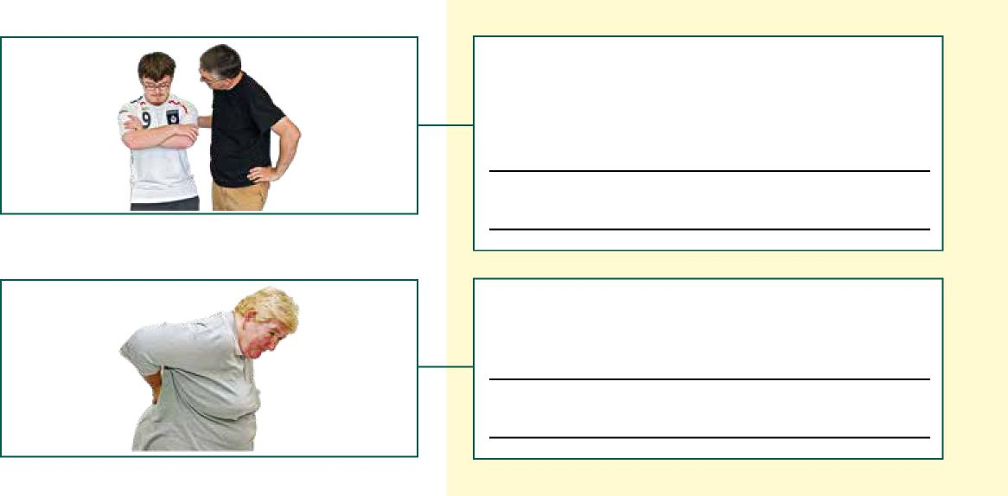
Things I do if I am sore or in pain
How you can support me if I am afraid or worried
Medical history
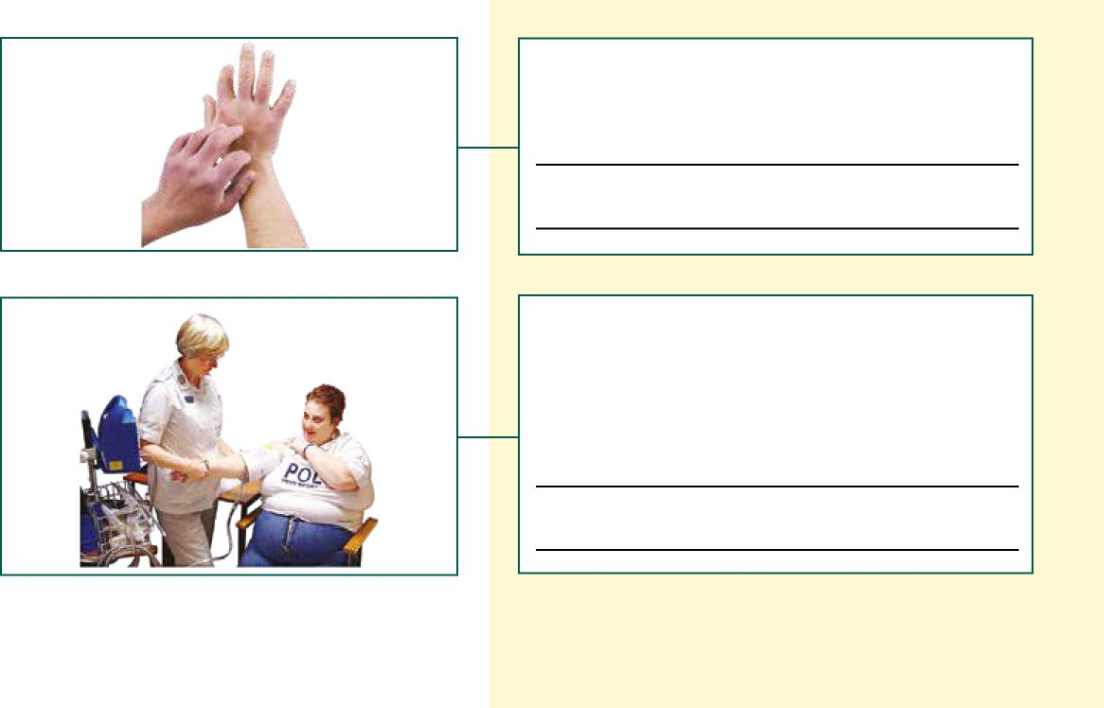
Things I am allergic to
Other conditions I have (for example, epilepsy, diabetes, mental illness, high blood pressure)

Medication

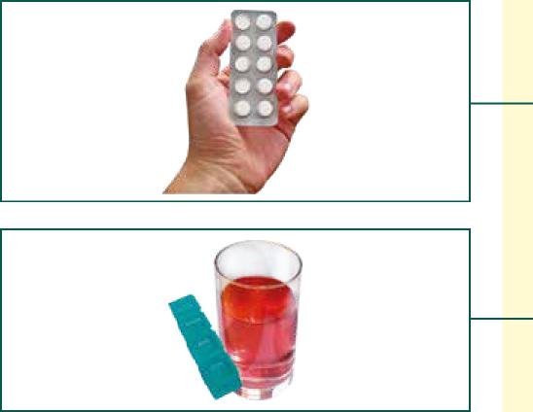

I am on medication Yes o
No o

(please bring all your medication with you)
How I prefer to take my medication (in food, with a drink, as a liquid)

Looking after me

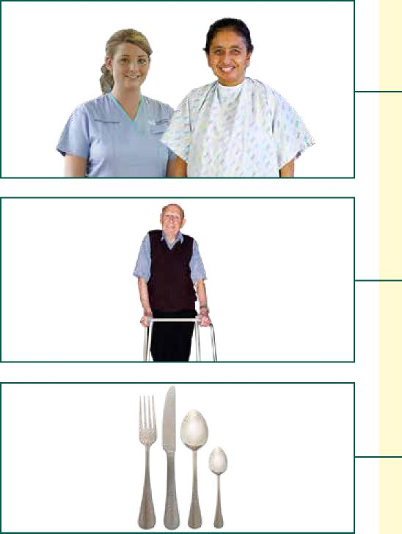
How best to gain my help when examining or caring for me
Support I may need with moving (in bed, sitting, walking)
Support I may need with eating

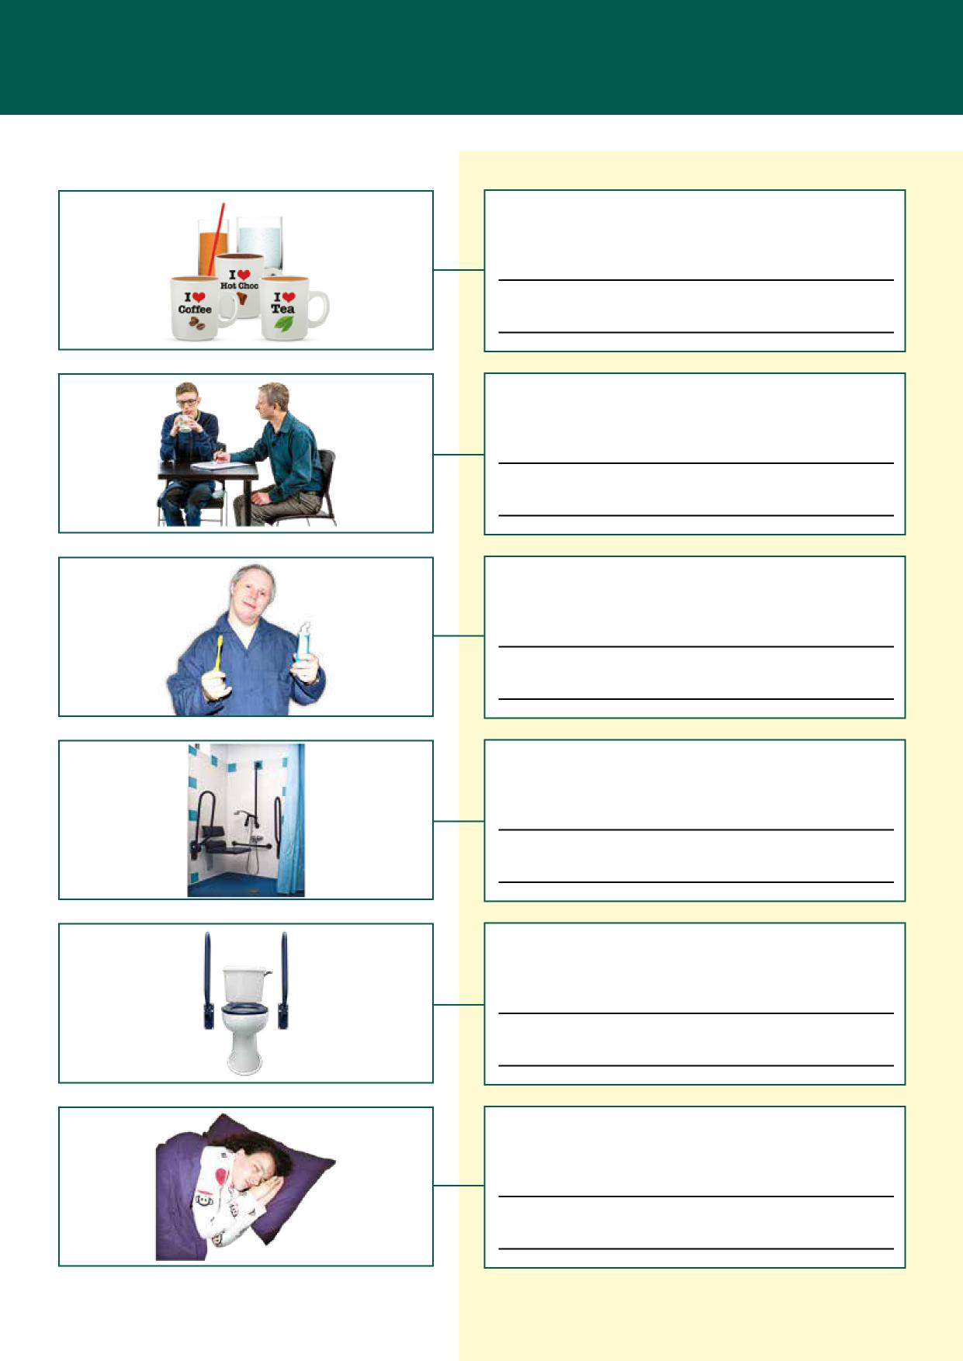
Help I need with drinking
How to reduce my risk of choking (if this applies to me)
Support I may need with my oral or dental care
You can help me with my personal care by
Support I may need with using the toilet
Things that help me have a good sleep

Keeping me safe and happy
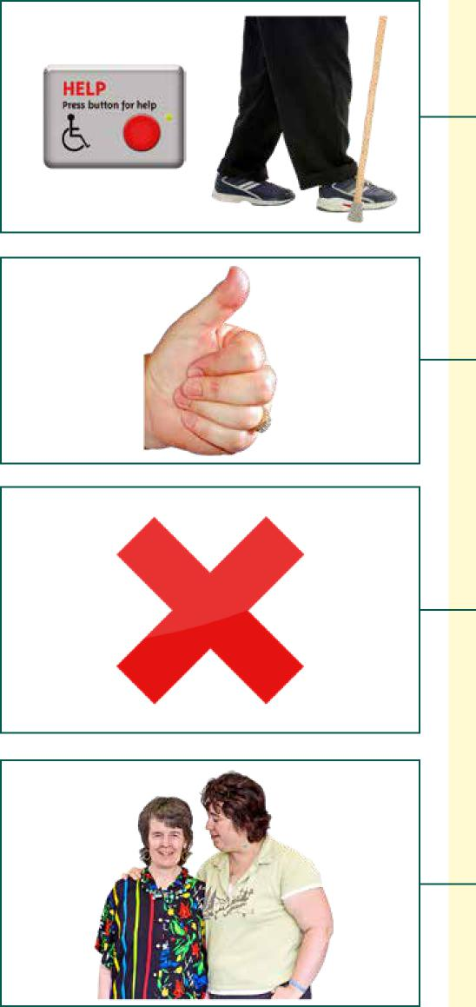
Things that I do or use to keep safe
Things I like (what makes me happy, things I like to do, see or talk about)
Things I do not like (what upsets me, things I do not like to do, see or
talk about)
If my behaviour becomes difficult for you, please support me by

Completed by:
Relationship to Health Passport owner:
Date:
Review Date:
Adapted with permission from the Public Health Agency

04/19

