…

Easy Read

Applying to the Legal Aid Board for legal representation

That application will have your personal details such as your name, your address, your date of birth, your PPS number and what you need representation for



We will submit that application on your behalf to the Legal Aid Board



You will need to make an application to the Legal Aid Board for a solicitor



You will need a solicitor to represent you in court



Due to the changes in law made by the Assisted Decision-Making (Capacity) Act 2015, you will need to make an application to the court



That solicitor will then represent you in court



Once they accept the instruction, we will send the Legal Aid Cert to the solicitor with this Easy Read Document as confirmation we have shared the information with you.

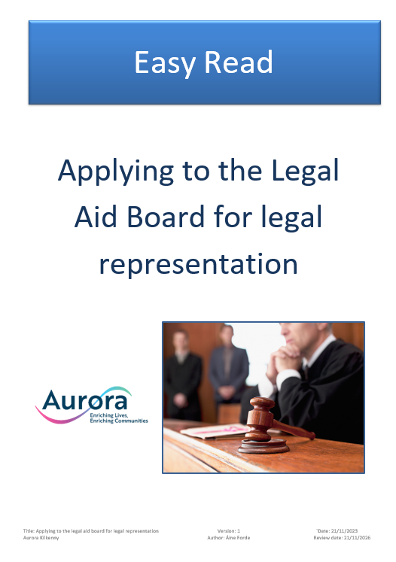

We will then support you to choose a solicitor and make contact with them for you



One your application has been approved, the Legal Aid Board will write to tell you who your solicitor is or give you a panel of solicitor’s names for you to choose from. They will give you a Legal Aid Cert for the solicitor.

