Procedure for the use of Standardised Clinical Care Plans in the Public Health Nursing Service

Policy ☐ Procedure ☒ Protocol ☐ Guideline ☐ Clinical Guideline ☐
DOCUMENT GOVERNANCE
Document Owner (post holder title): |  |  | National Practice Development Coordinator for Public Health Nursing (PHN) Service, ONMSD.
Document Owner name: |  |  | Grainne Ryan
Document Owner email contact:  (Generic email addresses only for the Repository) |  |  | Nursing.services@hse.ie
Document Commissioner(s): (Name and post holder title): |  |  | Grainne Ryan, National Lead for Public Health Nursing (PHN) Service
Document Approver(s): (Name and post holder title): |  |  | Quality Improvement (QI) governance group, National PHN service.
Lead responsibility for national implementation: |  |  | Grainne Ryan, National Lead for PHN Service.
Lead responsibility for national monitoring and audit: |  |  | Grainne Ryan, National Lead for PHN Service.
Development Group Name: |  |  | Procedure Development Group for the use of Standardised Clinical Care Plans in the Public Health Nursing Service.
Development Group Chairperson: |  |  | Yvonne Delaney Assistant Director of Public Health Nursing – Practice Development Coordinator Laois/Offaly & Longford/Westmeath.
Additional headings can be inserted as required
DOCUMENT MANAGEMENT
Date effective from: |  | 19/03/2024
Date set for next review: |  | 19/03/2027
Your Reference No: (if applicable) |  | PCPHN10
Current version no: | 0 | Archived version no: |  | This is the first version
Note: Original document is Version 0. First revision is Version 1. Second revision is Version 2, and so on.
Note: HSE National 3PGs should be formally reviewed every 3 years, unless new legislative/regulatory or emerging issues/research/technology/audit etc. dictates sooner.

VERSION CONTROL UPDATE
Version No. | Date reviewed | Section numbers changed | Approved by
 |  | (Insert additional lines as required)
Document management notes:
For example: If title of the HSE national document has been changed since the last version

PUBLICATION INFORMATION

Title:
Procedure for the use of Standardised Clinical Care Plans in the Public Health Nursing Service.

Topic:
Use of Standardised Clinical Care Plans in the Public Health Nursing Service.

National Group:
National Public Health Nursing (PHN) Service.

Short summary:

The purpose of this procedure is to provide guidance to all registered nurses/midwives working within the Public Health Nursing Service on the use of Standardised clinical care plans.

Description:
- To provide guidance to all nurses/midwives on the use of standardised clinical care plans.
- To guide nurses/midwives on individualising the standardised clinical care plans in order to address the individual needs of the client.
- To promote best practice regarding the recording of clinical practice including assessment, problem identification, goal planning, intervention and evaluation in the client healthcare record in a standardised way.

TABLE OF CONTENTS
- Planning…………………………………………………………………………………………………………………………………………………….4
  - Overview……………………………………………………………………………………………………………………………………… 4
  - Purpose……………………………………………………………………………………………………………………………………..…4
  - Scope…………………………………………………………………………………………………………………………………………..4
    - Target users………………………………………………………………………………………………………………..4
    - Target population………………………………………………………………………………………………………….4
  - Objective(s)……………………………………………………………………………………………………………………………………5
  - Outcome(s)…………………………………………………………………………………………………………………………………….5
  - Disclosure of interests………………………………………………………………………………………………………………………..5
  - Rationale/alignment with HSE national priorities………………………………………………………………………………………….6
  - Supporting evidence………………………………………………………………………………………………………………………….6
- Methodology………………………………………………………………………………………………………………….…………………………….7
  - List of key questions this National 3PG will answer………………………………………………………………………………………7
  - Describe and document the evidence search……………………………………………………………………………………………..7
  - Describe the method of screening and evidence appraisal……………………………………………………………………………..8
  - Resource implications………………………………………………………………………………………………………………………13
  - Attach any copyright or permissions sought……………………………………………………………………………………………...13

- Procedure…………………………………………………………………………………………………………………………………………………13
  - Background………………..…………………………………………………………………………………………………………………13
  - Standardised Clinical Care Plans………………………………………………………………………………………………………….13
  - Individualisation of Standardised Clinical Care Plans…………………………………………………………………………………...13
  - Consent………………………………………………………………………………………………………………………………………14
  - Care Planning………………………………………………………………………………………………………………………………..14
  - Use of the Standardised Clinical Care Plans…………………………………………………………………………………………….16
  - Closure of the standardised Clinical Care Plans…………………………………………………………………………………………21
  - Documentation………………………………………………………………………………………………………………………………22
  - Specific roles and responsibilities…………………………………………………………………………………………………………25
3.9.1 Outline formal governance arrangements………………………………………………………………………………….25
4.0 Consultation………………………………………………………………………………………………………………………………………………..26
4.1 Stakeholder involvement…………………………………………………………………………………………………………………….26
4.2 External review………………………………………………………………………………………………………………………………..26
5.0 National implementation plan…………………………………………………………………………………………………………………………….26
6.0 Governance and approval…………………………………………………………………………………………………………………………….…..27
7.0 Communication and dissemination plan…………………………………………………………………………………………………………………27
8.0 Sustainability………………………………………………………………………………………………………………………………………………..27
8.1 Plan for national monitoring and audit………………………………………………………………………………………………………27
8.2 Evaluation………………………………………………………………………………………………………………………………………28
9.0 Review /update……………………………………………………………………………………………………………………..………………………28
9.1 Next review date……………………………………………………………………………………………………………………………….28
10.0 References………………………………………………………………………………………………………………………………………………...29
11.0 Glossary of terms…………………………………………………………………………………………………………………………………………46
12.0 Acknowledgements……………………………………………………………………………………………………………………………………….49
13.0 Appendices………………………………………………………………………………………………………………………………………………..49

Appendix 1 Membership of the development group………………………………….………………………………………………………..50
Appendix 2 Membership of the approval governance group………………………………………………………………………………… 52
Appendix 3 Conflict of interest declaration form………………………………………………………………………………………………..54
Appendix 4 Search strategy………………………………………………………………………………………………………………………55
Appendix 5 List of standardised clinical care plans and codes……………………………………………………………………………….56
Appendix 6 Clinical care plans index…………………………………………………………………………………………………………….57
Appendix 7 Sample clinical care plan with guidance for use………………………………………………………………………………….58
Appendix 8 National implementation plan………………………………………………………………………………………………………61
Appendix 9 Audit tool for the procedure on the use of standardised clinical care plans in the PHN service……………………………63
Appendix 10 Checklist…………………………………………………………………………………………………………………………….64
Appendix 11 Subsequent reviews- additional sheet x 2 pages……………………………………………………………………………….65

Planning

Overview
Deriving from the national Public Health Nursing (PHN) service Quality Improvement (QI) Governance Group, a practice gap was identified which led to a request to develop standardised clinical care plans to guide clinical practice documentation nationally. Thus, a procedure development group was formed consisting of 33 members representing Practice Development Coordinators (PDCs), Assistant Directors of Public Health Nursing (ADPHNs), registered Public Health Nurses (RPHNs) and Community Registered General Nurses (CRGNs) across all Community Health Organisations (CHOs) nationally (Appendix 1). Consensus was reached as to which clinical care plans to prioritise based on the most common clinical problems encountered day to day within the PHN service. The formation of 4 sub-groups enabled the development of a suite of standardised clinical care plans as part of this project which will continue to evolve.

This national procedure has been developed to support the implementation of the standardised clinical care plans. Registered Nurses (RNs) (to include registered RPHNs, CRGNs) and Registered Midwives (RMs) should establish and maintain accurate, clear and contemporaneous client care records within a legal, ethical and professional framework (Nursing and Midwifery Board of Ireland (NMBI), 2015a). Furthermore, NMBI (2015b) indicate that the quality of records maintained by nurses and midwives is a reflection of the quality of the care provided by them to clients. Care plans have a legal function that represents the care service that the client receives (Østensen et al., 2020). Therefore, it is envisaged that the use of the standardised care plans will support person centred, evidenced based care with a view to enhancing the quality and safety of client care.

Purpose
The purpose of this procedure is to provide guidance to all nurses/midwives working within in the PHN Service on the use of standardised clinical care plans.

Scope

Target users
Target users; this procedure applies to all registered nurses/midwives working within the PHN Service nationally who provide clinical nursing care.

Target population
This procedure applies to all clients who are in receipt of clinical nursing care from the PHN Service.

Objective(s)
1.4.1 To provide guidance to all nurses/midwives on the use of standardised clinical care plans.
1.4.2 To guide nurses/midwives on individualising the standardised clinical care plans in order to address the individual needs of the client.
1.4.3 To promote best practice regarding the recording of clinical practice including assessment, problem identification, goal planning, intervention and evaluation in the client record in a standardised way.

Outcome(s)
A procedure is available for all nurses/midwives on the use of the standardised clinical care plans.
The aim of standardised clinical care plans is to:
- Promote evidence-based practice
- Reduce variation in practice and service delivery
- Lead to higher quality of care and greater client satisfaction
- Strengthen client’s confidence and skills to manage their health
- Avoid unnecessary duplication
- Act as educational tools
- Act as a basis for audit, evaluation and continuous improvement
- Impact positively on the data outcomes from Quality Care Metrics (QCMs) (HSE, 2018).

Disclosure of interests
None.
All signed declaration of interest forms are retained by the National Practice Development Coordinator (PDC) for Public Health Nursing on behalf of Office of the Nursing and Midwifery Service Directorate (ONMSD).

Rationale / alignment with HSE national priorities
The nurse/midwife is professionally responsible to ensure complete and appropriate documentation (NMBI, 2015b; NMBI, 2021). This document supports the service by promoting best practice regarding the recording of clinical practice including assessment, problem identification, goal planning, intervention and evaluation in the client record in a standardised way.

Supporting evidence
1.8.1 List relevant legislation/PPPGs.
Department of Health and Children (1966) Circular 27/66 District Nursing Service.
Department of Health and Children (2000) Circular 41/2000.
European Commission (2016) General Data Protection Regulations accessed via https://ec.europa.eu/info/law/law-topic/data-protection/eu-dataprotection-rules_en.
Health Information and Quality Authority (HIQA) (2012) A Guide to the National Standards for Safer Better Healthcare.
Health Information and Quality Authority (2015) Guidance for Providers of Health and Social Care Services: Communicating in Plain English.
Health Information and Quality Authority (2016) Supporting Peoples Autonomy: a Guidance Document.
Health Service Executive (2010c) Code of Practice for Healthcare Records Management Abbreviations.
Health Services Executive (2011) Standards and Recommended Practices for Healthcare Records Management.
Health Service Executive (2016) National Framework for developing policies, procedures, protocols and guidelines (PPPGs). HSE, Dublin.
Health Service Executive (2019) Data Protection Guidelines.
Health Service Executive (2022) National Consent Policy, Quality and Client Safety Directorate (Version 1.2). HSE, Dublin.
Health Services Executive (2023) HSE National Records Retention Policy: Health Service Executive, Dublin.
Nursing and Midwifery Board of Ireland (2015a) Scope of Nursing and Midwifery Practice Framework.
Nursing and Midwifery Board of Ireland (2015b) Recording Clinical Practice Professional Guidance.
Nursing and Midwifery Board of Ireland (2021) Code of Professional Conduct and Ethics for Registered Nurses and Registered Midwives.

1.8.2 List PPPGs that are being replaced by this procedure
This national procedure is the first national procedure to support the use of standardised clinical care plans for use within the PHN service.

Methodology

List of key questions this National 3PG will answer
Key questions (clinical/non-clinical)
- What is the guidance required by nurses/midwives to use the standardised clinical care plans?
- What is the evidence base to support the use of the standardised clinical care plans?
- Do standardised clinical care plans improve documentation?
- Do standardised clinical care plans improve quality and safety of client care?
- Barrier and facilitators for the use of standardised clinical care plans?
- How best to individualise standardised clinical care plans?

Describe and document the evidence search
A review of the relevant literature regarding the use of standardised care plans was undertaken by the chair of this national procedure development group. The search yielded limited information. Subsequently, a request was submitted for the assistance of the national HSE library service. A WebEx meeting held between the group chair and library service helped to define the literature review questions and it was agreed to perform a search over a 10 year span to include English language only and to expand the search beyond community nursing services to include other services such as the acute setting and other health and social care services. The search was expanded to include literature greater than 10 year span due to limited relevant findings (Appendix 4).
The term standardised care plans replaced core care plans in the 1990s. Literature reviewed was identified through searches of CINAHL, Medline, the Cochrane database, Google search of the following websites; NMBI, Health Information Quality Authority (HIQA), NICE. Key words included care plan, standard care plan, standardised care plan, evidence based standardised care plan, clinical care plans, individualised care plans, documentation, multidisciplinary, healthcare, Irish policy and nursing and quality and safe care (see appendix 4 for search history summary).

Describe the method of screening and evidence appraisal
Evidence in relation to utilising standardised care plans was considered. In evaluating the evidence the following areas were considered:
• What are the results/conclusions?
• Are the results relevant to the procedure?
The evidence consisted of a hybrid of qualitative and quantitative research looking at the use, effectiveness, barriers, enablers in the use of standardised care plans.
In developing this procedure, assistance from the national library service was sought to search the literature with a request for level 4 ‘summary of evidence’ (Appendix 4). A comprehensive search with an evidence summary informed the detail of this procedure. Recommendations supporting the use of standardised care plans and the individualising of standardised care plans were formulated through a review of the literature by the chair of the procedure development group.
Following several drafts, the final content of the standardised clinical care plans was informed by staff feedback from a pilot of the standardised clinical care plans over the month of May 2023 across 15 Director of PHN (DPHN) sites nationally ensuring broad representation of key stakeholders. Feedback from frontline staff indicated a strong desire to further expand the number of standardised clinical care plans beyond the initial 12 clinical care plans developed. All care plans are informed by the latest evidence based practice which was established by each sub group.
The procedure development group agreed on the final iteration for submission to the national PHN service QI governance group for their approval.
The nurse/midwife is professionally responsible to ensure complete and appropriate documentation (NMBI, 2015b; NMBI, 2021). While care plans are an essential record of actions undertaken by nurses/midwives for clients, many nurses struggle to articulate the complex relationship between theory and practice in their documentation (Ballantyne, 2016). This reflection of evidence based practice is essential considering that our records relating to care planned and undertaken can be utilised for research, audit, and evaluation and in legal proceedings. Many documented cases of professional misconduct against nurses and midwives relate to poor documentation therefore it must be objective enough to stand up to scrutiny (Marinič, 2015). Without complete documentation there is no evidence to prove that care was provided to the client leading to the old adage ‘what is not recorded has not been done’ (Marinič, 2015; Taiye, 2015). Thus, this procedure aims to enhance the nurse/midwife’s knowledge of, and skills in, the care planning process, appropriate use of standardised clinical care plans thus influencing the maintenance of quality nursing documentation.

In Ireland a number of regulatory bodies i.e. Mental Health Commission (MHC), NMBI, HIQA, and Health & Safety Authority (H&SA) have set out requirements to have robust documentation governance in place across the health service. In addition, several regulatory reports, inspections and recommendations from serious incidents have identified significant gaps in relation to nursing documentation. The HIQA published a set of requirements to achieve standards in relation to the production and utilisation of information across the Irish health services (HIQA, 2012). The HIQA National Standards for Safer Better Healthcare (2012) highlights the need for accurate, relevant, legible and complete information. The standards outline the need for appropriate information and communication technology to assist with both the collection and reporting of quality information related to client care. Many high profile cases reminds us that there are adverse consequences for inadequate or inappropriate documentation which can include deficits in care. NMBI (2021) outlines the individual responsibility of all registered nurses and midwives in being answerable for the decisions made in the course of one’s professional practice. The use of standardised clinical care plans offers evidence-based sets of pre-formulated nursing diagnoses, related goals, resources, characteristics and interventions that nurses can select from when completing a care plan (Monsen et al. 2011). By using a standardised care plan structure combined with standardised nursing language, documentation quality is expected to improve by easing the documentation of nursing care, and facilitating communication and workflow (Østensen et al. 2020). The existence of a care planning process has been associated with predictors of positive outcomes for client care. McIlfatrick et al. (2018) evaluated service user outcomes in a sequential mixed methods study. Qualitative analysis identified an overarching theme that a lack of care planning was associated with unmet needs. This indicated an unprepared care planning process in the implementation of care by clinical teams in addressing client needs.

Nursing care can be objective based on scientific knowledge, experience, intuition and critical thinking (Waldow & Borges, 2011). According to Juvé‐Udina (2012) a standardised care plan is “a structured summary of real problems and/or potential complications, together with the prescription of nursing interventions to achieve health results of a certain client population (or groups)”. Essentially standardised care plans have the potential to enhance the quality of nursing documentation in terms of content and completeness, thereby better supporting workflow, easing the documentation process, facilitating continuity of care, and permitting systematic data gathering to build evidence from practice (Østensen et al. 2021). In the optimal case, a standardised care plan will be based on up-to-date, evidence-based knowledge with an overall aim of nurses following a common plan in caring for a specific group of clients (Dahm & Wadensten, 2008). The overall goal is to ensure that all clients receive the same high-quality care. However, individualised care planning should take account of the uniqueness and values of clients, considers their personal characteristics, clinical conditions, personal life situation as well as preferences in the participation of care and as a result produces positive impact on the outcome of the care itself (Martins and Perroca, 2017). Furthermore, individualising standardised care plans means that the nurse/midwife formulates client-specific diagnoses, goals and interventions and plans the necessary care based on the assessment performed on the client and their family, and evaluates the results obtained (Castellà‐Creus et al. 2019a & 2019b). The HIQA standards (HIQA, 2012) have shaped care delivered in a variety of settings to ensure care is planned safely & effectively in consultation with the client or their representative where required. Nurses and midwives must ensure these standards are visible in the care delivered and in the documentation arising from that care.

The 5 step nursing process has been an integral part of client care for decades and more recently, nursing diagnoses have become another step in this process (Alfaro‐LeFevre, 2014). By acknowledging actual/potential health problems following nursing assessment, nursing goals/ interventions are developed to resolve them, acknowledging the impact of nursing on client and organizational outcomes (D’Agostino et al. 2017; MoraisI et al. 2018). Utilising clinical judgement skills, nurses examine client responses to their present health situation, and identify appropriate interventions to achieve goals of care (Sanson et al. 2017). Limited understanding and a recognised theory-practice gap, challenge not only the effective use of nursing systems, but also the responsibilities of registered nurses and midwives to keep records clear, intelligible and accurate (Glasper et al. 2015; Hussein and Osuji, 2017). Parahoo (2014) found that nurses and midwives who receive additional education, can understand and utilise nursing knowledge more clearly in their practice, therefore nurses and midwives must be supported to learn how to utilise all these tools to increase the quality and safety of care.

Following assessment, a clear documented plan of care for clients has been associated with benefits including clarity of treatment plans, ease of prioritisation of goals and greater involvement of clients in the overall management plan (Ademola and Sheerin, 2012). It has been proposed that the nature and quality of documented care planning is not standardised and requires development in Ireland (O'Brien & Cowman, 2011). Detailed, accurate records are essential requirements to support care planning and the achievement of consistently high standards of care. Furthermore, NMBI (2021) indicates that nurses and midwives are prepared to make explicit their rationale for decisions made in his/her professional practice and reminds us that we should justify such decisions in the context of legislation, professional standards and guidelines, evidence-based practice and professional and ethical conduct (NMBI, 2021). Therefore, accurately identifying client’s needs and preferences are part of nurses’/midwives’ responsibilities. When nurses/midwives are able to accurately identify client cues, they can assist clients to meet their goals and return to their highest level of functioning (Australian Commission on Safety and Quality in Health Care, 2017). The literature reminds us that every client has the right to make their own decisions based on their own beliefs & values (Morrell et al. 2019 and HIQA, 2016).

All stages of the nursing process require capacity of judgement or clinical reasoning. This judgement is a mental ability that enables a nurse/midwife to take the most appropriate decisions that help prevent and/or resolve problems in each one of the client’s situations. To develop it, nurses/midwives need to be able to think critically, basing their thoughts on a series of skills and behaviours (Castellà-Creus et al. 2019a & 2019b). When nurses/midwives do not use critical thinking skills, diagnostic errors can occur in client care (Morris, 2021).

In line with the NMBI professional code (NMBI 2021), nurses/midwives should be aware of their level of accountability when utilising a standardised care plan. Understandably, nurses/midwives cannot apply standardised care plans to all clients and, therefore, knowledge and critical thinking skills are required to ensure that care is client centred. The standardised care plan may address the majority of needs relating to specific problems, however nurses/midwives need to assess whether an individualised care plan needs to be generated or whether the standardised care plan can be adapted to meet the individual need. The nurse/midwife should devise an individual care plan when there is no standardised care plan for the identified healthcare needs.

Administering client‐centred care implies being able to individualise the care according to a client's needs and those of their family (Köberich et al. 2016). The individualisation process is the fundamental element for working with standardised care plans. This process consists of adapting the standardised care plan to a client's needs, according to the assessment and the subsequent re‐evaluations required by their condition. The result is the application of an individualised care plan (Juvé‐Udina 2012). Failure to carry out this individualisation can lead to the risk of only diagnosing expected, common problems (Castella-Creus et al. 2019a & 2019b). The client’s wishes must inform the content of the care plan in making it truly individualised. However, a client's need for autonomy may conflict with care guidelines or suggestions that nurses or other healthcare workers believe is best (Haddad & Geiger, 2020). Within the Irish context, the HIQA (2016), the HSE (2022) and the Decision Support Service (2023) sign posts professionals to how best to achieve autonomy of decision making, valuing client choice and promoting client centred care.

In summary, standardised care plans need to be written in line with the latest guidance and research related to that problem and updated if new evidence is found (Barrett et al. 2012). It is important that standardised care plans are updated when there is new evidence. In studies on the use of standardised care plans the majority of the nurses were of the opinion that standardised care plans increased their ability to provide the same high-quality basic care for all clients (Dahm & Wadensten, 2008). Furthermore another study showed that nurses considered standardised care plans manageable and, unlike free text, their structured content made it possible to record the care planning in a more complete and relevant manner (Svensson et al. 2012). The standardised care plans accompanying this procedure are evidence based, meaning that interventions associated are based on empirical evidence and thereby provide a means to disseminate evidence into practice. Castella-Creus et al. (2019a) & (2019b) reported that better use of standardised care plans would improve nurses’ access to appropriate and accurate information in decision-making, thus improving the documentation process and quality of care.

Resource implications
This procedure is available online on the PHN page of the HSE website www.hse.ie/phn. The care plans in both the editable (for completion on a computer) and printable (for handwritten completion) forms are available on https://dochub.healthservice.ie. The DPHNs nationally will be informed of the availability of these resources for the PHN service. An information session will be offered to all DPHNs/ADPHNs/Nurses/midwives as part of the formal roll out of the standardised care plans and this associated procedure. The national group of PDCs will offer assistance as required or the equivalent representative/champion as identified by the relevant DPHN.

Attach any copyright or permissions sought
No copyright or permissions are required in relation to this document.

Procedure

For the purpose of this procedure, the term ‘client’ will be used throughout; it encompasses the terms patient, individual, person, service user, male & female & indicates the person in receipt of the nursing intervention & the recipient of care.
Throughout this procedure and the standardised clinical care plans, the term ‘nursing problem/nursing diagnosis’ is used to indicate a clinical nursing judgment and this term will also refer to identified concerns, issues, deficits related to the client’s health status.

3.1 Background – see page 4 section 1.1 for overview.

3.2 Standardised clinical care plans are pre-developed plans developed by healthcare organisations to ensure that clients with a particular condition receive consistent care. These care plans are used to ensure that minimally acceptable criteria are met and to promote the efficient use of the nurse’s time by removing the need to repeatedly develop care plans reflecting common actions for clients (Nurselabs, 2023). Standardised care plans promote more complete documentation whilst supporting nurses' workflow (Charalambous & Goldberg, 2016).

3.3 Individualisation of standardised clinical care plans involves tailoring a standardised care plan to meet the specific needs and goals of the individual client. A collaborative approach between the nurse/midwife and client allows more personalised and holistic care better suited to the client’s unique needs, strengths and goals (Coulter & Oldham, 2016). Additionally, studies have shown that individualisation can lead to improvements in physical and psychological health and strengthen client’s confidence and skills to manage their health (Coulter et al. 2015). When clients feel that their care is tailored to their specific needs, they are more likely to feel heard and valued (Kwame and Petrucka, 2021). The HIQA (2016) identify the necessity for all healthcare professionals to facilitate increased autonomy regarding client care decisions. This is particularly important in today’s healthcare environment, where client satisfaction is a measure of quality (Prakash, 2020).

3.4 Consent must be obtained prior to completing any assessment or providing any intervention to ensure client participation and self-determination as a fundamental principle of person centred care planning (HIQA, 2016). All proposed interventions must be discussed with the client. The HSE’s national consent policy (HSE, 2022, v1.2) indicates the following key steps in facilitating informed consent and assisted decision making by checking if the client:
- Understands information relevant to the decision
- Retains that information long enough to make a voluntary choice
- Uses or weighs up that information as part of the process of making the decision
- Communicates their decision in whatever way they communicate (not only verbally)

3.5 Care planning
Care planning is an ongoing process which starts from the first contact with the client and involves 5 key cyclical steps (American Nurses Association, 2017) as follows:
- Assessment
- Diagnosis: Nursing diagnoses/identification of client problem(s)
- Planning goals/expected outcomes
- Interventions (nursing intervention and client intervention/self-management)
- Evaluation

3.5.1 Assessment
The process starts with a comprehensive assessment of the client’s physical, psychological, social and spiritual health needs (Younas, 2017), as well as identifying their abilities and deficits. In particular, client assessment may also relate to the following areas; sexual, psychosocial, cultural, cognitive, functional, age-related, economic and environmental. Information in this area can be subjective and objective.
For a comprehensive assessment to be achieved, reliable & valid assessment and risk identification tools must be used (as per local client healthcare record) to establish the client’s health status e.g. physical, psychological and social (Wiener et al. 2016) which informs the screening and detection of problems. Where appropriate, the views and observations of the client and family members in relation to that assessment should be sought (NMBI, 2015b).

3.5.2 Diagnosis/Problem Identification: Following assessment by the nurse/midwife, the client’s identified healthcare problem(s)/diagnosis should be documented in the care plan. This nursing diagnosis is a clinical judgement concerning human responses (individual, family, group or community) to health conditions or life processes (Herdman & Kamitsuru, 2017). The information gained from the assessment is used to identify actual and potential problems, as well as strengths (Yildirim and Ozkahraman, 2011). Based on these assessment findings, the person’s needs are categorised & prioritised to formulate a nursing diagnosis/problem identification.

3.5.3 Planning Expected Client Goals: This stage is where goals are set and interventions are planned to reduce, resolve or prevent the client’s problems, while supporting the client’s strengths in an organised, goal-directed way (Kozier et al. 2008). These specific goals will be set in partnership with the client/decision-making assistant/co-decision-maker/court appointed decision-making representative that will be achieved through a combination of both nursing intervention(s) and client self-management. These may be long and/or short-term goals of care. Hogston (2011) advises using the six REEPIG criteria to ensure that planned care is of the highest standards: Realistic, Explicit, Evidence-based, Prioritised, Involved and Goal-centred as follows:

Realistic  Explicit  Evidence-based  Prioritised  Involved  Goal-centred | Resources available to achieve  Explicitly stated, clear in exactly what needs to be done  Research based that supports what is being proposed  The most urgent problems being dealt with first  Involves both the client and other members of the MDT  Care planned will meet and achieve the goal set  (Hogston, 2011)

3.5.4 Intervention: Nursing intervention focuses on specific actions the nurse will take to address the nursing diagnosis and help the client achieve the expected outcome(s) (Klumer, 2008) in addition to the self-management actions that the client will take to achieve the goals of care. They should be based on evidence-based best practice.

3.5.5 Evaluation: includes monitoring and evaluating a client’s progress through frequent re-assessment and making necessary adjustments to the care plan as the client’s health status and goals change (Ernstmeyer and Christman, 2021). Within the care plan template this evaluation is indicated at the section titled ‘care plan review due date’. In the case that further interventions are required, they are completed in the section titled ‘subsequent review and care plan actions’ and signed and dated by the nurse/midwife who has undertaken the subsequent review and addition of actions. This section is hand written as the care plan is in the client’s healthcare record at this point.

3.6 Use of the Standardised Clinical Care Plans
3.6.1 A list of the available standardised clinical care plans is available in Appendix 5. The nurse/midwife should ensure the latest version of the appropriate standardised clinical care plan is downloaded from the national PHN service website indicated by version number, individual care plan number & year of publication which is visible at bottom right of each care plan. The care plans are available in editable word format on the website www.hse.ie/phn. The care plans will also be available in a printable version to allow completion by hand.

3.6.2 It is the responsibility of nurses/midwives to utilise their clinical judgement when completing a care plan in the client healthcare record. The standardised clinical care plan must be adapted to address the individual needs of each client. It is not acceptable to insert the care plan into the client’s healthcare record without first individualising it to the client. The standardised care plans prompt the nurse/midwife to insert specific observations in the ‘nursing problem/nursing diagnosis’ column and in the ‘expected goals’ section where it states ‘other client specific goals’. The standardised care plans can be individualised also within the ‘action plan/intervention’ section named ‘other actions’.

3.6.3 In the event that a standardised clinical care plan is not available to suit the identified nursing problem/nursing diagnosis of the client, the nurse/midwife should devise a care plan as per local practice and incorporate up to date evidence based practice to guide the nursing interventions.

    - Completing the standardised clinical care plan
(See sample care plan in appendix 7 with instructions for each section):
- Addressograph: If you have an addressograph attach it and add one to each page of the care plan.
- If an addressograph is not available, complete client’s name and date of birth on each page of the care plan as follows.
- Client name and date of birth: Insert clients name and date of birth as client identifiers. In the interactive version, once the client’s name and DOB is typed in, it populates this detail on each page automatically.
- IHI: Complete the Individual Healthcare Identifier (IHI) if available.
- Insert problem number: Each nursing problem/nursing diagnosis for which a care plan is developed will have a separate problem number. Problem numbers should be assigned chronologically. A care plan index may be commenced to log care plans & their respective care plan problem numbers (Appendix 6). Within the index page, the column titled ‘additional comments’ may be used to log care plans developed for the client other than the national standardised clinical care plans. When a nursing problem is resolved/closed, this completes that problem number; the problem number should not be reused. If the problem re-occurs, a new number is assigned – see scenario example below at table 1.
Table 1:

Scenario Example:
Client X, a 72 year old client not previously known to the PHN service presents with a referral letter from her doctor seeking treatment for a leg ulcer.
Client X has a leg ulcer = nursing diagnosis.
A care plan is commenced and is assigned problem number 1.

Client X reveals she also has urinary incontinence.
Client X has urinary incontinence = nursing diagnosis.
A care plan is commenced and is assigned problem number 2.

Client X’s leg ulcer is dressed 3 times a week for 5 weeks and is healed by week 5, Care plan number 1 goals have been achieved and the problem is resolved/closed.

Client X presents in 12 weeks with a new leg ulcer on the same leg.
Client X has a leg ulcer = nursing diagnosis.
A care plan is commenced and is assigned problem number 3.

- Date/time care plan commenced: Insert date/time (24 hour clock) that the care plan is commenced.
- Date care plan closed: Insert date the care plan is closed.
- Record the provision of information in regard to the nature, purpose, benefits and risks of interventions.
- Consent is obtained by ticking the relevant box (see figure 1 below):
  - Client
  - Parent/legal guardian (for a child up to the age of 16)
  - Other (where decision making assistance is required, choose one of the following options as relevant)
    - Client & decision-making assistant
    - Decision making representative
    - Designated healthcare professional
    - Person appointed under enduring power of attorney

Figure 1
- In the event that care or an aspect of care is refused, the details should be recorded.

3.6.4.1 Nursing Problem/Nursing Diagnosis: Within each of the standardised care plans, nursing problems/nursing diagnosis are pre-populated. In order to individualise the care plan, the nurse/midwife will insert any additional information that will highlight the client’s expression and understanding of their nursing problem/nursing diagnosis and any other information relevant to the client.

3.6.4.2 Expected Goals: Within each of the standardised care plans, goals are pre-populated. In order to individualise the care plan, the nurse/midwife will identify expected goal(s) as relevant and include any specific goal as identified by the client or the nurse/midwife.

3.6.4.3 Action Plan/Intervention: Pre-populated interventions on the standardised clinical care plans are evidence based. The nurse/midwife should record any additional relevant interventions based on re-assessment as indicated by ‘other actions’.
Under the section titled ‘initial assessment & care planning’ the nurse/midwife should tick the box to indicate all of the appropriate actions/interventions were implemented or choose appropriate actions/interventions to suit the individual needs of the client. The responsibility rests with the nurse/midwife to complete the care plan individual to the client’s care needs. Not all interventions may be relevant to the client’s identified needs/goals; where an intervention is not relevant, the boxes relevant to those actions/interventions are left unticked as per figure 2 below.

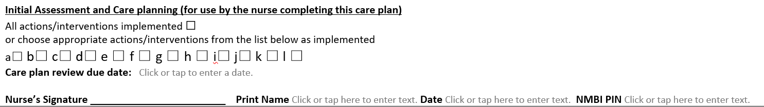
Figure 2
3.6.4.4 Care Plan Review Due Date – the nurse/midwife should insert the date when the evaluation is due – see figure 3.
- The care plan review will be based on clinical judgement and according to procedures, policies, protocols and guidelines.
- Sign signature section and print name and NMBI PIN in the appropriate section.
- See sample completed clinical care plan in Appendix 7.

Figure 3

3.6.4.5 In the case that further interventions are required, they are completed in “subsequent review and care plans” section and signed and dated by the nurse who has undertaken the subsequent review and documents the addition of actions. This section is hand written as the care plan is in the client’s healthcare record at this point - see figure 4. A template sheet titled ‘subsequent reviews’ is available in appendix 11 to allow for further reviews if required.

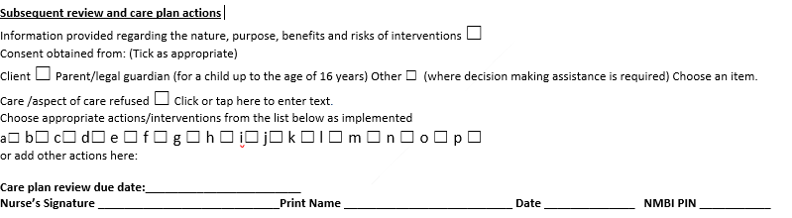
Figure 4
3.6.4.6 Evaluation/Progress Notes must be initiated for each standardised clinical care plan.
3.6.4.6.1 Evaluation/Progress Notes must be updated contemporaneously.
3.6.4.6.2 Evaluation/Progress Notes must provide evidence that the standardised care plan is being implemented; this involves the gathering of very specific and targeted information linked to a specific problem and goal/outcome.

3.6.5 All healthcare staff should be encouraged to read each other’s entries in the client healthcare record as this facilitates good communication between healthcare staff and aids continuity of care.
3.6.6 In the case where the care plan problem/diagnosis has not been resolved and the care plan is of 1 year’s duration, the care plan should be reviewed at least annually following client re-assessment. This review should also include verification that the up to date care plan version number is in use.

3.7 Closure of Care Plan
3.7.1 When the client’s goals have been met, the care plan should be closed and the date is recorded.
3.7.2 Care plans that are closed should be filed in the client’s healthcare record according to local procedures/guidelines.
3.7.3 The closure of the care plan should be recorded in the care plan index where in use.

3.8 Documentation
3.8.1 Legal Considerations for nursing documentation:
- Records are legal documents
- All records may be used to aid the legal process
- Nursing/Midwifery documentation within client healthcare records may be, and frequently are, used as evidence in legal cases
3.8.2 All narrative within the progress notes must be individualised, accurate, up to date, factual and unambiguous.
3.8.2.1 Narrative progress notes should be devoid of any jargon, witticisms or derogatory remarks.
3.8.2.2 It must be clear from the records that the client has been assessed and their individualised care is planned, provided and evaluated.
3.8.3 All written records are legible.
3.8.3.1 It is the nurse/midwife’s responsibility to ensure that the writing in a record is clear and legible.
3.8.3.2 Handwriting that is difficult to read must be in print form.
3.8.3.3 Black ink must be used for all entries.
3.8.3.4 Care should be taken to ensure that the record is permanent and facilitates photocopying if required. Pencil should never be used, as it can be altered or erased.
3.8.4 All entries in the progress notes are signed.
3.8.4.1 Nurses/midwives must sign entries using their name as entered on the Register of Nurses and Midwives maintained by the NMBI.
3.8.4.2 The nurse/midwife’s name must also be printed beside the signature.
3.8.4.3 The nurse/midwife’s NMBI PIN number must be entered.
3.8.4.4 Where signature banks exist in client healthcare records, the nurse/midwife must enter their signature and NMBI PIN in the signature bank.
3.8.4.5 If different health professionals write in the same part of the record, the registration status of the professional should also be indicated e.g. RPHN or CRGN.

3.8.5 All entries must be dated.
3.8.5.1 The format to be used is: day/month/year followed by time, using the 24 hour clock dd/mm/yyyy hh:mm; example 10/07/2023 1315hrs.

3.8.6 Entries in the client’s record should appear in chronological order, with time stated. Any variance from this should to be explained.

3.8.7 Documentation in the record is carried out as soon as possible after providing nursing care.
3.8.7.1 It should always be clear from the record what time an event occurred and what time the record was written.
3.8.7.2 This may prove to be difficult in an emergency situation. Late entries are acceptable provided that they are clearly documented as retrospective entries.
3.8.7.3 The nurse/midwife should not “squeeze” a late entry into existing notes, nor write in the margins.
3.8.7.4 Nurses/midwives should not record entries ahead of time, or otherwise, predate entries.
3.8.7.5 Nurses/Midwives should not re-write entries in the record or discard the originals, even if it is for a simple reason e.g. a torn page or a spilled drink.

3.8.8 Abbreviations should only be used if drawn from a list approved by the HSE (HSE, 2010c).
3.8.9 Entries made in error should be bracketed and have a single line drawn through them so that the original entry is still legible. Errors should be signed and dated.
3.8.9.1 No attempt should be made to alter or erase the entry made in error.
3.8.9.2 If an enquiry or litigation is initiated, then the record must not be altered in any way either by the addition of further entries or by altering an entry made in error.

3.8.10 A nurse/midwife making a referral or consulting with another member of the healthcare team should clearly identify, by name, the person in the record.

3.8.11 Any information, instruction or advice given by the nurse/midwife to a client should be documented. The version number of any educational material given to the client or carer should be documented.
3.8.11.1 Client education is a legitimate nursing intervention and should be recorded as such.

3.8.12 All written data in respect of a client’s care plan should be kept in the assigned section for care plans in the client healthcare record.
3.8.12.1 One of the basic principles of the provision of care is that there should be one comprehensive nursing record for each client which is available to the nurse/midwife for treatment of the client when required. Only in exceptional circumstances should there be a duplicate record (HSE, 2011).
3.8.12.2 The keeping of supplementary records should be the exception rather than the norm.
3.8.13 The client’s name and date of birth or unique identifier (IHI), addressogram (where applicable) should appear on every page of the record, including on care plans.
3.8.13.1 The identity of the person for whom the record is being maintained should always be obvious to the reader.

3.8.14 The standard of record keeping of those under supervision in the clinical area e.g. student PHNs undertaking supervised clinical practice prior to registration, should be monitored by their preceptor or her/his delegate.
3.8.14.1 Student PHNs are required to learn the practice of writing/documenting the delivery and management of nursing care in the community. This skill requires instruction and supervision, as the student is not solely responsible/ he/she cannot be held totally accountable for the record while under supervision. Entries to the client record should be countered signed/co-signed by preceptor/delegate preceptor.
3.8.14.2 If an entry by someone under supervision (i.e. student PHN) needs to be amended, then the procedure for any entry made in error should be followed as per section 3.8.9 above.

3.8.15 Nurses/midwives should adhere to HSE, HIQA and NMBI guidelines regarding documentation, record keeping and file management. The client healthcare record must be filed securely in line with General Data Protection Regulations (GDPR).

Specific roles and responsibilities

3.9.1 Outline Formal Governance Arrangements
This national procedure and accompanying care plans were commissioned by the National PHN service QI governance group. Final approval of the procedure was issued from the QI governance group. Follow up reviews will be initiated by the National PHN service QI governance group. Refer to Appendix 2 for Membership of the Approval Governance Group. This national procedure will be submitted to the HSE’s National Central Repository Office and the HSE’s national document hub.
3.9.1.1 The Role of the Director of Public Health Nursing
The DPHN is responsible for implementing, managing and auditing this procedure within her/his area of responsibility. The DPHN will identify and support on-going related educational opportunities to further enhance knowledge and skills.
3.9.1.2 The Role of the Assistant Director of Public Health Nursing
The ADPHN is responsible for the implementation of the procedure by ensuring that all nurses/midwives have access to this procedure. The ADPHN is responsible for ensuring that all nurses/midwives have knowledge of the steps to be followed within the document. The ADPHN will ensure that all nurses/midwives are aware of any revisions to the procedure. Compliance with this procedure will be monitored by all ADPHNs by ensuring all staff have confirmed their ‘reading’ of the procedure via electronic confirmation via the MAPS portal.
3.9.1.3 The Role of the Nurse/Midwife
Each nurse/midwife is responsible for adhering to this procedure and using it to guide their practice in the delivery of the service they provide. Each nurse/midwife is responsible for ensuring that they read and understand the document and have confirmed this electronically through the MAPS portal. When areas of concern are identified, where legislation is known to have changed or where a health, welfare and safety risk is identified, it is the responsibility of each nurse/midwife to ensure that their ADPHN is informed in order to ensure appropriate review and amendments are made to the procedure or accompanying care plans. It is every nurse/midwife’s responsibility to ensure they are working within their scope of practice at all times and that they identify their training needs to their manager to maintain standards of care. Nurses/midwives should adhere to HSE, HIQA and NMBI guidelines regarding documentation, record keeping and file management.

3.9.1.4 Role of Practice Development Coordinator in Public Health Nursing
The PDC (where in post) supports the implementation and operationalisation of this procedure. She/he has a key role in the transfer of knowledge to frontline staff through the dissemination of current evidence based practice.

Consultation

Stakeholder involvement

The content of the standardised clinical care plans was informed by staff feedback from a pilot of the standardised clinical care plans over the month of May 2023 across 15 Director of PHN (DPHN) sites nationally ensuring broad representation of key stakeholders. Feedback from frontline staff indicated a strong desire to further expand the number of standardised clinical care plans. All care plans are informed by the latest evidence based practice which was established by each sub group.
The penultimate draft was sent out nationally to capture wider stakeholder review and feedback. All feedback was collated and is held by the National Practice Development Coordinator for Public Health Nursing. This feedback was reviewed by the development group and recommendations accepted or rejected.
The procedure development group agreed on the final iteration to go forward for approval to the national PHN service QI governance group.

External review
A draft of the care plans and procedure was circulated to Nursing Professor UCD and State Claims Agency. All feedback was collated and is held by the National Practice Development Coordinator for Public Health Nursing. This feedback was reviewed by the development group and recommendations accepted or rejected.

National implementation plan
See appendix 8 for details of the implementation plan.

Governance and approval
This procedure was identified as a key requirement by the National PHN Service QI governance group to support safe effective practice and ensure continuity and consistency of care for clients.
6.1 Procedure Development Group
See Appendix 1 for Membership of the Procedure Development Group. See Appendix 3 for Procedure Conflict of Interest Declaration Form (Held by the national PDC on behalf of the ONMSD).

6.2 Procedure Governance Group
See Appendix 2 for Membership of the Approval Governance Group.

Communication and dissemination plan
The approved procedure will be circulated to all DPHNs nationally for dissemination to their respective nursing departments. A copy of the procedure is available on the National PHN website to download at; https://www.hse.ie/phn and at: https://dochub.healthservice.ie. This procedure will also be housed on the HSE National Central Repository for all National 3PGs.

Sustainability

Plan for national monitoring and audit
Monitoring of this procedure will be coordinated by the national lead for the PHN service as the chair of the QI governance group.

8.1.1 Monitoring
Monitoring of this procedure will occur by the ADPHN through professional supervision, team meetings, annual caseload reviews and documentation audit and through monitoring of any relevant complaints or compliments.

8.1.2 Audit
Audit of the operation of this procedure will be initiated by each DPHN in consultation with the local CHO audit lead or designated person. Good governance arrangements and an identified lead person are required to ensure systematic monitoring (HIQA, 2012). Audit will be carried out retrospectively by the designated person appointed by the DPHN one year after this procedure’s implementation. This procedure will be the standard for audit using the attached audit tool (Appendix 9).

Frequency of audit, sampling processes and timescales for completions will be determined at local level following the first initial audit. Quality care metrics may assist in this process. Action plans will be developed as a result of the audit findings if necessary.

8.1.2.1The objectives of the audit will be:
- To provide evidence of compliance with the national procedure
- To ensure standardisation of application of the procedure
- To identify areas of improvement, make recommendations & prioritise actions

  - Evaluation
Evaluation of the procedure will be initiated by the DPHN/ADPHN and will occur through feedback at professional team meetings/quality care metrics (QCMs). Following audit, comments and feedback should be submitted to the National Lead for the PHN service or the National PDC.

8.3 National audit tool
This procedure will be the standard for audit using the attached audit tool (Appendix 9).

Review / update

  - Next review date
This is the first version of a national procedure for the use of standardised clinical care plans in the PHN Service. This procedure will be revised every three years on the date specified on the front page of this document. This review will be triggered by the national PHN service QI governance group. In the event an electronic healthcare record is introduced to the PHN service, this procedure will require review. An earlier review of this procedure if required will be initiated by the national PHN service QI governance group. Should updated versions of the standardised care plans be developed, DPHNs will be informed by the national PHN service lead.

References
Ademola F.T. Sheerin D. (2012) Developing a structured approach to individual care and treatment planning. 20th World Congress of the International Association for Child and Adolescent Psychiatry and Allied Professions, IACAPAP 2012. Paris France. Conference Publication: 60 (5 SUPPL. 1) (pp S292), 2012.

Alfaro-LeFevre, R. (2014). Applying nursing process: The foundation for clinical reasoning (8th ed.). Philadelphia, PA: Lippincott Williams & Wilkins.

American Nurses Association (2017) The Nursing Process. www.nursingworld.org/ EspeciallyForYou/What-is-Nursing/ToolsYou-Need/Thenursingprocess.html (accessed 29 June 2017).

Ballantyne, H. (2016). Developing nursing care plans. Nursing Standard, 30(26), 51–57. Barrett, D. Wilson, B. and Woodlands A. (2012) Care Planning A guide for nurses. 2nd ed. London: Routledge Taylor& Francis Group.

Carpenito-Moyet, L. (2008) Nursing Diagnosis Application to Clinical Practice 12th ed. USA; Wolters Kluwer Health. Lippincott Williams & Wilkins.

Castellà-Creus M., Delgado-Hito P., Andrés-Martínez Isabel., Juvé-Udina M., (2019a) Individualization process of the standardized care plan in acute care hospitalization units: Study protocol Journal of Advanced Nursing. 2019; 75:197–204.

Castellà‐Creus, M., Delgado‐Hito, P., Casanovas‐Cuellar, C., Tàpia‐Pérez, M., & Juvé‐Udina, M. E. (2019b). Barriers and facilitators involved in standardised care plan individualisation process in acute hospitalisation wards: A grounded theory approach. Journal of Clinical Nursing, 28(23-24), 4606-4620.

Charalambous L, Goldberg S. ‘Gaps, mishaps and overlaps’. Nursing documentation: how does it affect care? Journal of Research in Nursing. 2016;21(8): 638–648. doi:10.1177/1744987116678900.

Coulter, A., Entwistle, V. A., Eccles, A., Ryan, S., Shepperd, S. & Perera, R. (2015) Personalised care planning for adults with chronic or long-term health conditions. Cochrane Database of Systematic Reviews; Issue 3. Art. No.: CD010523. DOI: 10.1002/14651858.CD010523.pub2.

Coulter A, Oldham J. (2016) Person-centred care: what is it and how do we get there? Future Hosp J. 2016 Jun; 3(2):114-116. doi: 10.7861/futurehosp.3-2-114. PMID: 31098200; PMCID: PMC6465833.

D’Agostino, F., Sanson, G., Cocchieri, A., Vellone, E., Welton, J., Maurici, M., Zega, M. (2017). Prevalence of nursing diagnoses as a measure of nursing complexity in a hospital setting. Journal of Advanced Nursing, 73(9), 2129–2142. https://doi.org/10.1111/jan.13285.

Dahm M.F., Wadensten B., (2008) Nurses’ experiences of and opinions about using standardised care plans in electronic health records – a questionnaire study. Journal of Clinical Nursing 17, 2137–2145.

Decision Support Service (2023) Code of Practice for Healthcare Professionals; Dublin. April 2023.

Ernstmeyer, K., & Christman, E. (Eds.). (2021). Open RN Nursing Fundamentals by Chippewa Valley Technical College is licensed under CC BY 4.0.

Government of Ireland (2022) Assisted Decision-Making (Capacity) (Amendment) Act 2022 (Act 46 of 2022) Assisted Decision-Making (Capacity) (Amendment) Bill 2022 (Bill 59 of 2022).

Glasper A. (2011) Improving record keeping: important lessons for nurses. British Journal of Nursing 20(14), 886-887.

Griffin-Perry, A., Potter, P. A. & Ostendorf, W. R. (2020) Nursing Interventions and Clinical Skills. 7th Edition. Elsevier: St. Louis, Missouri.

Gulanick M. & Myers J.L. (2014) Nursing Care Plans –Diagnosis / Interventions Outcomes. Elsevier, United States.

Gullery, C. Hamilton, G. (2015) Towards integrated person centred-care, the Canterbury experience. Future Hospital Journal 2(2): 111-116.

Haugen N. & Galura S. (2011) Ulrich & Canale’s Nursing Care Planning Guides – Prioritization, Delegation and Critical Thinking. Elsevier: United States

Health Information and Quality Authority (HIQA) (2012) National Standards for Safer Better Healthcare. Health Information and Quality Authority. Dublin.
Health Information and Quality Authority (2016) Supporting people’s autonomy: a guidance document. HIQA. Health Information and Quality Authority. Dublin.

Health Services Executive (2010a) Achieving Excellence in Clinical Governance- Towards a Culture of Accountability. Available at: http://www.hseland.ie/LCdnn/Portals/0/GERALDINE/AchievementExcelleneceAndClinicalGovernance.pdf. (Accessed 23/08/11).

Health Services Executive (2010b) Achieving Excellence in Clinical Governance- Service User Involvement. http://www.hse.ie/eng/services/ysys/SUI/Library/strategy/clinicalgovernance.pdf (accessed 23/08/11).

Health Services Executive (2010c) Health Service Executive Code of Practice for Healthcare Records Management- Abbreviations. HSE @ http://www.hse.ie/eng/services/Publications/services/Hospitals/NHO_Abbreviations_Booklet.pdf.

Health Services Executive (2011) Health Service Executive Standards and Recommended Practices for Healthcare Records Management. Quality and Client Safety Directorate, QPSD-D-006-3 V3.0 HSE.

Health Service Executive (2023) HSE National Records Retention Policy. HSE. Dublin.

Health Services Executive (2016) National Framework for developing Policies, Procedures, Protocols and Guidelines (PPPGs). HSE: Dublin.

Health Services Executive (2017) Assisted Decision Making (Capacity) Act 2015. A Guide for Health and social Care Professionals. HSE: Dublin.

Health Service Executive (2018) National Guideline for Nursing and Midwifery Quality Care-Metrics Data Measurement in Public Health Nursing Services 2018. Office of the Nursing and Midwifery Services Director Health Service Executive.

Health Service Executive (2022) National Consent Policy, Version 1.2.

Herdman, T. H., & Kamitsuru, S. (2017). NANDA International nursing diagnoses: Definitions and classification, 2018–2020, 11th ed. Thieme Publishers.

Henry,M. Philips,D. Traynor, A. (2014) Introduction to Nursing Theory and Practice. Dublin: Gill & Macmillan.

Hogston R (2011) Managing nursing care. In: Foundations of Nursing Practice: Themes, Concepts and Frameworks. 4th edn. Palgrave Macmillan, London. 2–21.

Hooks, R. (2016) "Developing nursing care plans". Nursing Standard 30(45): 64–65.

Howatson-Jones L., Standing M. & Roberts S. (2012) Client Assessment and care Planning in Nursing. Sage: London.

Hughes, R. H. (2008) Client Safety and Quality: An Evidence-Based Handbook for Nurses. Agency for Healthcare Research and Quality: Rockville.

Juvé-Udina, M. E. (2012). Evaluación de la validez de una terminología enfermera de interfase. [Validity evaluation of an interfase nursing terminology].Doctoral Thesis. Science nursing Program. University of Barcelona, Barcelona, Catalonia.

Kwame, A., Petrucka, P.M. (2021) A literature-based study of patient-centered care and communication in nurse-patient interactions: barriers, facilitators, and the way forward. BMC Nurs 20, 158. https://doi.org/10.1186/s12912-021-00684-2.

Köberich, S., Feuchtinger, J., & Farin, E. (2016). Factors influencing hospitalized clients’ perception of individualized nursing care: A cross-sectional study. BMC Nursing, 15, 14. https://doi.org/10.1186/s12912-016-0137-7.

Kozier B, Erb G, Berman A. (2008) Fundamentals of Nursing: Concept, Process and Practice. Pearson Education, London.

Kreitzer, M. J. (2015) Integrative Nursing: Application of Principles Across Clinical Settings. Frontiers in Nursing 6(2):1-8.

Marinič, M. (2015). The importance of health records. Health, 7(05), 617.

Martins PF, Perroca MG (2017) Care necessities: the view of the patient and nursing team. Rev Bras Enferm [Internet]. 70(5):1026-32. [Thematic Edition “Good practices and fundamentals of Nursing work in the construction of a democratic society”] DOI: http://dx.doi.org/10.1590/0034-7167-2016-0197.

McIlfatrick S. Doherty L.C. Murphy M. Dixon L. Donnelly P. McDonald K. Fitzsimons D. (2018) 'The importance of planning for the future': Burden and unmet needs of caregivers' in advanced heart failure: A mixed methods study. Palliative Medicine. 32(4):881-890, April 2018.

Meehan, T. C. (2012) The careful nursing philosophy and professional practice model, Journal of Clinical Nursing, 21, pp. 2905-2916.

Mitchell, G. Burridge, L. Zhang, J. Donald, M. Scott, I, Dart, J. Jackson, C. (2015) Systematic review of integrated models of health care delivered at the primary-secondary interface: how effective is it and what determines effectiveness. Australian Journal of Primary Care 21(4): 391- 408.

Monsen, K. A., Foster, D. L., Gomez, T., Poulsen, J. K., Mast, J., Westra, B. L., & Fishman, E. (2011). Evidence-based Standardized Care Plans for Use Internationally to Improve Home Care Practice and Population Health. Applied clinical informatics, 2(3), 373–383. https://doi.org/10.4338/ACI-2011-03-RA-0023.

MoraisI, S. C. R. V., da NóbregaII, M. M. L., & de CarvalhoI, E. C. (2018). Cross-mapping of results and Nursing Interventions: contribution to the practice. Rev Bras Enferm [Internet], 71(4), 1883-90.

National Office for Human Rights and Equality (2023) Code of Practice for Healthcare Professionals. Decision Support Service.

Nishamali Jayatilleke, Anne Mackie Swearingen, P. L. (2019) All-in-One Nursing Care Planning Resource: Medical-Surgical, Pediatric, Maternity, and Psychiatric-Mental Health. 5th edn. Elsevier: St. Louis.

Nurselabs (2023) https://nurseslabs.com/nursing-care-plans/

Nursing and Midwifery Board of Ireland (NMBI) (2015a) Scope of Nursing and Midwifery Practice Framework Dublin: Nursing and Midwifery Board of Ireland.

Nursing and Midwifery Board of Ireland (NMBI) (2015b) Recording Clinical Practice. Professional Guidance. NMBI: Dublin.

Nursing and Midwifery Board of Ireland (NMBI) (2018) Standards for Registered Nurses and Midwives on Medication Management. Draft for Consultation. NMBI: Dublin.

Nursing and Midwifery Board of Ireland (NMBI) (2020) NMBI Guidance for Registered Nurses and Midwives on Medication.

Nursing and Midwifery Board of Ireland (2022) Code of Professional Conduct and Ethics for Registered Nurses and Registered Midwives.

Nursing and Midwifery Board of Ireland (2023) Glossary of Nursing & Midwifery Terms; accessed on 10th July 2023 via https://www.nmbi.ie/Standards-Guidance/Glossary.aspx.

Østensen, E., Hardiker, N. R., Bragstad, L. K., & Hellesø, R. (2020). Introducing standardized care plans as a new recording tool in municipal healthcare. Journal of Clinical Nursing, 12, https://doi. org/10.1111/jocn.15355.

Phaneuf,M. (2008) Clinical judgement- an essential tool in the nursing profession,
http://www.infiressources.ca/fer/Depotdocument_anglais/Clinical_Judgement%E2%80%93An Essential_Tool_in_the_Nursing_Profession.pdf

Prakash, B. (2010). Patient satisfaction. Journal of cutaneous and aesthetic surgery, 3(3), 151.

Østensen, E., Hardiker NR, Hellesø, R (2021) Facilitating the Implementation of Standardized Care Plans in Municipal Healthcare. Computers, Informatics, Nursing August 2021 Quinn C. (2012) Nursing Children & Young People. 24(9):25-28, November 2012.

Royal College of Nursing (2003) Defining Nursing. London: Royal College of Nursing.

Svensson, S., Ohlsson, K., Wann-Hansson, C. (2012). Development and implementation of a standardized care plan for carotid endarterectomy. Journal of Vascular Nursing, 30(2), 44–53 https://doi.org/10.1016/j.jvn.2012.01.002.

Taiye B.H, 2015, ‘Knowledge and practice of documentation in Ahmadu Bella University Teaching hospital9Abth) Zaria, Kaduna State’, IOSR Journal of Nursing and Health Science 4(6), 1–6.

Waldow VR, Borges RF (2011). Caring and humanization: relationships and meanings. 24(3):414-18. Available from: http://www.scielo.br/pdf/ape/v24n3/en_17.pdf.

Wilson, B., Woollands, A. & Barrett, D. (2019) Care Planning: A Guide for Nurses. 3rd edn. Rutledge: London.

Yildirim B, Ozkahraman S (2011) Critical thinking in nursing process and education. Int J Human Soc Sci Res 1(13): 257–62.

Younas, A. (2017) Nursing made Incredibly Easy. Wolters Kluwer Health.

Yura H., Walsh M. (1967) The Nursing Process; Assessing, Planning, Implementing and Evaluating. Connecticut: Appleton & Lange.

Appendix 10.1: Care Plan Specific References

Personal Care V12024 CCPPHN 01
Government of Ireland (2022) Assisted Decision-Making (Capacity) (Amendment) Act, no. 46 of 2022 https://data.oireachtas.ie/ie/oireachtas/act/2022/46/eng/enacted/a4622.pdf.
HIQA (2012) National Standards for Safer Better Healthcare. Dublin: HIQA.
HIQA (2016) Supporting people’s autonomy: a guidance document.
Health Service Executive, Royal College of Physicians Ireland (RCPI) and Advisory Group for Healthcare Associated Infections (HCAI) (2015) Guidelines for hand hygiene in Irish healthcare settings. Update of 2005 guidelines January 2015. HSE, RCPI, HCAI.
HSE (2022) National Consent Policy Version 1.2.
HSE (2022) Community Infection Prevention &Control Manual. Available at: https://www.lenus.ie/bitstream/handle/10147/631787/HSE-Community%20Infection%20Control%20Manual%20March%202022_%20ELECTRONIC%20VERSION.pdf?sequence=1&isAllowed
HSE (2023) HSE Enterprise risk management policy and procedures 2023 https://www.hse.ie/eng/about/who/riskmanagement/risk-management-documentation/hse-enterprise-risk-management-policy-and-procedures.pdf.
NCEC (2022) Draft Guidance on Infection Prevention and Control, 2022. https://www.hse.ie/eng/about/who/nqpsd/nirp/ncec-ipc-guideline-2022-for-consultation.pdf.
Nursing and Midwifery Board of Ireland (2019) Standards & Guidance: Glossary of nursing and midwifery terms. https://www.nmbi.ie/Standards/Guidance/Glossary.
NMBI (2015) Scope of Nursing and Midwifery Practice Framework, NMBI: Dublin.
NMBI (2019) Standards & Guidance: Glossary of nursing and midwifery terms, NMBI: Dublin https://www.nmbi.ie/Standards/Guidance/Glossary.
NMBI (2022) Code of Professional Conduct and Ethics for Registered Nurses and Registered Midwives, NMBI: Dublin.
Orem D. E. (2001). Nursing: Concepts of practice (6th ed.). St. Louis, MO: Mosby.
Orem D. E. (2015). Dorothea E. Orem's self-care deficit nursing theory. In Smith M. C. & Parker M. E. (Eds.), Nursing theories and nursing practice (4th edition, pp. 105–132). Philadelphia, PA: Davis.
Roper, N., Logan, W., & Tierney, A. J. (2000). The Roper-Logan-Tierney model of nursing: Based on activities of living. Churchill Livingstone, London.
Pressure Ulcer Prevention V12024 CCPPHN 02
Government of Ireland (2022) Assisted Decision-Making (Capacity) (Amendment) Act, no. 46 of 2022 https://data.oireachtas.ie/ie/oireachtas/act/2022/46/eng/enacted/a4622.pdf.
European Pressure Ulcer Advisory Panel (EUPAP) (1998) Pressure Ulcer Prevention Guideline.
European Pressure Ulcer Advisory Panel, National Pressure Injury Advisory Panel and Pan Pacific Pressure Injury Alliance (2019) Prevention and Treatment of Pressure.
Ulcers/Injuries: Quick Reference Guide. www.epupa.org.
HIQA (2012) National Standards for Safer Better Healthcare. Dublin: HIQA.
HIQA (2016) Supporting people’s autonomy: a guidance document. Dublin: HIQA.
HSE (2015) Health and Safety Standards.
Health Service Executive, Royal College of Physicians Ireland (RCPI) and Advisory Group for Healthcare Associated Infections (HCAI) (2015) Guidelines for hand hygiene in Irish healthcare settings. Update of 2005 guidelines January 2015. HSE, RCPI, HCAI.
HSE (2018) Manual Handling and People Handling Policy.
HSE (2019) Data protection Policy.
HSE (2019) Open Disclosure Policy.
HSE (2022) Pressure Ulcers- A practical Guide for Review, Revision 2 HSE.
National Wound Care Guidelines (2018).
HSE (2022) National Consent Policy Version 1.2.
HSE (2022) Community Infection Prevention &Control Manual. Available at: https://www.lenus.ie/bitstream/handle/10147/631787/HSE-Community%20Infection%20Control%20Manual%20March%202022_%20ELECTRONIC%20VERSION.pdf?sequence=1&isAllowed.
HSE (2023) HSE Enterprise risk management policy and procedures 2023 https://www.hse.ie/eng/about/who/riskmanagement/risk-management-documentation/hse-enterprise-risk-management-policy-and-procedures.pdf.
Malnutrition Universal Screening Tool (MUST) (2003) Malnutrition Advisory Group. Armagh and Dungannon Health and Social Services Trust.
NCEC (2022) Draft Guidance on Infection Prevention and Control 2022 https://www.hse.ie/eng/about/who/nqpsd/nirp/ncec-ipc-guideline-2022-for-consultation.pdf.
NMBI (2015) Scope of Nursing and Midwifery Practice Framework, NMBI: Dublin.
NMBI (2019) Standards & Guidance: Glossary of nursing and midwifery terms, NMBI: Dublin https://www.nmbi.ie/Standards/Guidance/Glossary.
NMBI (2022) Code of Professional Conduct and Ethics for Registered Nurses and Registered Midwives, NMBI: Dublin.
O'Brien J.A. Cowman S. (2011) An exploration of nursing documentation of pressure ulcer care in an acute setting in Ireland. Journal of Wound Care. 20 (5) (pp 197-205), 2011. Date of Publication: May 2011.

Medication Management V12024 CCPPHN 03
Government of Ireland (2022) Assisted Decision Making Act 2015 Assisted Decision Making Act 2015 Assisted Decision-Making (Capacity) (Amendment) Act 2022 (Act 46 of 2022) Assisted Decision-Making (Capacity) (Amendment) Bill 2022 (Bill 59 of 2022).
HSE (2023) National Records retention Policy.
HSE (2022) National Consent Policy v1.2.
Health Service Executive, Royal College of Physicians Ireland (RCPI) and Advisory Group for Healthcare Associated Infections (HCAI) (2015) Guidelines for hand hygiene in Irish healthcare settings. Update of 2005 guidelines January 2015. HSE, RCPI, HCAI.
NMBI (2020) guidance in the administering of the medication to the client.
NMBI (2020) NMBI Guidance for Registered Nurses and Midwives on Medication Administration.
NMBI (2022) Code of Professional Conduct and Ethics for Registered Nurses and Registered Midwives www.hpsc.ie Latest infection prevention and control advice.

Catheter Management V12024 CCPPHN 04
AMRIC (2021) HSE-AMRIC clinical programme. V1. Nov 2021 Decision aid for management of suspected UTI in persons >65yrs in residential care.

Health Service Executive, Royal College of Physicians Ireland (RCPI) and Advisory Group for Healthcare Associated Infections (HCAI) (2015) Guidelines for hand hygiene in Irish healthcare settings. Update of 2005 guidelines January 2015. HSE, RCPI, HCAI.

Health Protection Surveillance Centre (2023) accessed via https://www.hpsc.ie/az/microbiologyantimicrobialresistance/infectioncontrolandhai/guidelines/File,12913,en.pdf.
https://www.hse.ie/eng/services/publications/clinical-strategy-and-programmes/adult-patients-information-leaflet-2018.pdf

https://www2.hse.ie/conditions/how-to-clean-your-hands/

https://www.hse.ie/eng/about/who/healthwellbeing/infectcont/sth/gl/app-12-1-2.pdf

https://www.hpsc.ie/a-/microbiologyantimicrobialresistance/infectioncontrolandhai/urinarycatheters/publications/

www.hse.ie/eng/services/list/2/primarycare/community-funded-schemes/continence/healthcare-professionals/continence-care-adults.html

NMBI (2022) Code of Professional Conduct and Ethics for Registered Nurses and Registered Midwives.

www.hpsc.ie Latest infection prevention and control advice.

Safeguarding V12024 CCPPHN 05
HSE (2014) Safeguarding Vulnerable Persons at risk of Abuse: National Policy & Procedures.

Health Service Executive, Royal College of Physicians Ireland (RCPI) and Advisory Group for Healthcare Associated Infections (HCAI) (2015) Guidelines for hand hygiene in Irish healthcare settings. Update of 2005 guidelines January 2015. HSE, RCPI, HCAI.

www.hse.ie/eng/about/who/socialcare/safeguardingvulnerableadults/safeguardingvuladts.html#:~:text=If%20anyone%20has%20a%20concern,of%20its%20nine%20Community%20Healthcare.

Donnelly S., O’Brien M., Walsh J., Mc Inerney J., Campbell J., Kodate N., (2017) Adult Safeguarding Legislation and Policy Rapid Realist Literature Review: Commissioned by the HSE National Safeguarding Office and Trigraph Limited.

Falls Risk Management V12024 CCPPHN 06
Health Service Executive, Royal College of Physicians Ireland (RCPI) and Advisory Group for Healthcare Associated Infections (HCAI) (2015) Guidelines for hand hygiene in Irish healthcare settings. Update of 2005 guidelines January 2015. HSE, RCPI, HCAI.

Registered Nurses’ Association of Ontario. (2017). Preventing Falls and Reducing Injury from Falls (4th ed.). Toronto, ON: Author.

Montero-Odasso M.M., Kamkar N., Pieruccini-Faria F., Osman A., Sarquis-Adamson Y., Close J., Hogan D.B., Winifred Hunter S., Kenny R.A., Lipsitz L.A., Lord S.R., Madden K.M., Petrovic M., Ryg J., Speechley M., Sultana M., Pin Tan M., Van der Velde N., Verghese J., Masud T.,(2021) Evaluation of Clinical Practice Guidelines on Fall Prevention and Management for Older Adults A Systematic Review, JAMA Network Open.4(12):e2138911. doi:10.1001/jamanetworkopen.2021.38911.

National Clinical Programme for Older People (NCPOP) (2016) ‘A Guide to Comprehensive Geriatric Assessment for Older People: https://www.hse.ie/eng/services/publications/ClinicalStrategy-and-Programmes/Comprehensive-Geriatric-Assessment-National-Clinical-Programmefor-Older-People.pdf.

NICE (2013) Falls in older people: assessing risk and Prevention, www.nice.org.uk/guidance/cg161.

Eckstrom E, Parker EM, Shakya I, Lee R. Coordinated Care Plan to Prevent Older Adult Falls. Edition 1.1. Atlanta, GA: National Centre for Injury Prevention and Control, Centres for Disease Control and Prevention, 2021.

HSE (2022) Service user Falls: A Practical Guide for Review. www.hse.ie/eng/about/who/nqpsd/qps-incident-management/incident-management/service-user-falls-a-practical-guide-for-review.pdf

https://www.hse.ie/eng/about/who/nqpsd/patient-safety-programme/resources-falls.html

Promoting Urinary Continence and Managing Incontinence V12024 CCPPHN 07
Health Service Executive, Royal College of Physicians Ireland (RCPI) and Advisory Group for Healthcare Associated Infections (HCAI) (2015) Guidelines for hand hygiene in Irish healthcare settings. Update of 2005 guidelines January 2015. HSE, RCPI, HCAI.

www.continencecare/hse.ie.

www.stressincontinence.

NMBI (2022) Code of Professional Conduct and Ethics for Registered Nurses and Registered Midwives.

www.hpsc.ie Latest infection prevention and control advice.

Bowel Management V12024 CCPPHN 08

Government of Ireland (2022) Assisted Decision Making Act 2015 Assisted Decision Making Act 2015 Assisted Decision-Making (Capacity) (Amendment) Act 2022 (Act 46 of 2022) Assisted Decision-Making (Capacity) (Amendment) Bill 2022 (Bill 59 of 2022).

Heaton, K W & Lewis, S J 1997, 'Stool form scale as a useful guide to intestinal transit time'. Scandinavian Journal of Gastroenterology, vol.32, no.9, pp.920 - 924. Bristol Stool Chart https://www.hse.ie/eng/services/list/2/primarycare/community-funded-schemes/continence/healthcare-professionals/bristol-stool-chart.pdf.

HIQA (2016) Supporting people’s autonomy: a guidance document (HIQA 2016).

Health Service Executive, Royal College of Physicians Ireland (RCPI) and Advisory Group for Healthcare Associated Infections (HCAI) (2015) Guidelines for hand hygiene in Irish healthcare settings. Update of 2005 guidelines January 2015. HSE, RCPI, HCAI.

HSE (2022) National Consent Policy V1.2.

NRH (National Rehabilitation Hospital) (2017) https://www.nrh.ie/healthcare-professionals/healthcare-professional-disciplines-nrh/+.

NRH (2023) Management of Neurogenic Bowel Dysfunction in Individuals with a Spinal Cord Injuries (2023) National Rehabilitation Hospital Dun Laoghaire.

NMBI (2022) Code of Professional Conduct and Ethics for Registered Nurses and Registered Midwiveswww.hpsc.ie Latest infection prevention and control advice.

Bristol Stool Chart https://www.hse.ie/eng/services/list/2/primarycare/community-funded-schemes/continence/healthcare-professionals/bristol-stool-chart.pdf.

National Rehabilitation Hospital (2017) Neurogenic Bowel Dysfunction; The practical management of a bowel care programme for the spinal cord injured population. https://www.nrh.ie/healthcare-professionals/healthcare-professional-disciplines-nrh/

Urinary Catheter Maintenance and/or Bladder Irrigation V12024 CCPPHN 09
NMBI (2022) Code of Professional Conduct and Ethics for Registered Nurses and Registered Midwives.

www.hpsc.ie Latest infection prevention and control advice.

National Consent Policy (HSE 2022) Version 1.2.

Assisted Decision Making Act (2015).

Supporting people’s autonomy: a guidance document (HIQA 2016).

Guidelines for the Prevention of Catheter associated Urinary Tract Infection Published on behalf of SARI by HSE Health Protection Surveillance Centre (2011) https://www.hpsc.ie/az/microbiologyantimicrobialresistance/infectioncontrolandhai/guidelines/File,12913,en.pdf.

Reid et al (2021) British Association of Urological Surgeons (BAUS) and Nurses (BAUN) consensus document: management of the complications of long-term indwelling catheters. British Journal of Urology International 2021; 128: 667–677 doi:10.1111/bju.15406.

Jordan, D. A. (2022) The role of the district nurse in managing blocked urinary catheters British Journal of Community Nursing July 2022 Vol 27, No 7: 350-356.

Gibney, Linda E. (2016) Blocked urinary catheters: can they be better managed? British Journal of Nursing, 2016, Vol 25, No 15:828-833.

Surgical wound V12024 CCPPHN 10
NMBI (2022) Code of Professional Conduct and Ethics for Registered Nurses and Registered Midwives.

www.hpsc.ie Latest infection prevention and control advice.

National Consent Policy (HSE 2022) Version 1.2.

Assisted Decision Making Act 2015.

Supporting people’s autonomy: a guidance document (HIQA 2016).

Health Service Executive, Royal College of Physicians Ireland (RCPI) and Advisory Group for Healthcare Associated Infections (HCAI) (2015) Guidelines for hand hygiene in Irish healthcare settings. Update of 2005 guidelines January 2015. HSE, RCPI, HCAI.

Health Services Executive (2018) National Wound Management Guidelines. HSE: Dublin.

Client at Risk of Autonomic Dysreflexia V12024 CCPPHN 11
Government of Ireland (2022) Assisted Decision Making Act 2015.
NMBI (2022) Code of Professional Conduct and Ethics for Registered Nurses and Registered Midwiveswww.hpsc.ie Latest infection prevention and control advice
HIQA (2016) Supporting people’s autonomy: a guidance document.
HSE (2022) National Consent Policy. Version 1.2.
National Rehabilitation Hospital (NRH) (2022) Policy and Procedure for the Management of Autonomic Dysreflexia (2022) National Rehabilitation Hospital Dun Laoghaire.
NRH (2017) Autonomic Dysreflexia (2017) National Rehabilitation Hospital https://www.nrh.ie/healthcare-professionals/healthcare-professional-disciplines-nrh/+.
Solinsky, R. Kirshblum, S. C. Burns, S. (2018) Exploring detailed characteristics of autonomic dysreflexia. Journal of Spinal Cord Medicine. (41)5, p549-555.

Diabetes Type 2 V12024 CCPPHN 12
Government of Ireland (2022) Assisted Decision-Making (Capacity) (Amendment) Act, no. 46 of 2022 https://data.oireachtas.ie/ie/oireachtas/act/2022/46/eng/enacted/a4622.pdf.

Health Service Executive, Royal College of Physicians Ireland (RCPI) and Advisory Group for Healthcare Associated Infections (HCAI) (2015) Guidelines for hand hygiene in Irish healthcare settings. Update of 2005 guidelines January 2015. HSE, RCPI, HCAI.

HIQA (2016) Supporting people’s autonomy: a guidance document.

HSE (2022) National Consent Policy Version 1.2.

HSE (2018) Model of Integrated Care for Patients with Type 2 Diabetes A Guide for Health Care Professionals (Clinical Management Guidelines).

HSE (2021) Diabetic Foot Model of Care, National Clinical Programme for Diabetes Clinical Design and Innovation.

HSE (2022) Community Infection Prevention &Control Manual. Available at: https://www.lenus.ie/bitstream/handle/10147/631787/HSE-Community%20Infection%20Control%20Manual%20March%202022_%20ELECTRONIC%20VERSION.pdf?sequence=1&isAllowed=y.

HSE (2023) HSE Enterprise risk management policy and procedures 2023 https://www.hse.ie/eng/about/who/riskmanagement/risk-management-documentation/hse-enterprise-risk-management-policy-and-procedures.pdf.

NCEC (2022) Draft Guidance on Infection Prevention and Control 2022 https://www.hse.ie/eng/about/who/nqpsd/nirp/ncec-ipc-guideline-2022-for-consultation.pdf.

Nursing and Midwifery Board of Ireland (2019) Standards & Guidance: Glossary of nursing and midwifery terms. https://www.nmbi.ie/Standards/Guidance/Glossary.

NMBI (2015) Scope of Nursing and Midwifery Practice Framework, NMBI: Dublin.
NMBI (2019) Standards & Guidance: Glossary of nursing and midwifery terms, NMBI: Dublin https://www.nmbi.ie/Standards/Guidance/Glossary.

NMBI (2022) Code of Professional Conduct and Ethics for Registered Nurses and Registered Midwives, NMBI: Dublin.

Glossary of terms
11.1 Abbreviations
ADPHN Assistant Director of Public Health Nursing
CHO Community Healthcare Organisation
CRGN Community Registered General Nurse
DPHN Director of Public Health Nursing
GDPR General Data Protection Regulation
HIQA Health Information and Quality Authority
H & SA Health and Safety Authority
HSE Health Services Executive
MHC Mental Health Commission
NANDA North American Nursing Diagnosis Association
NMBI Nursing and Midwifery Board of Ireland
ONMSD Office of the Nursing and Midwifery Services Director
PDC Practice Development Coordinator
PHN Public Health Nursing
PHNs Public Health Nurses
PPPG Policy Procedure Protocol Guideline or aka 3PGs
QCM Quality Care Metrics
QI Quality Improvement
RCN Royal College of Nursing
RGN Registered General Nurse
RNs Registered Nurses
RPHN Registered Public Health Nurse
RM Registered Midwife

11.2 Definitions
Accountability: being able to give an account of one’s nursing and midwifery judgements, actions, and omissions as they relate to life-long learning. It also incorporates maintaining competency, and upholding both quality client care outcomes and standards of the nursing and midwifery professions (adapted from Krautscheid 2014 cited in Scope of Nursing and Midwifery Practice Framework for Nursing and Midwifery (NMBI, 2015a).
Care Plan: a nursing care plan outlines the nursing care to be provided to the client. It is a set of actions the nurse will implement to resolve the nursing problems identified by assessment and it does this by using the nursing process.
Client: ‘client’ encompasses the terms patient, individual, person, service user, male & female & indicates the person in receipt of the nursing intervention & the recipient of care (Health Service Executive (HSE), 2022).
Client centred care: client care that focuses on the needs and rights of the client which respects his/her values and preferences and actively involves him/her in the provision of care (HIQA, 2012).
Clinical judgment: Clinical judgment is the conclusion or enlightened opinion at which a nurse arrives following a process of observation, reflection and analysis of observable or available information or data (Phaneuf, 2008).
Competency: the attainment of knowledge, intellectual capacities, practice skills, integrity and professional and ethical values required for safe, accountable and effective practice as a registered nurse or registered midwife. Competence relates to the nurse’s or midwife’s role or practice within a division of the Register, is maintained through continuing professional development and is adaptive to the needs of a changing population profile (NMBI, 2015a).
Consent: the giving of permission or agreement for an intervention, receipt or use of a service or participation in research following a process of communication about the proposed intervention. (HSE, 2022 V1.2).
Desired outcome: the goal which the intervention is expected to achieve, each problem should have an anticipated outcome to correctly evaluate the client’s progress. Goals may be immediate, short or long term. (NANDA, 2000 cited in Carpenito-Moyet, 2008).
Must: Commands the action a nurse or midwife is obliged to take from which no deviation whatsoever is allowed (NMBI, 2023).
Nursing Assessment: during the assessment stage the nurse gathers information about the client’s health care needs (in a systematic and organised way) and their ability to manage their needs. The assessment phase is a vital part of the nursing process as all other stages rely on the valid and complete data collected and documented (Henry et al. 2014).
Nursing diagnosis is a clinical judgment concerning a human response to health conditions/life processes, or a vulnerability for that response, by an individual, family, group or community. Whereas a medical diagnosis identifies a disorder, a nursing diagnosis identifies problems that result from that disorder (Younas, 2017). It provides the basis for the selection of interventions to achieve outcomes for which the nurse is accountable (North American Nursing Diagnosis Association (NANDA) 2000 cited in Carpenito-Moyet, L. 2008).
Nursing Intervention: Nursing is the use of clinical judgement in the provision of care to enable people to improve, maintain, or recover health, to cope with health problems, and to achieve the best possible quality of life, whatever their disease or disability, until death. It is concerned with empowerment, identification of nursing needs, therapeutic interventions, personal care, information, education, advice and advocacy, physical, emotional and spiritual support (Royal College of Nursing (RCN), 2003).
Nursing evaluation: the nurse’s judgement on the effectiveness of nursing actions towards goal achievement within a specified time frame (NANDA, 2000 cited in Carpenito-Moyet, 2008).
Nursing process: is a dynamic, systematic goal orientated framework for problem-solving that helps the nurse to care for the client while promoting critical thinking (Henry et al., 2014). Yura & Walsh (1967) established a number of stages in the nursing process. There are currently 5 steps assessment, diagnosis, planning, implementation and evaluation.
Progress notes: notes used to document nursing/midwifery actions such as client care or response to care; contact with clients/families/carers; contacts with other professionals or agencies.
Scope of Nursing Practice is the range of roles, functions, responsibilities and activities which a registered nurse is educated, competent and has authority to perform (NMBI, 2015).The definition of scope of nursing practice should be understood in the context of the following definition provided by the Nursing and Midwifery Board of Ireland: Nursing is a professional, interpersonal caring process that encompasses autonomous and collaborative care of individuals of all ages, families, groups and communities, sick or well and in all settings through the promotion of person centred care. Fundamental to nursing practice is the therapeutic relationship between the nurse and the client that is based on trust, understanding, compassion, support and serves to empower the client to make life choices. Nursing involves the use of clinical judgment to guide professional intervention for the promotion of health, prevention of illness and injury, provision of safe care to the person, families, communities, and populations (NMBI, 2015a).
Should: Indicates a strong recommendation to perform a particular action from which deviation in particular circumstances must be justified (NMBI, 2023).

12.0 Acknowledgements
The procedure development group with like to extend our thanks to colleagues within the States Claims Agency (SCA) and University College Dublin (UCD) who reviewed the care plans and provided advice and feedback. Our appreciation also to DPHN and ADPHN colleagues who supported the piloting of the clinical care plans within their respective areas. Special thanks to all frontline staff who facilitated the pilot of the draft clinical care plans during the month of May 2023.

13.0 Appendices
Appendix 1 Membership of the Procedure Development Group
Appendix 2 Membership of the Approval Governance Group
Appendix 3 Conflict of Interest Declaration Form
Appendix 4 Search Strategy
Appendix 5 List of Approved Standardised Clinical Care Plans & Codes
Appendix 6 Care Plan Index
Appendix 7 Sample Clinical Care Plan with built in Instructions
Appendix 8 National Implementation Plan
Appendix 9 Procedure Audit Tool
Appendix 10 Checklist
Appendix 11 Subsequent Reviews Additional Sheet

Appendix 1: Membership of Development Group
Membership of the Procedure Development Group
Name | Role/Position
Chairperson(s) of the Procedure Development Group:

Yvonne Delaney, Assistant Director of PHN - Practice Development Coordinator (PDC) Laois/Offaly and Longford/Westmeath, CHO8.

Sinead Lawlor - National PDC for Public Health Nursing Services.
Brenda Horgan | PDC CHO9
Anne Tully | PDC CHO 1
Olivia O’Connor | PDC CHO 2
Fiona Martin | PDC, CH0 8
Deirdre McEldowney | PDC, CHO 9
Tara Mulleary | PDC, CHO 1
Edel Maxwell | PDC, CHO
Edel Marken | ADPHN CHO 9
Tara Curran | CNS Tissue Viability Dublin North City
Edel Norris | CRGN, CHO 3 & INMO Representative
Deirdre Mulligan | PHN, CHO 7
Membership of the Procedure Development Group Continued:
Tracy Dowling | PHN, CHO 5
Ann Mason Huntley | IADPHN, CHO 4
Stephanie O’ Neill | CRGN, CHO 6
Laura Money | CRGN, CHO 1
Margaret Dwyer | ADPHN, CHO 6
Sharon Linnane | ADPHN, CHO 2
Elizabeth Delaney | TVN, CHO 2
Sarah Hendrick | CRGN, CH0 4
Julie Lee | CRGN, CHO 2
Niamh Smith | CRGN, CHO 8

Appendix 2: Membership of Approval Governance Group
Membership of National PHN Service QI Governance Group
Name | Role and position
Grainne Ryan | National Lead PHN services
Mary Shanahan | DPHN (CHO 3)
Anne Marie McDermott | DPHN (CHO 2)
Helen Sweeney | DPHN (CHO 4)
Sinéad Lawlor | National PDC
Tara Mulleary | PDC (CHO 1)
Olivia O’Connor | PDC (CHO 2)
Anne Tully | PDC (CHO 1)
Pauline Keogh | DPHN (CHO 7)
Nikki Dempsey | ADPHN (CHO 2)
Janet Caulfield | ADPHN (CHO 8)
Lloyd Philpott | HEI/UCC/Lecturer
Sarah Hegarty | PHN INMO CHO 5
Yvonne Heaney | PHN (CHO 2)
Andrea Collins | Clinical Skills Facilitator (CHO 9)
Rachel Eustace | PHN INMO CHO 9
Kathleen Heery | RGN Continence Advisor (CHO 1)
Tara Curran | RGN CNS Tissue Viability (CHO 9)
Carmel Twomey | RGN (CHO 4) Digital CNM2
Deirdre O’Brien | RGN (CHO 7)
Eileen Tormey | Quality and Safety rep
Tracey McEntee | HCA (CHO 3)

Sign-off by Chair of Approval Governance Group
Procedure for the use of Standardised Clinical Care Plans in the Public Health Nursing Service was formally ratified and recorded in the minutes of the Approval Governance Group on 19/3/2024

Name: (print) | Grainne Ryan
Title: | National Lead of PHN Service
Signature:
(e-signatures accepted)
Registration number: (if applicable)

Appendix 3: Conflict of Interest Declaration Form
CONFLICT OF INTEREST DECLARATION FORM

This form has been completed and is being held in the master file by the national PDC for the PHN Service on behalf of the ONMSD.

Appendix 4: Search Strategy

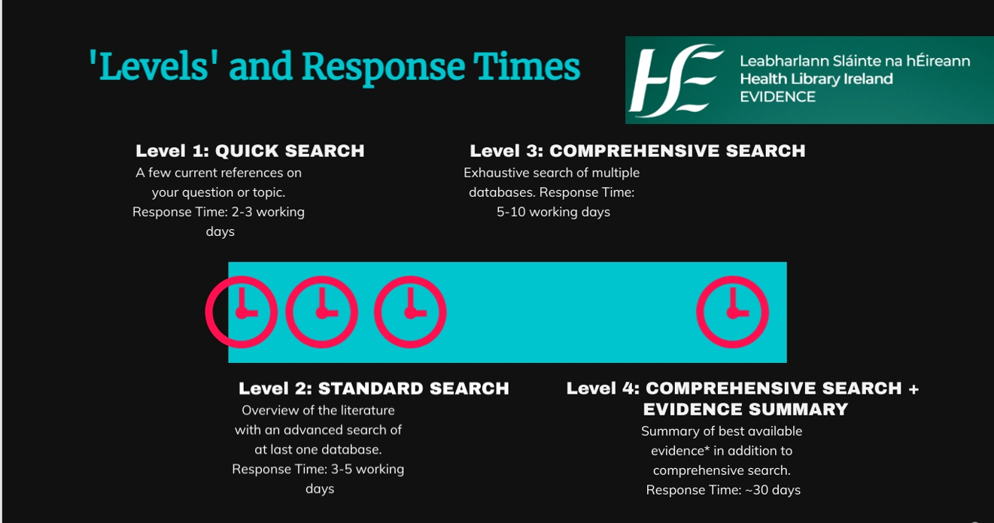
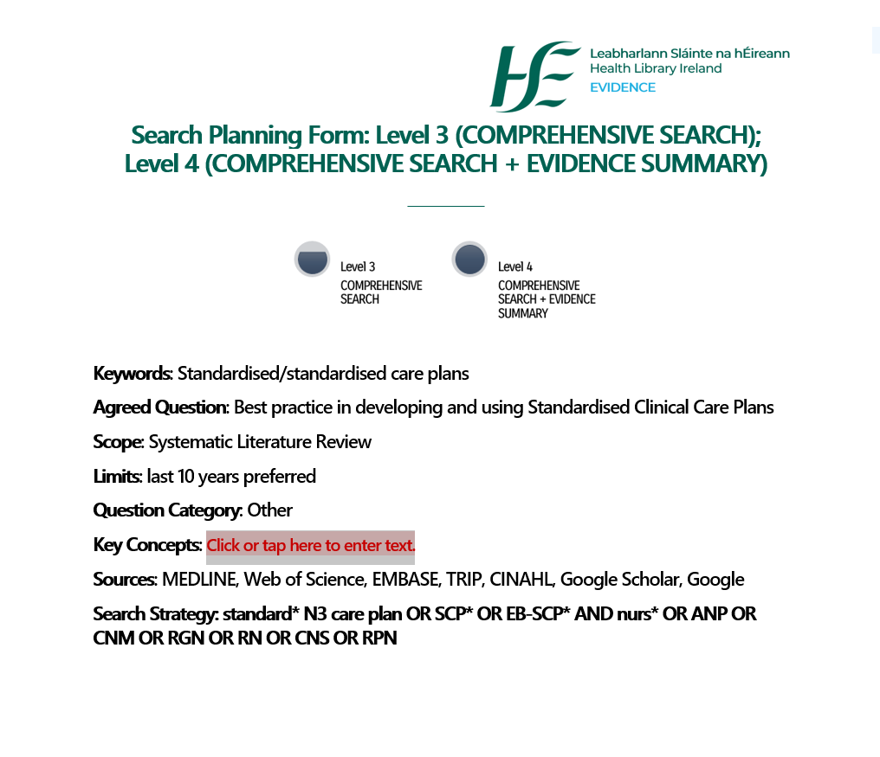

Appendix 5: List of Standardised Clinical Care Plans & Codes

Appendix 5: List of Standardised Clinical Care Plans & Codes

Care Plan Code | Name of Standardised Clinical Care Plan
V1 2024 CCPPHN 01 | Pressure Ulcer Prevention
V1 2024 CCPPHN 02 | Personal Care
V1 2024 CCPPHN 03 | Medication Administration
V1 2024 CCPPHN 04 | Catheter Management
V1 2024 CCPPHN 05 | Safeguarding
V1 2024 CCPPHN 06 | Falls Risk Management
V1 2024 CCPPHN 07 | Promoting Urinary Continence and Managing Incontinence
V1 2024 CCPPHN 08 | Bowel Care Management
V1 2024 CCPPHN 09 | Urinary Catheter Maintenance and/or Bladder Irrigation
V1 2024 CCPPHN 10 | Surgical Wound
V1 2024 CCPPHN 11 | Client at risk of Autonomic Dysreflexia
V1 2024 CCPPHN 12 | Diabetes Management

Appendix 6: Clinical Care Plan Index

Clinical Care Plan Index
Client’s Name |  |  | Client’s DOB
Problem Number | Clinical Care Plan Name | Date Care Plan Commenced | Date Care Plan Closed | Additional Comments

Appendix 7: Sample Clinical Care Plan with Guidance for use – page 1 of 3

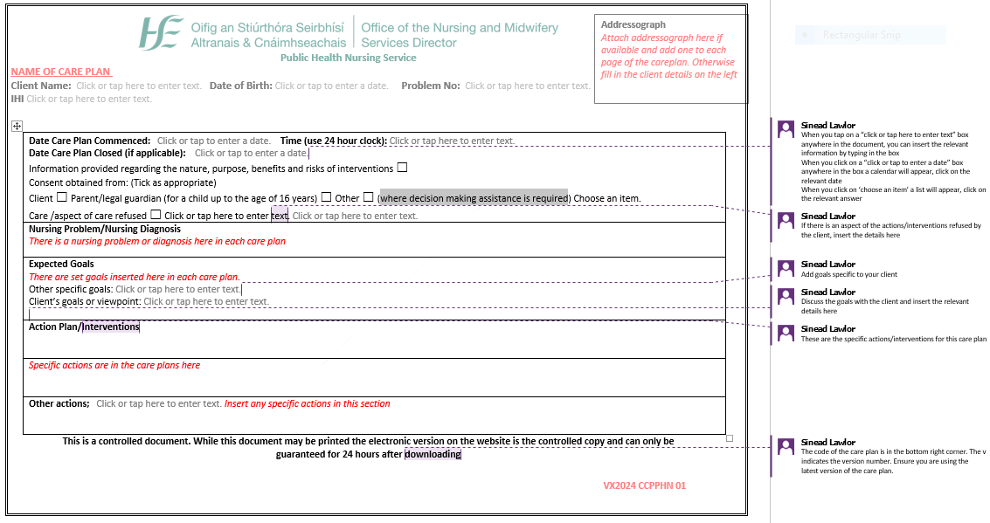

Appendix 7: Sample Clinical Care Plan with Guidance for use – page 2 of 3

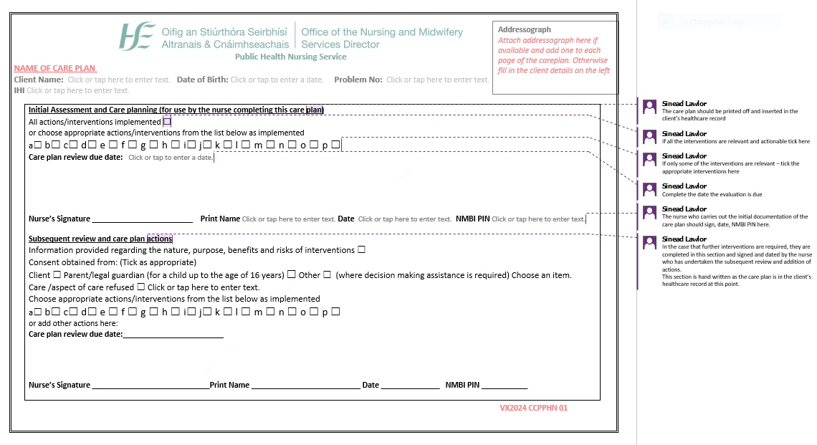

Appendix 7: Sample Clinical Care Plan with Guidance for use – page 3 of 3
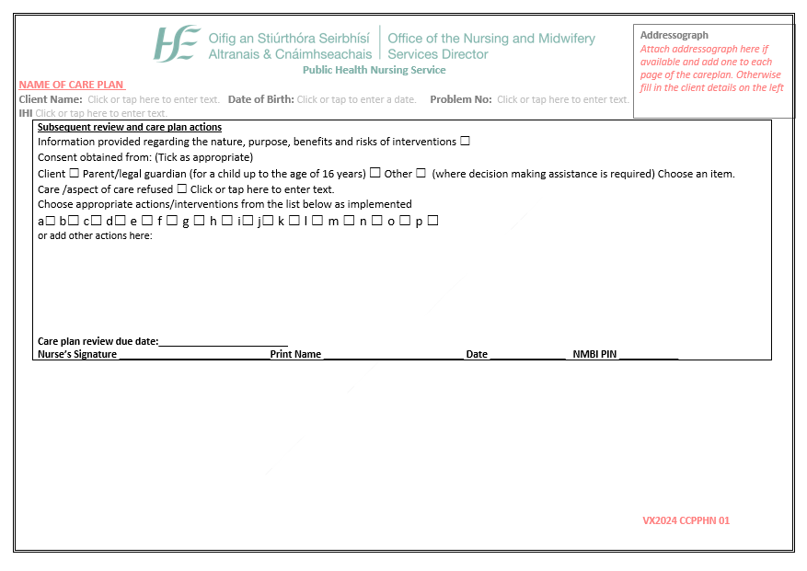

Appendix 8: National Implementation plan
National 3PG Title: Procedure for the use of standardised clinical care plans in the public health nursing service.
Date National 3PG approved: 19/03/2024
Expected date of full implementation: The care plans will be launched nationally within 3 months of the approval date.
National 3PG implementation lead/role: Grainne Ryan, National Lead for Public Health Nursing Service
IMPLEMENTATION ACTION | Implementation barriers / enablers | List of tasks to implement the action | Lead responsibility for delivery of the action | Expected completion date | Expected outcomes
Information sessions developed nationally and delivered via webinar. | - Enabler: Support of PDCs or DPHN appointed champion  - Enabler: Webinar will be recorded for all nurses/midwives to watch beyond the ‘go live’ webinar.  - Enabler: Sample clinical care plan developed with instructions embedded to aid correct use of clinical care plans.  - Enabler: PowerPoint slide set to support implementation.  - Barrier: IT access is variable. | - Identify PDCs to assist with CHO wide implementation.  - Link with DPHNs to identify champions to support implementation.  - Set date for national live webinar.  - Provide and record webinar.  - Disseminate recorded webinar and slides.  - Provide DPHN areas with access to care plans (2 care plan formats & procedure,  - DPHNs to be advised for the procedure to be uploaded to the MAPS portal for mandatory reading/compliance. | Sinead Lawlor National PDC | 6 months from approval date | The standardised clinical care plans and associated procedure will be available for use across the PHN services nationally 6 months from approval date.
National Implementation Plan Continued
Education / training required to implement the National 3PG:
- National procedure on the use of standardised clinical care plan available on www.hse.ie/phn and in the national central repository of the HSE.
- Sample care plan with embedded instructions.
- Live webinar.
- Recorded webinar.
- PDC support/champion’s support for implementation.
- The national procedure will require dissemination to all DPHNs nationally and supporting information sessions will be provided as part of the formal roll out of the standardised care plans and their associated procedure. A standardised PowerPoint presentation will be developed to ensure uniformity in terms of the information conveyed to all nurses/midwives.
- Communication from the national PHN office with the Higher Education Institutes responsible for student PHN education will occur to ensure awareness of the national procedure.
- Local induction programmes for new nurses commencing employment will include briefing on all 3PGs approved for use within the PHN service.
Resources: A copy of the procedure and the standardised clinical care plans is available on the National PHN website to download at; https://www.hse.ie/phn and on the HSE’s document hub at https://dochub.healthservice.ie
Recorded webinar disseminated to all DPHNs.
Information resources links built into each care plan as part of standardised care.

Adapted from National Clinical Effectiveness Committee (NCEC) Implementation Guide and Toolkit (Department of Health 2018)

Appendix 9: Audit Tool for the Procedure on the use of the Standardised Clinical Care Plans in the PHN Service
Audit should be carried out within 12 months of implementation of this procedure using this audit tool. Frequency of subsequent audit, will be determined at local level following the first audit. Please answer all questions indicating Yes (Y) or No (N) or Not Applicable (N/A) and give a comment if necessary in the ‘evidence’ column.

No | Is standard/criteria being met for the following statements: | Y | N | N/A | Evidence
1 | Has the nurse read the procedure on the MAPs portal?
2 | Have the principles of good documentation been adhered to throughout the care plan; e.g. use of black ink, legible, date and timed with 24 hour clock, signature and NMBI number?
3 | Is there evidence that information was provided regarding the nature, purpose, benefits & risks of interventions?
4 | Is there evidence that consent was gained?
5 | Is the client’s name and date of birth recorded on the care plan?
6 | Has the problem(s) been clearly identified?
7 | Is the care plan number evident?
8 | Has a care plan index been commenced?
9 | Has the care plan been individualised to reflect specific Client need?
10 | Was an evaluation review date set?
11 | Is the evaluation of the care plan evident?
12 | In the case where the care plan problem/diagnosis has not been resolved and the care plan is of 1 year’s duration, is there evidence that the care plan has been reviewed at least annually following client re-assessment.  Please verify that the up to date care plan version number is in use.
13 | Is the closure of the care plan evident where applicable?
14 | Is there evidence that the progress notes were maintained during each episode of care?
Date & time of Audit:
Audited by (name/title):
Health Centre/Primary care centre:
Compliance Rate %: /14
Quality Improvement plan required: Yes/No (please circle)
Action areas identified:

Appendix 10: Checklist
Checklist for Best Practice in Developing HSE National 3PGs

Stage 1 | Deciding the need
 | Aligned with HSE National Priorities | ☒
 | Clearly defined document type (P,P,P or G) | ☒
 | Approval obtained to develop | ☒
Stage 2 | Planning
 | Governance clearly established | ☒
 | Appropriate stakeholder involvement | ☒
 | Defined in-scope and out-of-scope | ☒
 | Development Group (terms of reference/conflict of interest forms) | ☒
Stage 3 | Development
 | Evidence methodology based | ☒
 | Creation of guidance / recommendations | ☒
 | Explicit link between the evidence to guidance / recommendations | ☒
 | Circulated for national consultation/independent expert review (as required) | ☒
 | Audit Tool developed | ☒
Stage 4 | Implementation
 | Implementation plan completed / Team established | ☒
 | Communication and dissemination plan developed | ☒
 | Supports: advice, tools, resources developed and where to access | ☒
Stage 5 | Sustainability
 | Monitoring and Audit Plan outlined | ☒
 | Audit outcomes: structure in place to link to quality improvement and risk management processes | ☒
Document Control
 | Mandatory pages 1+2 of this template are fully completed. | ☒

I confirm that all of the above key activities have been met: ☒
Chairperson name: Yvonne Delaney | Title: Assistant Director of Public Health Nursing (PHN) Service – Practice Development Coordinator.
Signature: (e-signatures accepted)
Registration number: 63194
Co-chair name: Sinead Lawlor | National Practice Development Coordinator
Signature: (e-signatures accepted)

Registration number: 40339
Date: | 16/02/2024

Appendix 11: Subsequent Reviews – Additional Sheet page 1 of 2
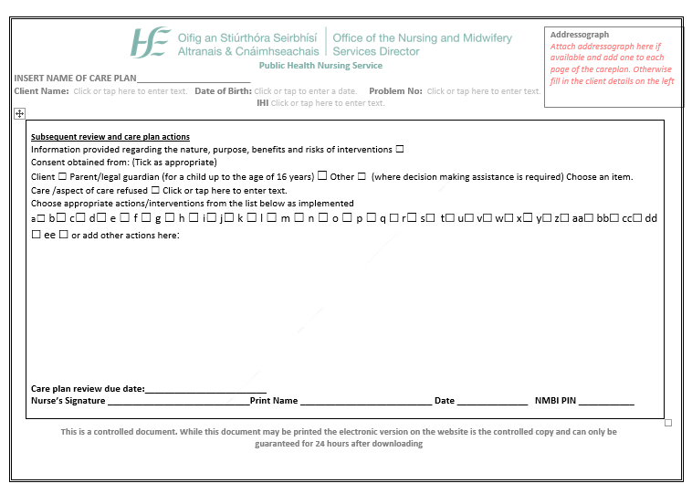

Appendix 11: Subsequent Reviews – Additional Sheet page 2 of 2
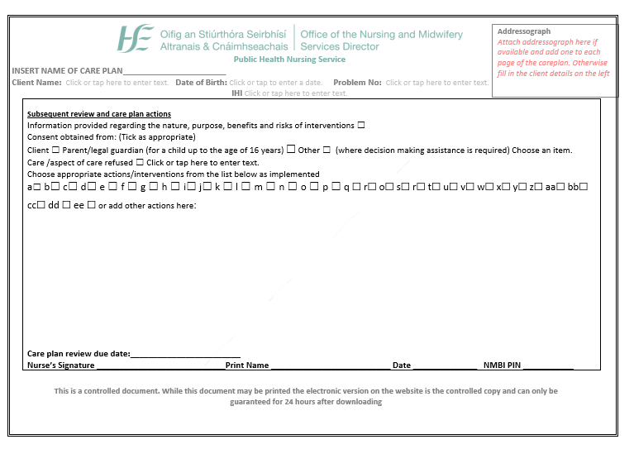

Records the senior management roles involved in the governance and development of the document.
Records the control information about the document.
Records details when a document is reviewed, even if no changes are made.
Records the document information required for publication on the HSE National Central Repository.

