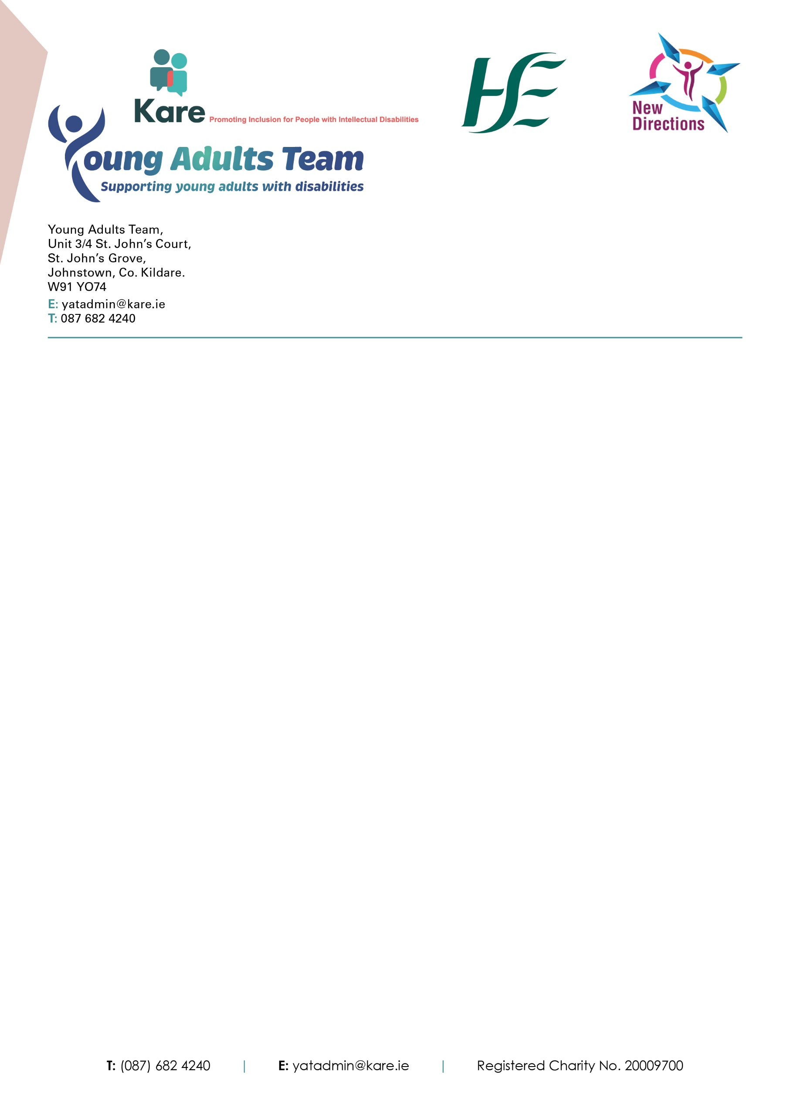

Young Adults Team,

Unit 3/4 St. John’s Court,

St. John’s Grove, Johnstown,

Co. Kildare W91 YO74.

E: yatadmin@kare.ie

T: 087 682 4240

**Young Adults Team Consent form**

**Informed Consent**

In line with the Assisted Decision-Making (Capacity) Act 2015, capacity to consent should be assumed unless proven otherwise. The Individual Consent form is to be signed by the young adult who is being referred.

The referral to Young Adults Team should be explained to the young adult in a manner they understand by someone who knows the person well, understands their communication needs, their will and preference, values and beliefs.

Information on the Young Adults Team in accessible format, including an introduction video for the team is available on the Young Adults Team’s website at https://[www.kare.ie/young-adults-team](http://www.kare.ie/young-adults-team)

Should you require additional support to explain the Young Adults Team to the person, please contact us and we will be more than happy to provide additional resources and information.

If the young adult can consent to the referral being sent to the Young Adults Team, please complete the Young Adult’s consent form. If you feel the person’s capacity to consent is lacking, or is in question, the referrer must complete the checklist on page 3.

**Young Adult’s Consent Form**

|  |  |  |
| --- | --- | --- |
| Email symbol clipart clipart kid 3 - ClipartixI consent/do not consent to the following:  For a referral to be sent by email/post to The Young Adults Team.  This referral will let the team know that I would like their help. It will include information about me such as my address, date of birth and any diagnosis I may have. | Thumbs up clipart 2 - Clipartix | manage your Google Workspace ... |
| SimplySfdc.com: Salesforce: Subscribe Reports in Classic and Lightning  For the team to contact the HSE/other clinical teams who may have supported me in the past to get copies of reports, support plans, assessments, recommendations and other information about me. | Thumbs up clipart 2 - Clipartix | manage your Google Workspace ... |
| 21,900+ Adult Siblings Illustrations, Royalty-Free Vector Graphics & Clip  Art - iStock | Adult siblings talking, Adult siblings fighting, Adult  siblings arguing  For the team to talk to me, my family, doctor, staff or others who support me, to understand how they can help. | Thumbs up clipart 2 - Clipartix | manage your Google Workspace ... |
| Illustration vector graphic cartoon ...  For The Young Adults Team to keep information about me on the team’s computer system. Information will include but not limited to name, date of birth, address, reports, notes etc. | Thumbs up clipart 2 - Clipartix | manage your Google Workspace ... |

Name: ……………………………….

Yes, I agree:  or No, I do not agree  (please circle)

**Where a person’s capacity to decide about an intervention is in question or lacking**

When a person’s capacity to decide about an intervention is in question, may shortly be in question or is lacking this checklist may be useful to step through relevant considerations related to this referral.

|  |
| --- |
| Signature of Young Adult …………………………………………………………………………………. |

|  |  |  |
| --- | --- | --- |
| **Checklist** | **Yes** | **No** |
| 1. Have you discussed the reason for referral with the individual? |  |  |
| 1. Have you shown the individual the accessible information provided on the Young Adults Team’s website? |  |  |

|  |
| --- |
| 1. If the young adult was able to show their consent to the referral, how did they do this e.g. Lámh, visuals, gesture, verbal, talking mats (please specify)?   _____________________________________________________________________________   1. What is the proposed intervention or support being requested?   _____________________________________________________________________________   1. Why is this necessary at this time? |
| **The Decision support service promote the rights and interests of people who may need support with decision making. They register decision support arrangements and supervise decision supporters. More information on the decision support service and arrangements can be found on** [**www.decisionsupportservice.ie**](http://www.decisionsupportservice.ie)  **If there is a decision support arrangement in place that is registered by the Decision Support service, please answer Q 6 and Q7**  **If there is no decision support arrangement in place, please go to Q 8** |
| 1. Is there a legal decision support arrangement which is registered with the decision support service and if so, please specify what this arrangement is?   Decision making assistance agreement  Co-decision making agreement  Advanced Healthcare directive  Designated Healthcare representative  Decision Making Representative  Enduring power of attorney   * If there is a decision support arrangement in place, does this proposed request for intervention fall within the scope of this arrangement?   Yes  No |
| 1. Has valid consent been given via the relevant decision support arrangement under the ADM Capacity Act?   Yes  No   1. If there is no decision support arrangement in place, please answer the following questions:   Is the intervention for the benefit of the person and if so, please specify why?  It will optimise their health and well being  It is consistent with their will and preferences if ascertainable  It is consistent with their beliefs and values  It is consistent with the views of those consulted  Other ________________________________________________________________________  Who was consulted and what were their views?  _______________________________________________________________________ |
| **Checklist completed by** |
| **Signature** |
| **Name (in BLOCK CAPITALS)** |
| **Relationship to person being referred** |
| **Date** |