SAFETY ALERT FOR DISPOSABLE ELECTRONIC CIGARETTE

BRAND NAME McKesse MK Bar 7000 12ml

Date: July 2023
Summary of Recall
Alert Notification: The product contains more than the permitted concentration of nicotine (measured values up to 28.9mg/ml) which is set in legislation at 20mg/ml. Acute exposure to high amounts of inhaled nicotine may cause dizziness, nausea, or vomiting. Nicotine is acutely toxic and can endanger the user’s safety if the product comes into contact with the skin or is ingested.
Product Identification:
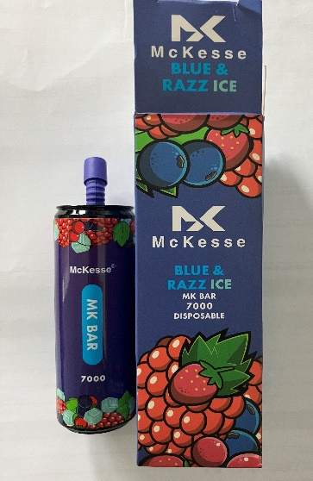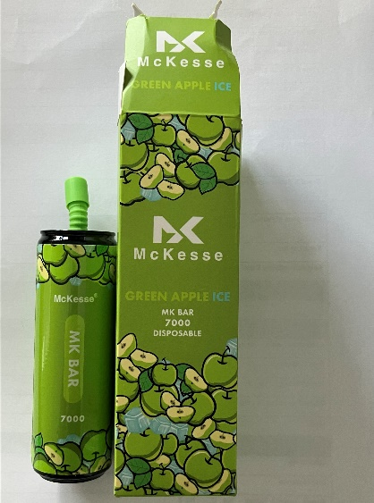

Product name: McKesse MK Bar 7000 Disposable electronic cigarettes
Sub-brands (flavours): Blue & Razz Ice
Green Apple Ice
Batch Numbers:
Sub-Brand / Flavour | Batch Code
Blue & Razz Ice | Exp:03/12/2023
Green Apple Ice | Exp:03/12/2023

Country of Origin: People’s Republic Of China

ADVICE ON WHAT YOU SHOULD DO IF YOU HAVE THE PRODUCT:

If you have the product, do not use and return it to the shop where you bought it.

Ref: Scientific Committee on Health, Environmental and Emerging Risks SCHEER Opinion on electronic cigarettes

