SAFETY ALERT FOR E-LIQUID REFILL CONTAINERS

BRAND NAME Fantasi Ice 20mg/ml nicotine 10ml

Date: June 2023
Summary of Recall
Alert Notification: The product contains more than the permitted concentration of nicotine (measured values up to 25.3mg/ml) which is set in legislation at 20mg/ml. Acute exposure to high amounts of inhaled nicotine may cause dizziness, nausea, or vomiting. Nicotine is acutely toxic and can endanger the user’s safety if the product comes into contact with the skin or is ingested.
Product Identification:
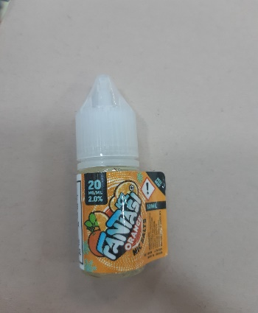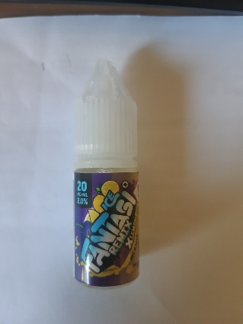

Product name: Fantasi Ice 20mg/ml nicotine Refill Containers

Sub-brands (flavours): Orange
Remix Blackcurrant and Lemon

Batch Numbers:
Sub-Brand / Flavour | Batch Code
Orange | 20614188
Remix Blackcurrant and Lemon | 20506085

Country of Origin: UK

ADVICE ON WHAT YOU SHOULD DO IF YOU HAVE THE PRODUCT:

If you have the product, do not use and return it to the shop where you bought it.

Ref: Scientific Committee on Health, Environmental and Emerging Risks SCHEER Opinion on electronic cigarettes

