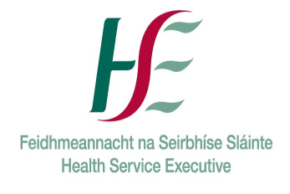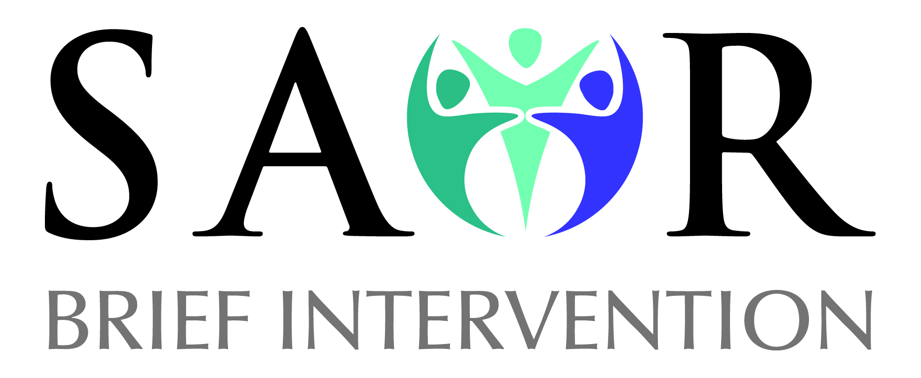
SAOR©: Screening & Brief Interventions for Problem Alcohol and Substance Use
Course Duration: 1 day
Who should attend?  Staff who have occasion to ask people about their drug and alcohol use in a diverse range of settings including: acute care settings, mental health services, community based drugs services, child and family services, homeless agencies, family support, employment support, vocational training, criminal justice, probation, primary care services, third level colleges and sporting organisations. | Date & Venue
Number of Places Available: 18
Course Description:
The SAOR model of screening and brief intervention for problem alcohol and substance use aims to prepare professionals to assess, and if necessary, assist a person to alter their alcohol or drug consumption. The SAOR model (O’Shea, Goff & Armstrong, 2017) advocates a four step by step guide to Brief Intervention for problem alcohol and substance use:
- Support
- Ask and Assess
- Offer Assistance
- Refer
The SAOR Model has been adopted by the HSE as the national model for delivering screening and brief intervention for drug and alcohol use.
Course Content:
The key course content which emerges from the course learning outcomes is outlined below:
- Evidence for the effectiveness of screening and brief interventions (SBI);
- How alcohol and drug problems present in health and social care settings;
- Overview of the SAOR model of intervention for problem alcohol and substance use;
- Establishing a supportive working relationship with the service users;
- Asking about alcohol and drug use and screening for alcohol and drug related problems;
- Delivering a structured brief intervention based upon the SAOR model;
- Developing appropriate care pathways for service users and arranging appropriate follow up;
- Accessing useful links and reference materials for further reading and research.

Learning Outcomes:
On completion of this course, participants should be able to:
- Understand how problem alcohol and substance use impacts their current work;
- Understand how to utilise the SAOR Model to intervene with alcohol and drug users;
- Understand how to utilise a number of alcohol and other drugs screening tools;
- Identify problem alcohol and drug users who present to health and social care settings;
- Utilise the SAOR model of Screening & Brief Intervention (SBI) in practice based scenarios;
- Discuss the application of the SAOR model of screening and brief intervention for problem alcohol and drug use into their practice.
How to book:
Complete the attached booking form and return to socialinclusion@hse.ie or post to National Social Inclusion Office, Stewart's Hospital,Mill Lane,Palmerstown,Dublin 20,D20 HY57
We will contact you when training dates are scheduled.
Certification/Accreditation:
A Certificate of Attendance will be awarded on completion of the training

General Training Booking Form
Name of Course | SAOR©: Screening & Brief Interventions for Problem Alcohol and Substance Use
Date of Course
Applicant Details
Name:
Position Held:
Phone No:
Email:
Organisation Details
Name of Organisation:
Organisation details:
Profile of your target group:

Address:
Contact Details
Training Application
Have you previously completed any drug/alcohol training?

Please give details
How do you think this training will be of benefit to you or the group with whom you work?

Do you have any special access requirements?
Please explain
Any other comment
Please return booking form to:
Complete the attached booking form and return to socialinclusion@hse.ie or post to National Social Inclusion Office, Stewart's Hospital,Mill Lane,Palmerstown,Dublin 20,D20 HY57
We will contact you when training dates are scheduled.

