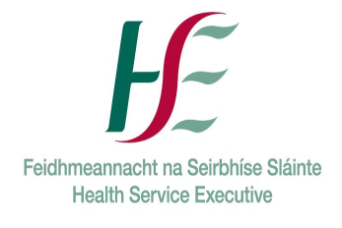Request for SAOR© 1 Day Training 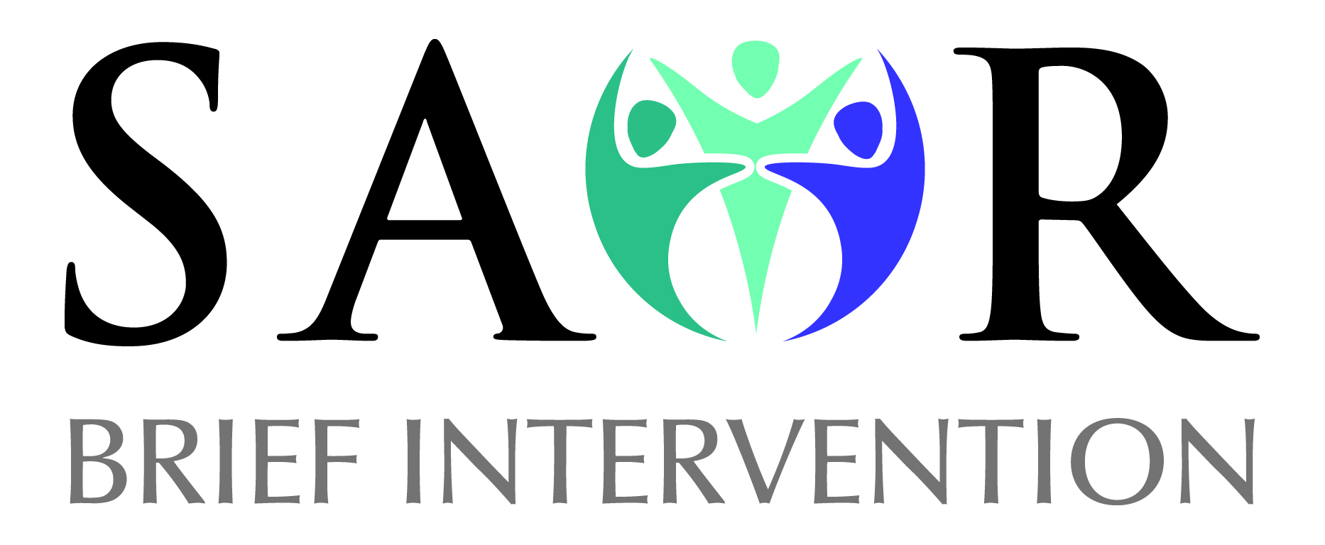
Thank you for your interest in running a 1 Day SAOR: Screening and Brief Intervention for Problem Alcohol and Substance Use. Please complete the details below and return
Name of Organisation:
Address:
Phone No:
Email:
Contact Person:
Training Request Information
Participants/audience:
(Staff/volunteers etc.)
Size of group: (max 18)
Preferred dates for training to take place:
Address of training venue
Location of training room
What do you hope to achieve by running this course?
Training requirements:  Are you in a position to provide the following in your venue/service?  Please tick | - Room that is 30' X 30' minimum.
 | - Table at the top for equipment that is 3' X 4' minimum.
 | - Screen or light coloured wall to project on to.
 | - U-shape of chairs (max 18).
 | - Power outlets and extension leads at top table.
 | - Tea/coffee on site.
 | - Lunch on site if possible (or options locally for participants at their own expense)
 | - Parking for trainers onsite/nearby
The trainer(s) will | - Provide you with information on the training course  - Booking forms for participants  - Participant Packs – these will be delivered on site in advance of the training or brought by the trainer on the morning of the training.  - Sign In Sheet  - Evaluation forms (copies of which will be sent to the National Social Inclusion Office*  *A list of all participants and the evaluation forms will be sent to the National Social Inclusion Office and the numbers will be included in national statistics for those training in the country.
Completed by: | Name:  Position in Organisation:  Date completed:
Any Other Comment/Info
Please return booking form to:
socialinclusion@hse.ie or post to National Social Inclusion Office, Stewart's Hospital,Mill Lane,Palmerstown,Dublin 20,D20 HY57

