Social Inclusion (Inclusion Health) Resources

RSV resources collated by the [National Social Inclusion Office](https://www.hse.ie/eng/about/who/primarycare/socialinclusion/) (NSIO) Public Health Team (October 2024)

**Please note if you have difficulty opening the YouTube videos or any of the leaflets from this document, if you copy and paste the hyperlink into the address bar at the top of your search engine page that should bring you to the required resource.**

1. [RSV immunisation resources](https://www.hpsc.ie/a-z/respiratory/respiratorysyncytialvirus/resources/)

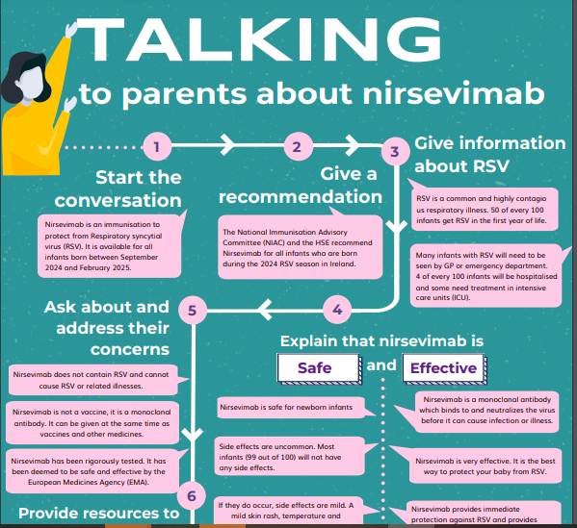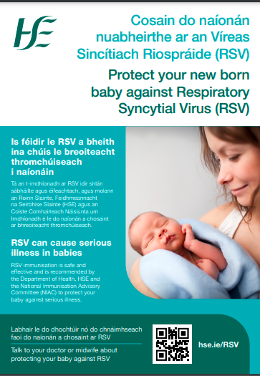

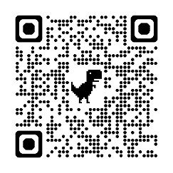

# Traveller Health

Pavee Point Traveller and Roma Centre and The Rotunda Hospital developed [Traveller RSV - leaflet](https://www.hse.ie/eng/about/who/primarycare/socialinclusion/about-social-inclusion/translation-hub/multilingual-resources-and-translated-material/rsv-traveller-english-info-leaflet.png) and [RSV video Travellers](https://www.youtube.com/watch?v=cqN98uZE2A0)

(September 2024).

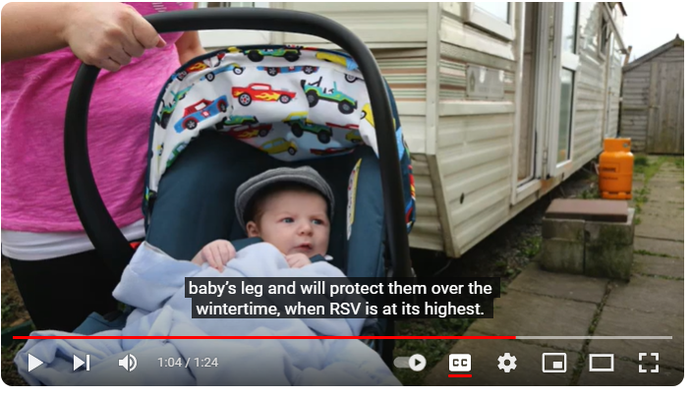

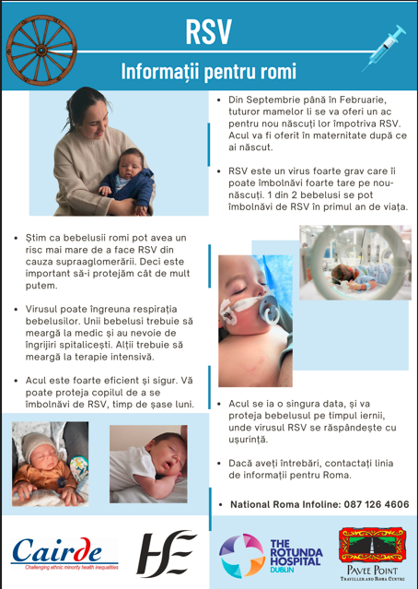

1. Roma Health

Cairde, Pavee Point Traveller and Roma Centre and The Rotunda developed a [Roma - RSV leaflet](https://www.hse.ie/eng/about/who/primarycare/socialinclusion/about-social-inclusion/translation-hub/multilingual-resources-and-translated-material/rsv-roma-romanian-info-leaflet.png) and [Roma - RSV video](https://www.youtube.com/watch?v=mcoN5WDOPH4)

in Romanian (September 2024) .

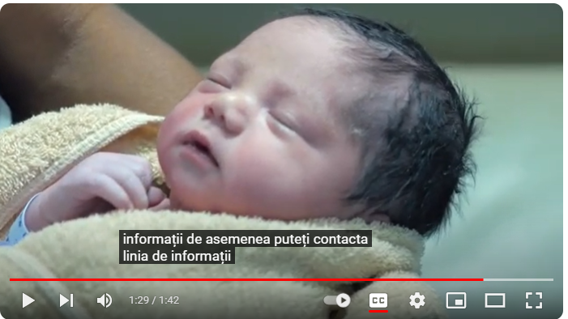

|  |
| --- |
|  |

# Migrant Health

HSE developed leaflets in Ukrainian, Russian, Romanian, Portuguese, Polish, Chinese (simplified), Arabic, (August 2024), English, Georgian, Urdu and Somali (October 2024).

[RSV immunisation resources](https://www.hpsc.ie/a-z/respiratory/respiratorysyncytialvirus/resources/)

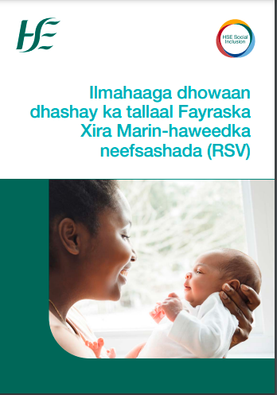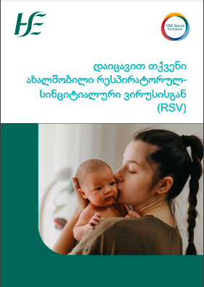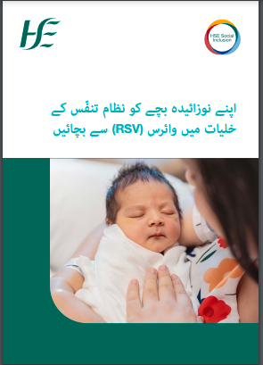

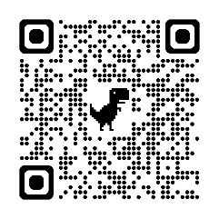

|  |  |
| --- | --- |
|  | [About the Irish health system: A guide for refugees and other migrants](https://www.hse.ie/eng/about/who/primarycare/socialinclusion/intercultural-health/about-the-irish-health-service.html).  **Guide** (pdf) available in [[English](https://www.hse.ie/eng/about/who/primarycare/socialinclusion/about-social-inclusion/translation-hub/multilingual-resources-and-translated-material/hseorienguide-en-2023.pdf)], [[English/Irish](https://www.hse.ie/eng/about/who/primarycare/socialinclusion/about-social-inclusion/translation-hub/multilingual-resources-and-translated-material/hseorienguide-eng2022-irish.pdf)], [[English/Albanian](https://www.hse.ie/eng/about/who/primarycare/socialinclusion/about-social-inclusion/translation-hub/multilingual-resources-and-translated-material/hseorienguide-english-albanian-2022.pdf)], [[English/Arabic](https://www.hse.ie/eng/about/who/primarycare/socialinclusion/about-social-inclusion/translation-hub/multilingual-resources-and-translated-material/hseorienguide-english-arabic2022.pdf)], [English/Bulgarian](https://www.hse.ie/eng/about/who/primarycare/socialinclusion/about-social-inclusion/translation-hub/multilingual-resources-and-translated-material/hseorienguide-english-bulgarian-2022.pdf)], [[English/Chinese](https://www.hse.ie/eng/about/who/primarycare/socialinclusion/about-social-inclusion/translation-hub/multilingual-resources-and-translated-material/hseorienguide-chinese-2023.pdf)],  [English/Czech], [[English/Farsi](https://www.hse.ie/eng/about/who/primarycare/socialinclusion/about-social-inclusion/translation-hub/multilingual-resources-and-translated-material/hseorienguide-eng-farsi2022.pdf)], [[English/French](https://www.hse.ie/eng/about/who/primarycare/socialinclusion/about-social-inclusion/translation-hub/multilingual-resources-and-translated-material/hseorienguide-english-french2022.pdf)], [[English/Georgian](https://www.hse.ie/eng/about/who/primarycare/socialinclusion/about-social-inclusion/translation-hub/multilingual-resources-and-translated-material/hseorienguide-eng-georgian2022.pdf)], [[English/Kurdish](https://www.hse.ie/eng/about/who/primarycare/socialinclusion/about-social-inclusion/translation-hub/multilingual-resources-and-translated-material/hseorienguide-english-kurdish2022.pdf)], [English/Lithuanian], [[English/Pashto](https://www.hse.ie/eng/about/who/primarycare/socialinclusion/about-social-inclusion/translation-hub/multilingual-resources-and-translated-material/hseorienguide-english-pashto2022.pdf)], [[English/Polish](https://www.hse.ie/eng/about/who/primarycare/socialinclusion/about-social-inclusion/translation-hub/multilingual-resources-and-translated-material/hseorienguide-english-polish-2022.pdf)], [[English/Portuguese](https://www.hse.ie/eng/about/who/primarycare/socialinclusion/about-social-inclusion/translation-hub/multilingual-resources-and-translated-material/hseorienguide-english-portu-2022.pdf)], [[English/Romanian](https://www.hse.ie/eng/about/who/primarycare/socialinclusion/about-social-inclusion/translation-hub/multilingual-resources-and-translated-material/hseorienguide-english-romanian2022.pdf)], [[English/Russian](https://www.hse.ie/eng/about/who/primarycare/socialinclusion/about-social-inclusion/translation-hub/multilingual-resources-and-translated-material/hseorienguide-engrussian2022.pdf)], [[English/Slovak](https://www.hse.ie/eng/about/who/primarycare/socialinclusion/about-social-inclusion/translation-hub/multilingual-resources-and-translated-material/hseorienguide-slovak-2023.pdf)], [[English/Somali](https://www.hse.ie/eng/about/who/primarycare/socialinclusion/about-social-inclusion/translation-hub/multilingual-resources-and-translated-material/hseorienguide-english-somali2022.pdf)], [[English/Spanish](https://www.hse.ie/eng/about/who/primarycare/socialinclusion/about-social-inclusion/translation-hub/multilingual-resources-and-translated-material/hseorienguide-english-spanish2022.pdf)], [English/Ukrainian], [[English/Urdu](https://www.hse.ie/eng/about/who/primarycare/socialinclusion/about-social-inclusion/translation-hub/multilingual-resources-and-translated-material/hseorienguide-english-urdu-2022.pdf)].  **Posters** with QR codes available in 21 languages ([WEB](https://www.hse.ie/eng/about/who/primarycare/socialinclusion/about-social-inclusion/translation-hub/multilingual-resources-and-translated-material/about-irish-health-service-poster-web-copy-1.pdf) and [PRINT](https://www.hse.ie/eng/about/who/primarycare/socialinclusion/about-social-inclusion/translation-hub/multilingual-resources-and-translated-material/about-irish-health-service-poster-print-copy-1.pdf)) versions. |

|  |  |  |
| --- | --- | --- |
|  | |  |
|  |  | |

1. Asking about ethnicity

The National Social Inclusion Office (NSIO) have a programme of work to support the collection of ethnicity data (Ethnic Equality Monitoring) within a range of health services, including training on HSELanD on how to sensitively ask about ethnicity. See the following links for more detail:

* **eLearning module** on [HSELanD](https://www.hseland.ie): ***Introduction to ethnic equality monitoring***
* [What is Ethnicity and Ethnic Equality Monitoring?](https://scanner.topsec.com/?d=2120&r=show&u=https%3A%2F%2Furldefense.com%2Fv3%2F__https%3A%2Fwww.hse.ie%2Feng%2Fabout%2Fwho%2Fprimarycare%2Fsocialinclusion%2Fintercultural-health%2Fethnic-equality-monitoring%2Fwhat-is-ethnicity-and-ethnic-equality-monitoring.html__%3B%21%21CfJOjA%21B7VYvG_uEKQ2o5aGFPZwcfJgrIoX6wsaPkGrIZ-iWRdf-bWhBc3iA1BB0Mi-Li6O_QyHxCfMdwkk_xxLivYUfQ%24&t=833015054f43c630ad985652bd24620bb8f0cd50)
* [NSIO webinar on Ethnic Equality Monitoring](https://youtu.be/t4xqOaDFp7o?si=U5O1RByWkhN0C6H7) (1:11:00) from 08 March 2023 C:\Users\aileenkitching\Pictures\Logos\YouTube logo.jpg
* Report on [NSIO online survey of HSE and NGO staff on the collection and use of ethnicity data](https://www.hse.ie/eng/about/who/primarycare/socialinclusion/intercultural-health/ethnic-equality-monitoring/ethnic-equality-monitoring-survey.html)
* [Legal requirement](https://www.hse.ie/eng/about/who/primarycare/socialinclusion/intercultural-health/ethnic-equality-monitoring/legal-requirements-and-actions-in-strategies.html) for the HSE to provide fair and equal service to all ethnic groups under the Public Sector Equality and Human Rights Duty
* [More information and resources on Ethnic Equality Monitoring](https://www.hse.ie/eng/about/who/primarycare/socialinclusion/intercultural-health/ethnic-equality-monitoring/more-information.html)
* [Posters to explain to patients and clients why they might be asked about their ethnicity](https://www.hse.ie/eng/about/who/primarycare/socialinclusion/intercultural-health/ethnic-equality-monitoring/posters.html), country of birth, language etc. Available in English, Irish, Arabic, Chinese, French, Polish, Russian, Ukrainian.

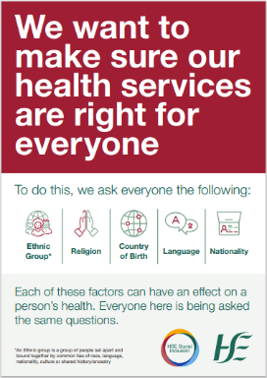

* Pavee Point Traveller and Roma Centre [*Counting us In* video](https://www.paveepoint.ie/video-ethnic-data-collection/) (May 2016) on C:\Users\aileenkitching\Pictures\Logos\Vimeo-Logo-2006-present.jpg on the importance of ethnic data collection. Pavee Point advocates for the collection and disaggregation of ethnicity data (including Travellers and Roma) within a human rights framework.
* Best practice approach: All individuals asked a **universal ‘ethnic identifier’ question**. This universal question should be **comparable with national data sets**, such as Census data.

*Census 2022 question on ethnicity*



  
  
  