National Office for Human Rights and Equality Policy,
National Quality Improvement Team.

The Team

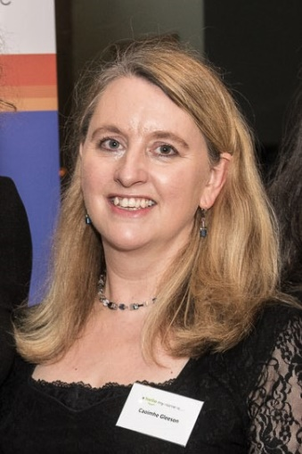

Caoimhe Gleeson is General Manager for the National Office for Human Rights and Equality Policy at the Health Service Executive (HSE). Caoimhe is the HSE representative on the Inter-departmental Steering Board for the commencement of the Assisted Decision Making (Capacity) Act 2015 and has overseen the drafting of the Healthcare Codes of Practice on the Assisted Decision Making (Capacity) Act (2015) on behalf of the Minister for Health. As a member of the National Disability Authority Technical Group, Caoimhe participated in the drafting of the non-healthcare Codes of Practice on the 2015 Act on behalf of the Department of Justice. Caoimhe has responsibility for the oversight of HSE National Consent Policy, oversight of the implementation programme to support compliance with the Assisted Decision Making (Capacity) Act 2015 in the HSE and works to progress equality, human rights advocacy and policy issues for people with disabilities and other diverse groups in Ireland.
Prior to joining the HSE, Caoimhe worked in Community Development across the border counties and in Northern Ireland. Throughout her career, Caoimhe has worked on and volunteered in several international programmes based in Central America, Africa, Eastern Europe and beyond, that focus on gender equality, youth work, intercultural education, conflict transformation and mediation.
Caoimhe holds a BA, an LLB, a master’s degree in Community Development, a professional diploma in Equality and Human Rights, is a trained mediator and is currently studying for the Barrister at Law degree in Kings Inns.
Caoimhe was a ministerial appointee to the National Research Ethics Committee for COVID-19 during its tenure from April to August 2020 and is a current member of the National Research Ethics Committees for Clinical Trials.
Caoimhe has contributed to a number of publications on equality and human rights issues. She recently co-edited “The Assisted Decision-Making (Capacity) Act 2015- personal and professional reflections”.

`
Elaine McCaughley is a senior project manager who has developed a wealth of training and education resources across a number of programmes including the Assisted Decision-Making (Capacity) Act. Elaine leads on work relating to the National Consent Policy. Elaine has extensive clinical experience as a speech and language therapist, where she gained first-hand experience of the challenges faced by people who are disempowered within health and social care systems. Elaine holds an LLM in Healthcare Ethics and Law from the University of Manchester where she volunteered at the Dementia Legal Advice Clinic. Elaine has a strong interest in ethics education and advocacy, and enjoys collaborating with people using services, and teams within and outside HSE.

Jacqueline Grogan is Project Manager in the National Office for Human Rights and Equality Policy. She is responsible for the Assisted Decision-Making (Capacity) Act 2015, Wardship, Public Sector Duty, Transgender and Intersex issues, and Universal Access.
Prior to joining the HSE in 2016, she worked in disability services both in Scotland and Ireland, including Sense Scotland, Momentum Scotland, the Rehab Group, Headway Ireland and the Disability Federation of Ireland, in the areas of service delivery, research, communications, governance and service development. She holds an honours degree in Psychology, a Master’s degree in Social Research, a Certificate in Public Relations, and is a PRINCE II Practitioner. She has recently completed a Professional Diploma in Human Rights and Equality.
Jacqueline strongly advocates for the right for everyone to be supported to make decisions about their care and treatment choices and the need for services and organisations to listen to and learn from the experiences of people who use our services, their families and their advocates.
Shem Romanowski is the Programme Support Officer in the National Office for Human Rights and Equality Policy. He supports and champions the delivery and implementation of policy programmes like Assisted Decision-Making (Capacity) Act 2015, as amended, National Consent Policy, Do Not Resuscitate CPR amongst others.
Shem began his career with the HSE in 2019 assisting the CFO Office. During the Covid 19 pandemic, Shem offered to be redeployed to Public Health to support colleagues there, while working as the Executive Assistant to the National Clinical Director for Health Protection. Progressing from there, Shem was involved in programme administration for Health Threats Preparedness Programme. Shem holds a Master’s degree in Applied Social Research from Trinity College Dublin and he contributed to a published research project analysing and examining Irish health protection response to Covid-19 Pandemic.
In his spare time, Shem is an active volunteer coordinating social inclusion projects for refugees and asylum seekers in the Dublin area and he is a member of the Board of Trustees with Serve the City Ireland. Shem is a strong supporter of the European Project, loves travelling off the beaten track, enjoys gardening and ancestry is his most recent project. Shem enjoys sports and competes in powerlifting competitions at amateur level.

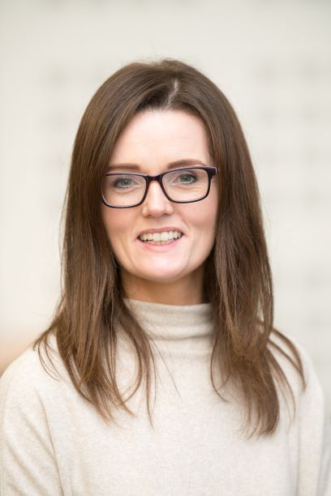
Orlaith Branagan is Office Administrator in the National Office for Human Rights and Equality Policy. Orlaith is responsible for the management of the website www.assisteddecisionmaking.ie, co-ordinating the programme of events delivered by the office as well as managing day to day operations.
Orlaith has a strong interest in Person Centredness and putting the rights of the person first.
She is also a qualified Yoga teacher and loves to paint and sketch.

Sandra Guidon is a dedicated Office Administrator at the National Office of Human Rights and Equality Policy, where she plays a vital role in supporting the delivery and implementation of key policy programs such as the National Consent Policy 2022, Do Not Attempt Resuscitate CPR, and the Assisted Decision-Making (Capacity) Act 2015, among others.

With a career spanning over two decades within the HSE, Sandra's journey began in 2000 and has seen her excel in various roles, from serving as a Personal Assistant to the Director of Nursing. Her expertise further expanded to encompass financial operations, patient accounts, payroll administration, and therapies services in the Community. Eventually leading her to oversee and manage the Childhood & School Immunisation Programme in Dublin West.

At the heart of Sandra's work is a deep commitment in advocating for service users and prioritising their needs ensuring they are heard & respected at every stage of their individual journeys within the healthcare system. Her commitment to providing dignity and care to all those she serves is at the core of her professional ethos.
Sandra participates in working groups and committees related to specific policies. These forums allow her to collaborate with experts & external stakeholders, share insights, and collectively address challenges.
Beyond her professional background, Sandra holds NEFPC Certificates in Fitness Instruction, Personal Training, and Group Instruction, showcasing her dedication to personal development and well-being.
These achievements demonstrate Sandra’s multifaceted contributions to healthcare, finance, and community well-being and personal professional development.

When she's not in the office, Sandra can often be found enjoying long walks in nature, reflecting her passion for the great outdoors.
As Sandra continues her journey, she aspires to impact lives in meaningful ways. Her unwavering commitment to service users, her passion for bridging gaps and her dedication to personal wellness all point toward a future where she advocates for dignity, compassion, and positive change.

