Name:
Address:

DOB:
HCRN:
Ward:

Primary Consultant:

Assessment: Baseline

Patient details
Patient preferred name:  Patient contact number: | Is there an interpreter present? Yes No  Interpreting Service Family member/Friend N/a
 | Allergies/ sensitivities:
Pharmacy:  Contact number:  Fax number:  Email: | Family doctor/specialist:  Address:  Contact number:  Fax number:  Email:
Name of Next of Kin:  Relationship:  Contact number:  Name of Next of Kin:  Relationship:  Contact number: | Public/Private Medical Card Yes No  Insurance company name:  Medical card number
Any patient infection control alerts/issues? Yes No Details: __________________________________
If yes, has patient had appropriate infection control screening? Yes No
Date of last screen:
Result of last screen:

Confirmed Therapy Plan
Primary diagnosis: | Disease Stage (e.g. TNM): |  |  |  |  | ECOG Status:
NCCP Regimen: | Number of planned cycles: |  |  |  |  | Frequency of cycles:
Timing of treatment:  Adjuvant  Neo-Adjuvant  Definitive | Treatment intent:  Curative  Disease-control  Palliative |  |  |  |  |  | Height:  Weight:  BSA:  Checked and verified by:  /
 |  | Yes | No | Comments
Study Participant |  |  |  | Trial name: |  |  |  | Trial nurse:
G-CSF prophylaxis |  |  |  | Type used: |  |  |  | Frequency:
Radiotherapy |  |  |  | N/A | Start Date:
Concomitant radiotherapy |  |  |  | N/A | Start Date:
Did the patient receive a discharge prescription? |  |  |  | N/A
Treatment start date given |  |  |  | Date: |  |  |  | Time:
Appointment booked
SACT script complete
SACT prescription sent to pharmacy
Consent form signed
HCG test (where required) |  |  |  | Test result:
Restage at cycle:

Social Assessment
Occupation
Name of the person the patient lives with
Accommodation | Type of accommodation: Two story House Bungalow Nursing home Sheltered accommodation/No fixed abode Other Details:
Support/care services involved | Is there anyone dependent or reliant upon the patient? Yes No Details
 | Meals on wheels_______days per week
 | Home help : ___________hours per day/week
 | Hospice and palliative home care involvement? Yes No Details
Public Health Nurse:
Health centre:

Contact number:
Email:
Fax number:
Community services: e.g. CIT
Special needs/disabilities | Language for interpreter:
Disabilities: Hearing Sight Mobility Learning Other
Details

Alcohol/Tobacco use | Alcohol use: Yes No Units weekly:
Smoking status Current Ex-smoker Never Unknown/Not asked

Is this patient interested in quitting smoking? Yes No NA
Advise to contact their GP or HSE quit team Yes No NA
 | Other substances
Financial | Income concerns
Notes:

Baseline Vital Signs (as applicable)
Blood pressure (mmHg) | Pulse  (bpm) | Respirations  (bpm) | SpO2  (%) | Temperature  (°C)

Current Medications
Medication | Dose | Frequency |  | Medication | Dose | Frequency
Has a drugs interactions check been completed? Yes No

Relevant Medical and Surgical History
Include prior cancer treatment: e.g. surgery, radiotherapy, hormonal and biological therapy
Relevant Family History
Patients Activities of Daily Living (ADL’s) Assessment
Activity | Tick if no Issues | Comments
Communication

Breathing/Circulation

Eating and Drinking |  | Document weight loss or use MST score using appendix 3
Further action required | Yes No
Elimination

Washing & Dressing

Mobility

Sleeping

Dying/Spirituality
Pain |  | State pain assessment tool that was used:
Further action required | Yes No
Maintaining a Safe Environment

Expressing Sexuality
Controlling Body Temperature

Oral Health
Current dental routine:

 | Yes | No | N/A | Comments
Has patient had a recent dental review?
Does patient wear dentures?
Do they fit well?
Is the patient for bisphosphonates?
Does patient require a dental review prior to treatment?
Pre Existing Problems and Risk Factors
Signs of fungal infection Herpes infection Mouth pain Dry mouth Elderly Endotracheal intubation Head & neck cancer Previous history of oral mucositis
Heart Disease Radiotherapy <6 weeks ago Steroidal Inhaler
Other:
OAG Score
Use the Oral Assessment Guide (OAG) to allocate a score to the patient (see appendix 2):

Skin (as applicable)
Include details of general skin condition, wounds, drains, existing rashes etc
No skin related Issues

Fertility
 | Yes | No | N/A | Comments
Use of contraception discussed
Does the patient wish to discuss fertility preservation?
Has the patient any existing fertility issues/concerns?
Fertility clinic referrals sent? |  |  |  | Date:
Virology bloods taken for the National Virus Reference Laboratory?
Written information given on egg/embryo freezing/sperm banking?
Information given

Venous Access Assessment
Does the patient have a CVAD in place? Yes No
If yes, when was it inserted:
Where was it inserted:
Is a CVAD indicated for any of the following reasons:
Drug requirement Poor peripheral venous access Needle phobia Lymphodema
Bilateral mastectomy Other:

Type of CVAD
PICC Portocath Hickman Other:
Line Insertion Organisation
 | Yes | No | NA | Comments
Insertion appointment booked |  |  |  | Date: Time:
Pre insertion bloods ordered/taken
Advised to fast from X am morning of insertion
Information leaflet given
Coagulation issues |  |  |  | Details:  Actions taken and advice given:
Consent form signed
Are any investigations required pre insertion?
Are investigations booked? |  |  |  | Details:

Pre-treatment Investigations
(e.g. CT,MRI,PET,CXR, ECG, ECHO, MUGA SCAN, cardiac MR, PFTs, Audiogram )
Type of investigation | Request sent? |  |  | Comments  including frequency required
 | Yes | No

Pre-SACT Assessment Bloods and urinalysis
Bloods ordered Bloods taken

FBC U&E LFTs Bone profile Coagulation screen Iron studies TFTs CRP Virology Cortisol Tumour Markers Other: Details

Urinalysis: Yes No NA
Sample sent to lab: Yes No NA

Referrals made
Disciplines | Yes | No | N/A | Comments
Medical Social Worker
Dietician
Physiotherapy
Speech and Language
Occupational therapy
Psycho-oncology/
Psychology
Prehabilitation
Palliative care
CNS Referral
(state discipline)
Public health nurse
Community Intervention team
Hair piece referral
ICS care to drive
Smoking cessation
Dentist
Support Centres
Other

Education Record
- Education provided by: Name: ___________________ Role: ________________
- Has the patient received any education from the Irish Cancer Society or other support organisation Yes No
- Education provided to: Patient Family member Friend Care provider
Name(s): ___________________________________________________
- Teaching aids used: Verbal Written Demonstration Multimedia
- Does the patient have any literacy issues Yes No
- Contact details given for acute oncology nurse telephone triage line Yes No NA
- Out of hours contact details given Yes No NA
- Has alert card been issued Yes No NA
Topics | Education Given? |  |  |  | Comments
 | Yes | No | N/A
Side effects
Alopecia/hair thinning
Anaemia
Cardiac toxicity
Endocrinopathies
Eye disorders
Fatigue
Gastrointestinal disorders
Hand/foot syndrome
Hepatobiliary toxicity
Hypersensitivity reactions
Infection
Mood changes
Nail changes
Mucositis
Musculoskeletal and connective tissue disorders
Nephrotoxicity
Neurological toxicity
Ototoxicity
Peripheral neuropathy
Respiratory side effects
Skin Reactions
Self-Medication (OAMs) See appendix 4 for MOATT
MOATT Key Assessment Questions
MOATT Patient Education
MOATT Drug Specific Education
MOATT Evaluation
Other
Consent process
CVAD insertion
Survivorship
Palliative Care
Safe Handling of cytotoxic drugs
Scalp cooling
Patient information given
(as per local guidelines)
Assessment of patient understanding of treatment
Question | Yes | No |  | N/A |  | Comments
Is patient aware of extent of disease?
Is patient aware of the goals of treatment?
Can the patient verbalise their understanding of the treatment regimen and treatment process?
Does the patient know how response will be measured?
Does the patient understand their treatment options? i.e. SACT versus supportive care
Is the patient aware they have the right to refuse or stop treatment at any time?
Does the patient understand that there may be a need for the use of blood products or other supportive interventions during the course of their treatment?
Notes:

Distress Thermometer
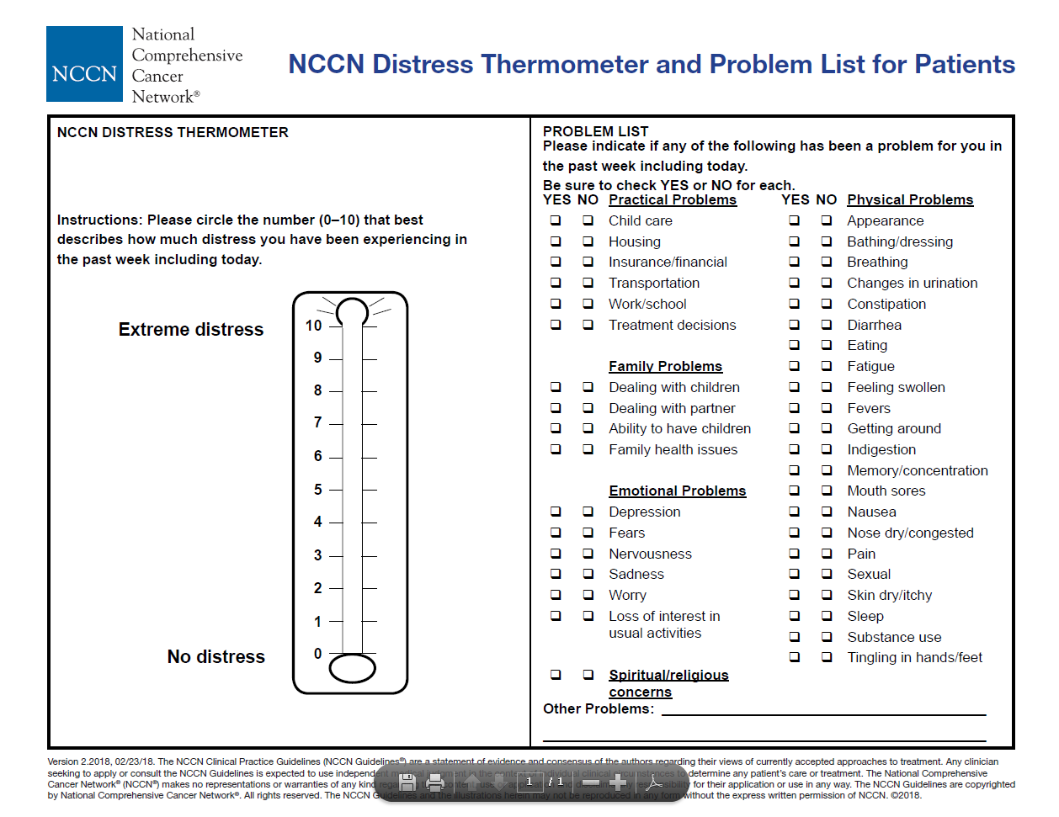

Assessment completed by________________ NMBI pin_______________ Date_________
Date | Time | Notes | Initials/NMBI pin

Signature Bank
Name | Signature | Initials | Role | NMBI Pin

Appendix 1: ECOG Status

ECOG Status
ECOG score 0 | ECOG score 1 | ECOG score 2 | ECOG score 3 | ECOG score 4
Fully active, able to carry on all pre-disease performance without restriction | Restricted in physically strenuous activity but ambulatory and able to carry out work of light or sedentary nature, e.g. light house work, office work | Ambulatory and capable of all self-care but unable to carry out any work activities. Up and about more than 50% or waking hours | Capable of only limited self-care, confined to bed or chair more than 50% of waking hours | Completely disabled, cannot carry on any self- care. Totally confined to bed or chair
Oken M, Creech R, Tormey D, et al. Toxicity and response criteria of the Eastern Cooperative Oncology Group.Am J Clin Oncol. 1982;5:649-655.

Appendix 2: Oral Assessment Guide (OAG)

When the scores of the eight categories are summed, a normal mouth will receive a score of 8
Oral Assessment Guide (OAG) Eilers et al 1988
Category | Rating 1 | Rating 2 | Rating 3
Voice | Normal | Deeper or raspy | Difficulty talking or crying, or painful
Swallow | Normal swallow | Some pain on swallowing | Unable to swallow
Lips | Smooth, pink and moist | Dry or cracked | Ulcerated or bleeding
Saliva | Watery | Thick or ropey | Absent
Tongue | Pink, moist and papillae present | Coated, loss of papillae with a shiny appearance with or without redness.  Fungal infection | Blistered or cracked
Mucous membranes | Pink and moist | Reddened or coated without ulceration or fungal infection | Ulceration with or without bleeding
Gingiva | Pink and firm | Oedematous with or without redness. | Spontaneous bleeding or bleeding with pressure
Teeth (if none, score 1) | Clean and no debris | Plaque or debris in localized areas (between teeth) | Plaque or debris generalized along gum line
Eilers J, Berger AM, Petersen MC. Development, testing, and application of the oral assessment guide (OAG). Oncology Nursing Forum. 1988 May-Jun;15(3):325-30

Appendix 3: Malnutrition Universal Screening Tool (MST)

How to use The Malnutrition Screening Tool (MST) 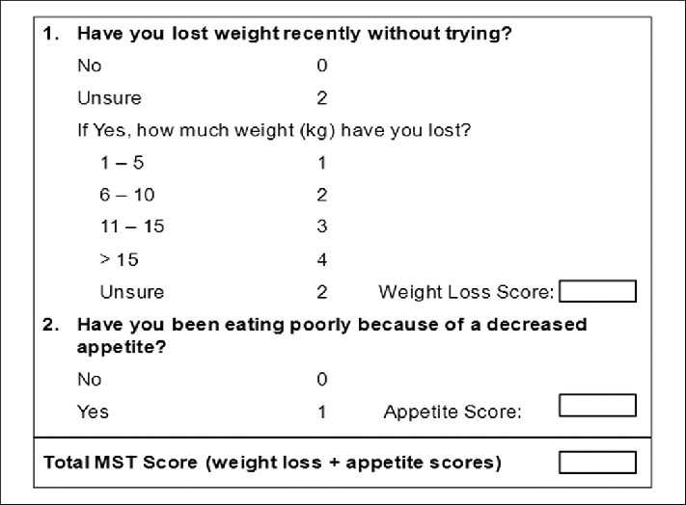

Step 1: Determine Weight Loss
- Ask patient if weight loss has occurred
- If unsure:
  - Compare current weight to previous recorded weight
  - Seek evidence of recent weight loss: loose fitting clothing/jewellery/dentures
  - Use clinical judgment in estimating degree of weight loss based on response
  - Enter a score of 2 for unsure only if the above fail to clarify.
Step 2: Determine Reduced Appetite
- Ask the patient
  - Are you eating less food at mealtimes than usual?
  - Are you eating less often in the day?
  - Do you have chewing or swallowing difficulties?
  - Clarify with care giver if required.

Step 3: Determine score
- Weight score + Appetite score = MST Score

Risk Identification
MST Score | Malnutrition Risk | Action
0 | Not at Risk | Rescreen at next SACT infusion
1 | Not at Risk | Rescreen at next SACT infusion
≥2 | At risk of Malnutrition | Follow local malnutrition risk policy

Appendix 4: MOATT© - MASCC Teaching Tool for Patients Receiving Oral Agents for Cancer

Key Assessment Questions
1 | What have you been told about this treatment plan with oral medications?  Verify that the patient knows that these oral agents are for cancer and are taken by mouth.
2 | What other medications or pills do you take by mouth?  If you have a list of medicines, go over the list with the patient.  If you do not have a list, ask the patient what medicines he/she is taking (both prescription and non-prescription), as well as herbal and dietary supplements, complementary therapies, and other treatments.
3 | Are you able to swallow pills or tablets? If no, explain.
4 | Are you able to read the drug label and provided information?
5 | Are you able to open your medicine bottles or packages?
6 | Have you taken other pills for your cancer?  Find out if there were any problems taking the medications or any adverse drug effects.
7 | Are you experiencing any symptoms, for example nausea or vomiting, that would affect your ability to keep down the pills or tablets?
8 | How will you fill your prescription?  Delays in obtaining the pills may affect when the oral drugs are started.

Special considerations when assessing patients receiving oral agents for cancer:
When teaching the patient, you may need to adapt your teaching to accommodate special considerations, such as age, a feeding tube, vision problems including colour blindness, dietary issues, or mental health problems (dementia, depression, cognitive impairments).

Patient Education
Generic education for all oral drugs
Discuss the following items with the patient and/or caretaker.
1 | Inform any other doctors, dentists, and healthcare providers that you are taking pills or tablets for your cancer.
2 | Keep the pills or tablets away from children and pets and in a childproof container.
3 | Keep the pills or tablets in the original container, unless otherwise directed. It could be dangerous to mix them with other pills.
4 | Wash your hands before and after handling the pills or tablets.
5 | Do not crush, chew, cut or disrupt your pills or tablets unless directed otherwise.
6 | Store your pills or tablets away from heat, sunlight, and moisture. These can break down the pills or tablets and make them less effective.
7 | Have a system to make sure you take your pills or tablets correctly.  Give the patient some ideas, such as using a timer, clock, or calendar.
8 | Make sure you have directions about what to do if you miss a dose.
9 | If you accidentally take too many pills, or if someone else takes your pills or tablets, contact your doctor or nurse immediately.
10 | Ask your nurse or pharmacist what you should do with any pills or tablets you have not taken or any that have passed their “use by” date.  The patient can be asked to bring unused pills or tablets back to the next visit.
11 | Carry with you a list of medicines that you are taking, including your cancer pills or tablets.
12 | Let us know if you have a problem with getting your pills or paying for them.
13 | Be sure to get your refills ahead of time, and plan for travel and weekends.

Drug-Specific Education
Whichever tool is used to educate the patient, include the following drug-specific information. You can complete the form provided below and give it to the patient using reference material you have on the specific pills or tablets.
1 | Drug name (generic and trade)
2 | What the drug looks like
3 | Dose and schedule:  How many different pills?  How many times a day?  For how long?
4 | Where to store the pills or tablet  Be specific, for example, away from heat (not in the kitchen), humidity (not in the bathroom), and sun (not on the window sill).
5 | Potential side effects and how to manage them  Include lab evaluations or any medical tests that will be used for drug monitoring.
6 | Any precautions that should be discussed
7 | Any drug or food interactions
8 | When and whom to call with questions  Give names and phone numbers here.

Evaluation Date: .…/.…./…….
Ask the patient and/or caregiver to answer the following questions to ensure that they understand the information you have given them.
1 | You have received a lot of information today.  Let’s review key points.
2 | What is/are the name(s) of your cancer pills or tablets?
3 | When will you take your cancer pills or tablets?
4 | Does it matter if you take your pills or tablets with food or not?
5 | Where do you plan to keep your pills or tablets?
6 | When should you call the doctor or nurse?
7 | Do you have any other questions?
8 | When is your next appointment?
9 | For problems, contact:

This assessment can also be used for a patient commencing oral anti-cancer agents
See appendix 1 ECOG status
Roper, Logan and Tierney Model of Nursing
Please see appendix 2: Oral Assessment Guide (OAG) Eilers et al 1988
Adapted from the National Comprehensive Cancer Network (NCCN) Clinical Practice Guidelines in Oncology (NCCN Guidelines®) for Distress Management, Distress Thermometer V 2. 2018
Ferguson et al. Development of a valid and reliable malnutrition screening tool for adult acute hospital patients. Nutrition. 1999 Jun;15(6):458-64.
“Permission to use the MASCC Oral Agent Teaching Tool (MOATT) granted by the Multinational Association of Supportive Care in Cancer (MASCC).”

