NCCP National Systemic Anti-Cancer Therapy (SACT) Competency Programme for Nurses Working in Cancer Care
Aim
The aim of the ‘NCCP National Systemic Anti-Cancer Therapy (SACT) Competency Programme for Nurses Working in Cancer Care’ is to standardise the education and assessment of SACT administration and patient care, ensuring consistently safe and high-quality SACT practice. Upon completion of the programme, registered SACT administrators are then free to move between employers within Ireland and the UK without the need for retraining. This programme is not designed to provide guidance about assessing clinical competence of either administering SACT to children, or using non-systemic anti-cancer drug treatment, e.g. localised/topical anti-cancer therapy such as intrathecal, intravesical, inhalation, isolated limb perfusion, intraperitoneal and topical chemotherapy.
Programme Overview
The National SACT Competency Programme is a continuous professional development programme with Category 1 approval from NMBI, equating to 16 CEU’s. There are four steps to competency attainment:
- Attending the 2 day training programme to cover theoretical learning (virtually, in the classroom or blended learning is offered in some centres).
- Completion of the theoretical sections of the UKONS SACT Competency Passport with an approved SACT assessor.
- Completion of the clinical practice competency sections of the United Kingdom Oncology Nursing Society (UKONS) SACT Competency Passport with an approved SACT assessor.
- Completion of the UKONS SACT Safe Handling and Administration Certificate and then annual completion of the Re-accreditation Competency Certificate to ensure the nurse remains a competent SACT administrator.

Prerequisite Requirements:
Nurses must be registered with NMBI and be on the live register for 12 months or more and
- Be working in cancer care for a minimum of 3 months.
- Be working in a publically funded SACT Hospital or service
- Complete the application form online through HSELand following discussion with the relevant manager with commitment to full attendance.
- Have explored NCCP guidance documents and resources, local PPPG’s as well as other recommended reading outlined in Appendix 1.
- Have achieved competence in intravenous (IV) administration of medicines by successfully completing an IV Study Day at local level.
- Have gained perquisite competence related to medicines management, including calculations for medicine administration in accordance with local policy and have successfully completed Medicines Management on HSeLanD.
- Have achieved competence in the care and management of central venous access devices (CVAD’s) by successfully completing relevant training and certification at local level.
- Have achieved competence in peripheral venous cannulation and venepuncture by successfully completing relevant training and certification at local level.
- Have gained perquisite competence in the management of anaphylaxis by successfully completing the National Anaphylaxis Education Programme for Healthcare Professionals on HSeLanD.
- Have successfully completed Chemical Safety in the Workplace (Introduction) on HSeLanD.
- Have successfully completed the National Intrathecal Chemotherapy e-learning tool on HSeLanD.
Duration
Nurses must attend a two day (16 hrs) theoretical programme, delivered virtually, in the classroom or a combination of both, depending on the centre running the programme. It is recommended that day 2 be attended in person as there is a practical workshop. Day 1 and 2 will be a week apart to allow participants to consolidate learning. It will be supplemented by work based learning, reflection on practice and additional self-directed learning. Participants from Type 3 or Type 4 SACT hospitals/services will be offered a 1 day clinical placement in the ambulatory day unit of the programme provider.
Nurses then have up to 8 months to successfully complete their UKONS SACT Competency Passport with an approved assessor.
Where can I attend this programme?
This national programme is provided on a monthly basis by the Centre’s of Nursing and Midwifery Education, Centre’s of Learning and Development, Centre’s for Nurse Education, Centre’s for Learning and Development in all of the publically funded Type 1 and 2 SACT service hospitals. Each centre will deliver the programme once annually. Cancer nurses from the publically funded Type 3 and 4 SACT services, or any of the publically funded SACT hospitals have equal opportunity to feed into the programme being delivered at any location nationally.

How do I register for this programme?
Registration is through HSeLanD. https://www.hseland.ie/dash/Account/Login
In the search bar: What courses are you interested in? Search for SACT.
Publically Funded SACT Hospitals
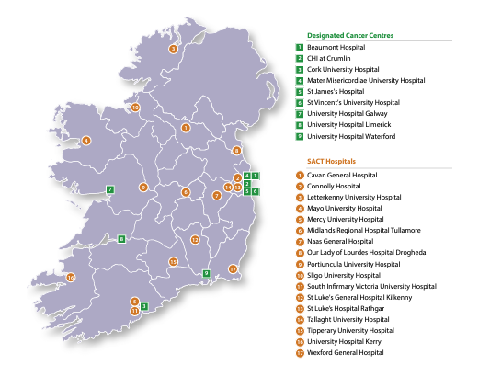
Organisation of SACT Services Per Type
Type 1 SACT Service | Type 2 SACT Service | Type 3 SACT Service | Type 4 SACT Service
Beaumont Hospital | Tallaght University Hospital | University Hospital Kerry | Community infusion clinics
Cork University Hospital | Sligo University Hospital | Portiuncula University Hospital | Primary care centres
University Hospital, Limerick | Letterkenny University Hospital | St Luke’s Hospital Rathgar | GPs
University Hospital Waterford | Midlands Regional Hospital, Tullamore | Mayo University Hospital | Home
St James's Hospital | Mercy University Hospital, Cork | Tipperary University Hospital
Mater Misericordiae University Hospital |  | Cavan General Hospital
St Vincent's University Hospital |  | St Luke's General Hospital, Kilkenny
University Hospital Galway |  | Wexford General Hospital
 |  | Naas General Hospital
 |  | Connolly Hospital
 |  | Our Lady of Lourdes Hospital, Drogheda
 |  | South Infirmary Victoria University Hospital

