National policy for Children’s Disability Network Teams on family engagement and attendance

Document reference number | CDNT 02 | Document developed by | Family engagement working group
Revision number | Version 1 | Document approved by | Head of Operations Disability Services
Approval date | 11.5.21 | Responsibility for implementation | Children’s Disability Network Managers
Revision date | May 2022 | Responsibility for review and audit | HSE Community Operations – Disability Services

Table of contents
- Policy statement 3
Family centred practice 3
Role of communication 5
International research 7
- Purpose of policy 8
- Scope of policy 8
- Legislation and related policies 8
- Glossary of terms and definitions 9
- Roles and responsibilities 10
- Procedure 11
Engaging families checklist 12
- Implementation plan 17
- Review and audit 17
- Appendices
Appendix 1 Information leaflet for families 18
Appendix 2 Procedural flow charts 20
Appendix 3 Standard letters 22

1.0 Policy Statement
The Children’s Disability Network Team (CDNT) model of service aims to empower families to support their child’s developmental needs. Families will be informed of what they can expect from the CDNT and also what the CDNT expects from them.
It is acknowledged that at times circumstances may make it difficult for some families to engage fully with the planned services and supports for their child. CDNTs will try to support families as best they can within the resources available. This may include appointments in the centre, home, school or community and using in person, telephone, video call or online support.
However, where the team has concerns that there is a consistent pattern of missed appointments, non-engagement with services, and /or refusal of an intervention which may impact on the child’s health, well-being and developmental progress, then this policy will apply.
The team also needs to ensure their time is maximised for the benefit of all children who access the team and those who are waiting to access the team.

Family Centred Practice
Family centred practice is a core and fundamental principle of the CDNT model of service. It is an empowering approach which focuses on the whole family and not just the child requiring support.

It is underpinned by the following concepts:

- Families and services listen to the child, taking into account the child’s age and maturity, and strive to achieve the best possible outcomes for that child or young person
- Families are, in the main, fully capable of making informed choices and acting on their choices. Parent/carers have the ultimate responsibility for the care of their children and for all decisions made about them
- Services exist to support children and families to attain the best possible outcomes
- Interventions are appropriate to the needs of the child and family, and emphasise capacity-building, strengthening existing skill sets, promoting the acquisition of new skills, medical care and other supports
- Children, families and service providers all benefit most when services are based on true collaborative partnerships between families and professionals
Family centred practice ensures that supports provided are determined from the family’s priorities identified through the Individual Family Service Plan process.
It recognises that each family has its own role, values, structures, beliefs and coping styles. It is important to appropriately assess the varieties of stressors that can adversely affect family patterns of interaction and use that information to strengthen families. This may require the selection and implementation of social supports, resource supports, information and services. Individualised plans that are sensitive to family and child issues assist in maximising participation of families.

The ongoing move from a professionally centred to family centred approach is a very significant change for professionals and for families.
Professionally Centred - the professional is the expert determining the priorities for the child and family, and is the key decision maker.
Family Centred – the professional and family are equal partners. Intervention is flexible, responsive to the family’s needs and priorities. Families are the key decision makers.
Example of what can be done to be more family centred regarding appointments
Families- Inform CDNT of your preferences for meeting times and location
CDNT- Try to offer families a choice of in person or online and times to meet. Ask what works best for them.

The Role of Communication in the Team’s Engagement with Families
(Taken from the National Team Development Programme on Family Centred Practice)
Encouraging communication
- Develop a climate that fosters communication. Families are encouraged to give their opinion/ feedback
- Tailor the communication environment to family’s needs. Provide information that is universally understood.
- Use and monitor basic communication skills. Regularly seek feedback from families on their experiences of communicating with the team.
What can cause a communication breakdown?
- A lack of purpose and no clear goals.
- A lack of understanding and expectations not aligned.
- Pre-existing perceptions and negative perceptions due to past experiences.
- Language barriers and not adapting to diverse needs.
- A lack of consistency in terms of message or frequency.
- A lack of skill for which CDNT members may need training.
What can the team do to promote effective communication?
- Create opportunities and allow time for families to digest the information.
- Be honest, share complete and unbiased information.
- Show respect and describe families in a respectful manner.
- Be open and avoid developing bias.
- Be inclusive.
- Use “person first” language, speak about the person, not the diagnosis.
Start as you mean to go on
The National Policy on Prioritisation of Referrals to Children’s Disability Network Teams states:
From the time of receipt of a referral, the service has a duty of care towards the child. If the child is placed on a waiting list for services their situation and needs must be monitored every six months, for instance by a key worker making contact with the family.
It is essential that engagement with families starts immediately a referral is received, in order to have a sound basis for developing a positive relationship. Families should receive prompt accurate information about the process of referral and any waiting list that may be in place. The CDNT should offer families all possible supports while they wait for their child to commence services:
- Information about the service (leaflets, introductory meetings, online webinars etc.)

- Universal supports through group meetings, in person or online e.g. behaviour management; post diagnosis support; preparing for school; sleep; toileting. The purpose and function of these waitlist initiatives will be clearly explained to families when they are offered. Families will be given the option to attend or not according to whether they consider the topic is appropriate for their child’s needs.

- Lists of useful online resources by topic (e.g. videos on specific aspects of child development, activities for children) that families can access, as they consider appropriate for their child’s individual needs.

International Research
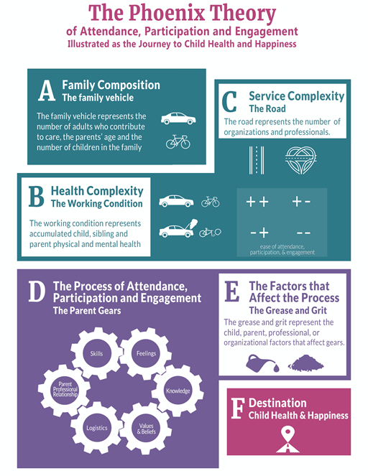
This theory views parent gears as a metaphor for factors that can impact on the process of attendance, participation and engagement. The successful ‘functioning’ of each gear will be characterised by good attendance, participation and engagement. ‘Every gear has the potential to help families move through therapy or limit their movement’. This policy and procedure and the Engaging Families Checklist (see Page 11) has been informed by this research.
2.0 Purpose of policy
This policy outlines steps the CNDT has in place to promote engagement and participation of families with the service. The procedures set out in this policy are to assist teams in responding to families who fail to attend appointments.
- To support families by facilitating attendance and helping to coordinate appointments
- To ensure effective communication and sharing of information between professionals when children are not brought.
- To make sure children’s health and well-being are paramount.
3.0 Scope of policy
This policy applies to all Children’s Disability Network Teams (CDNTs).
4.0 Legislation/other related policies
- Children First Act 2015 http://www.irishstatutebook.ie/eli/2015/act/36/enacted/en/pdf
- National Consent Policy HSE 2017 https://www.hse.ie/eng/about/who/qid/other-quality-improvement-programmes/consent/
- Disability Act 2005 http://www.irishstatutebook.ie/eli/2005/act/14/enacted/en/html
- Assessment of Need Standard Operating Procedure Version 2 (24/10/2019)

The following can all be found at https://www.hse.ie/eng/services/list/4/disability/progressing-disability/pds-programme/documents/
- National Policy on Access to Services for Children and Young People with Disability and Developmental Delay 2019
- National Policy on Prioritisation of Referrals to Children’s Disability Network Teams 2016
- National Policy on Discharge and Transfer from Children’s Disability Network Teams 2017
- Policy Framework for Service Delivery of Children’s Disability Network Teams
- Self-audit tool for Children’s Disability Network Teams

Child Safeguarding
Children First National Guidance for the Protection and Welfare of Children 2017 places the legal responsibility of mandated reporting of any child protection concerns on all health care professionals within CDNTs. Therefore if the level of non-engagement by a family reaches a threshold whereby their “child’s health, development or welfare has been, is being or is likely to be seriously affected” they are legally obliged to report these concerns to Tusla, the Child and Family Agency.
Neglect
Neglect is acknowledged as one of the four main types of abuse children can experience. Neglect is the most frequently reported category of abuse and, when it is ongoing or chronic in nature, it is recognised as being extremely harmful to the development and wellbeing of the child and may have serious long-term negative consequences. In the context of this policy, one of the features of neglect is “Failure to provide adequate care for the child’s medical and developmental needs, including intellectual stimulation”. It is generally defined in terms of an omission of care where a child’s health, development or welfare is impaired by being deprived of essentials, needs or interventions.
5.0 Glossary of Terms and Definitions
Children’s Disability Network Team (CDNT) A team of health and social care professionals (HSE and non-statutory S.38 and S.39 agencies) who provide services and supports for children aged from birth to 18 years who have complex needs and live within a defined catchment area.
Children’s Disability Network Manager (CDNM) The manager of the CDNT in a Children’s Disability Network.
Telepractice The use of technology to deliver services and supports at a distance. Methods of delivering telepractice may include but are not limited to email, telephone, video conferencing and pre-recorded materials.
Appointments can include but are not limited to:
  - Assessment
- Intervention, both individual and group based, for the child and for their family
- Meetings with the family and others involved
Appointments may be in or at: - the CDNT’s centre, the child’s school/preschool, home or another agreed venue, or via telepractice.
Missed Appointments include:
- Missed appointments for any discipline, interventions or supports offered.
- A pattern of cancelled appointments.
- A pattern of significantly late arrivals (arrival 15mins after the appointed time is considered significantly late).
Consecutive missed appointment is one immediately following another missed appointment.
Sporadic attendance Where a family attends for some appointments but has a history of irregular attendance i.e. regularly miss appointments, give late notice for cancellations and/or are significantly late attending for appointments.
Family A family in this policy refers to parents and others who are principal carers of the child or young person, including extended family and foster carers.
Child or Children In this policy ‘child’ or ‘children’ refers to babies, children and young people who are accessing the services of a CDNT.

6.0 Roles and Responsibilities
6.1 Children’s Disability Network Managers (CDNMs)
CDNMs hold the following responsibilities relevant to the implementation of this policy:
- Ensure that all staff are made aware of the policy and receive appropriate training.
- Ensure that the policy is implemented.
- Encourage family centred practice at all times.
- Ensure all families are treated fairly and appropriately according to their individual circumstances.
- Identify, manage and deploy resources for the maximum benefit of all children and their families.
6.2. Children’s Disability Network Teams (CDNTs)
CDNT staff hold the following responsibilities:
- To comply with the policy.
- To work with a family centred approach.
- To evaluate the policy - to identify issues and operational difficulties in the application of the policy and liaise with their CDNM.
- To coordinate appointments to minimise demands on families.
- To communicate clearly with families regarding the reason an appointment is being offered and to facilitate attendance.
- To validate the family's contact details and issue appointment letters and/or text messages.
- To inform families of the family engagement and attendance policy.
6.3 Family
It is the responsibility of each family accessing a CDNT service:
- To inform the team if they are unable to attend for their appointment 24 hours prior to appointment. In the case of an emergency arising they should notify the team as soon as possible.
- To inform the team of any change of address or contact details.

7.0 Procedure for supporting families to engage with the service
Where possible, and within the resources available, appointments and recommendations to support the child’s developmental needs will be agreed with the family and reviewed regularly to facilitate the child’s and the family’s individual circumstances. Appointment letters/phone calls should explain the reason for the appointment, referencing the relevant goal agreed with the family from the child’s Individual Family Service Plan (IFSP).
If appointments are missed the CDNT will use the following Engaging Families Checklist to work collaboratively with each family, identify the barriers and facilitate participation. This tool was developed based on the Phoenix Theory of Attendance, Participation and Engagement (see P.6).
The team should be updated as appropriate with information gained from this conversation with the family. The completed form must be included in the child’s records.
Recording attendance
Recording of attendance whether in electronic or in hard copy records must be accurate and timely. The nature of the appointment must be identified and, where known, the reason given by the family for not attending.
If a history of non-attendance is drawn from records, the completed Engaging Families Checklist and the appropriateness of the supports they have been offered must be fully considered before any correspondence is issued. Any inaccuracy consequently identified in the records must be corrected.
The purpose of this checklist is to guide the conversation with a family in exploring challenges for attendance. It should be adapted as appropriate for the family.
Preparation for the call | Have we a full Social Work assessment and understanding of family makeup?  Do we know about other significant current stressors in this family's life?  Do we know what supports the family has access to, for example extended family, community groups?  Are there complicating medical or health issues for the child or for the family?  Have we informed the family of our engagement policy?  Are there literacy or language barriers for the family?  Do family members have any other relevant difficulties such as a hearing or visual impairment?  Is there a pattern to missed appointments? Do they occur at particular times? Are the missed appointments typically for universal strategies?  Notes
Telephone call | Introduction  “I’m calling because you have missed some appointments. As you will know from our policy on managing attendance, we like to link in with families and find out if there is anything we can do to help.”  The reply to this opening may guide the next questions you ask. The following areas and potential questions may help you to explore with the family any issues they have with attendance.
Family Centred Service | Are your child’s IFSP and goals still relevant and appropriate?  Have we explained to you the reason for appointments and how they fit with your priorities and your child’s goals?  Are we giving you enough notice of appointments?  What is the best way to let you know about appointments - text, phone call, email or letter?  Are the times and locations for appointments suitable?  Notes
Family | Is there anything we should know about for your family right now which is making attendance difficult?  Do you feel that you and your family are well supported, such as by your wider family, friends, community connections?  Notes
Family Health & Wellbeing | Are there any new health or wellbeing issues impacting your child and family?  Notes
Practical Barriers | Do you have any childcare issues?  Have you any transport difficulties?  Are there other services which are also making demands on your time and availability?  Notes
Additional Comments | Any other information or comments?

7.1 Procedure for managing consecutive missed appointments (Appendix 2 Flow Chart A)
7.1.1 Following the first missed appointment, a text message is sent with a second appointment. For example: ‘You missed your appointment on…..with…. Your new appointment with…... is….’ Record in child’s central file as the first missed appointment and text message sent.
7.1.2 Second consecutive missed appointment – a CDNT member will make every attempt to communicate with the family by phone call to determine the issues in relation to missed appointments (team member will use the Engaging Families Checklist and the IFSP to guide this conversation). A third appointment will then be offered, if appropriate. If the team are unable to contact by phone, a letter will be sent. (See Letter A, Appendix 3) Record in child’s central file.
7.1.3 Third consecutive appointment is missed and no follow up contact is made by the family, they are sent a standard letter (see Letter B, Appendix 3) by the CDNM, who advises them to contact the service within 2 weeks if they wish to receive a further appointment.
7.1.4 If the family does not respond to Letter B, a decision will be made to discharge the child. A letter informing the family and the GP of the child’s discharge will be sent by the CDNM (see Letter D, Appendix 3). A copy of the letter should be forwarded to the referrer in the case of a new referral.
7.1.5 If, following Letter B, the family makes contact with the team, and requests a further (fourth) appointment and then the child is not brought to this appointment, a decision will be made to discharge the child. A letter informing family and the GP of the child’s discharge will be sent by the CDNM (see Letter D, Appendix 3). A copy of the letter will be forwarded to the referrer in the case of a new referral.
7.1.6 If the family advises the team they do not want another appointment so are withdrawing from the service, a letter informing the family and the GP of the child’s discharge will be sent by the CDNM (see Letter E, Appendix 3).
7.1.7 If there are concerns at any point in relation to the welfare of the child, a referral will be made to Tusla, the Child and Family Agency, and the family informed in accordance with Children’s First National Guidance 2017.

7.2 Procedure for managing sporadic attendance (Appendix 2 Flow Chart B)
7.2.1 If a pattern of sporadic attendance (see definition) is identified, a member of the CDNT will make a telephone call or meet with the family. The CDNT member will use the Engaging Families Checklist and the child’s IFSP, to guide the conversation. The purpose is to develop a plan to promote positive engagement with the family (e.g. this could take the form of active engagement with the service or a pause in service with identified reason). The completed Engaging Families Checklist will be kept on the child’s file. The CDNT member will also use this opportunity to reiterate the Family Engagement and Attendance Policy.
7.2.2 If a pattern of sporadic attendance (see definition) re-emerges, the CDNT member will inform the CDNM. The CDNM will issue a standard letter (Letter C, Appendix 3) requesting the family to make contact with the service within two weeks.
7.2.3 If the family does not make contact with the CDNT, the team will assume that the family wishes the child to be discharged from the CDNT and Letter D Appendix 3 will be sent to the family, GP and relevant professionals involved in the care of the child. Where appropriate,
7.2.4 If the family does not wish to continue with a service from the CDNT, a letter informing the family and the GP of the child’s discharge will be sent by the CDNM (see Letter E., Appendix 3).
7.2.5 If there are concerns at any point in relation to the welfare of the child, a referral will be made to Tusla the Child and Family Agency and the family informed, in accordance with Children First National Guidance 2017.

7.3 Attendance for a statutory Assessment of Need
The Assessment of Need Standard Operating Procedure 2019 section 7.3.2d states that services should use their own policy for handling non-attendance. Therefore this present policy for CDNTs applies for managing attendance for an Assessment of Need.
In addition to the procedure in this policy on managing attendance, if a child is not brought for any appointment linked to their Assessment of Need, the Assessment Officer will be informed as this may impact on the timelines for completion of the AON.

8.0 Implementation Plan
This policy will be implemented in all CHOs in conjunction with the National Policy on Access to Services for Children and Young People with Disability and Developmental Delay, the National Policy on Prioritisation of Referrals to Children’s Disability Network Teams and the National Policy on Discharge and Transfer from Children’s Disability Network Teams.
9.0 Revision and Audit
The operation of this policy will be reviewed and evaluated at national and at CHO level for effectiveness and consistency within one year of commencement of implementation and thereafter at a minimum of every two years.
10.0 Appendices
Appendix 1 Information Leaflet for families about the family engagement and attendance policy
Appendix 2 Procedural flow charts
Appendix 3 Standard letters

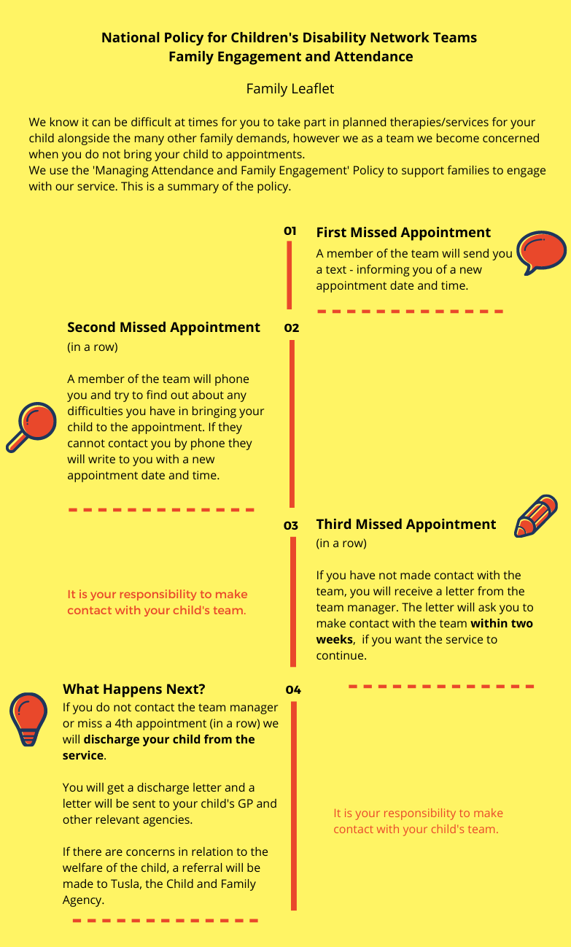
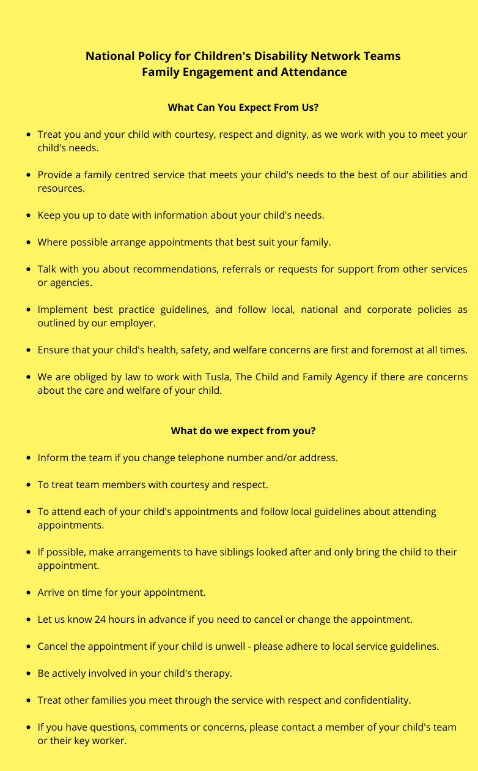
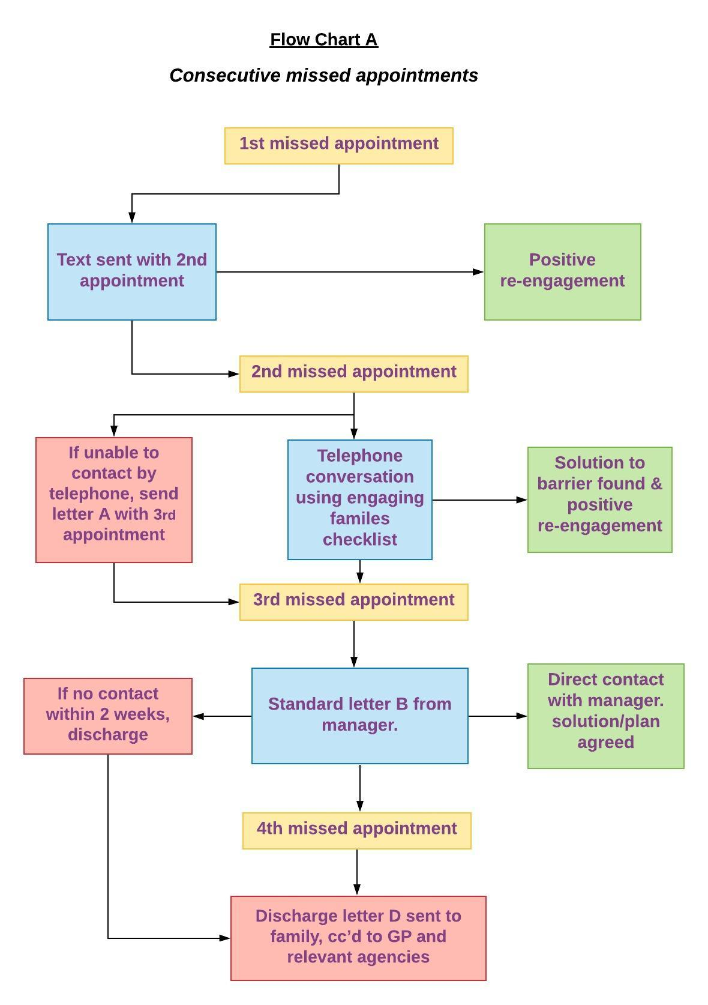
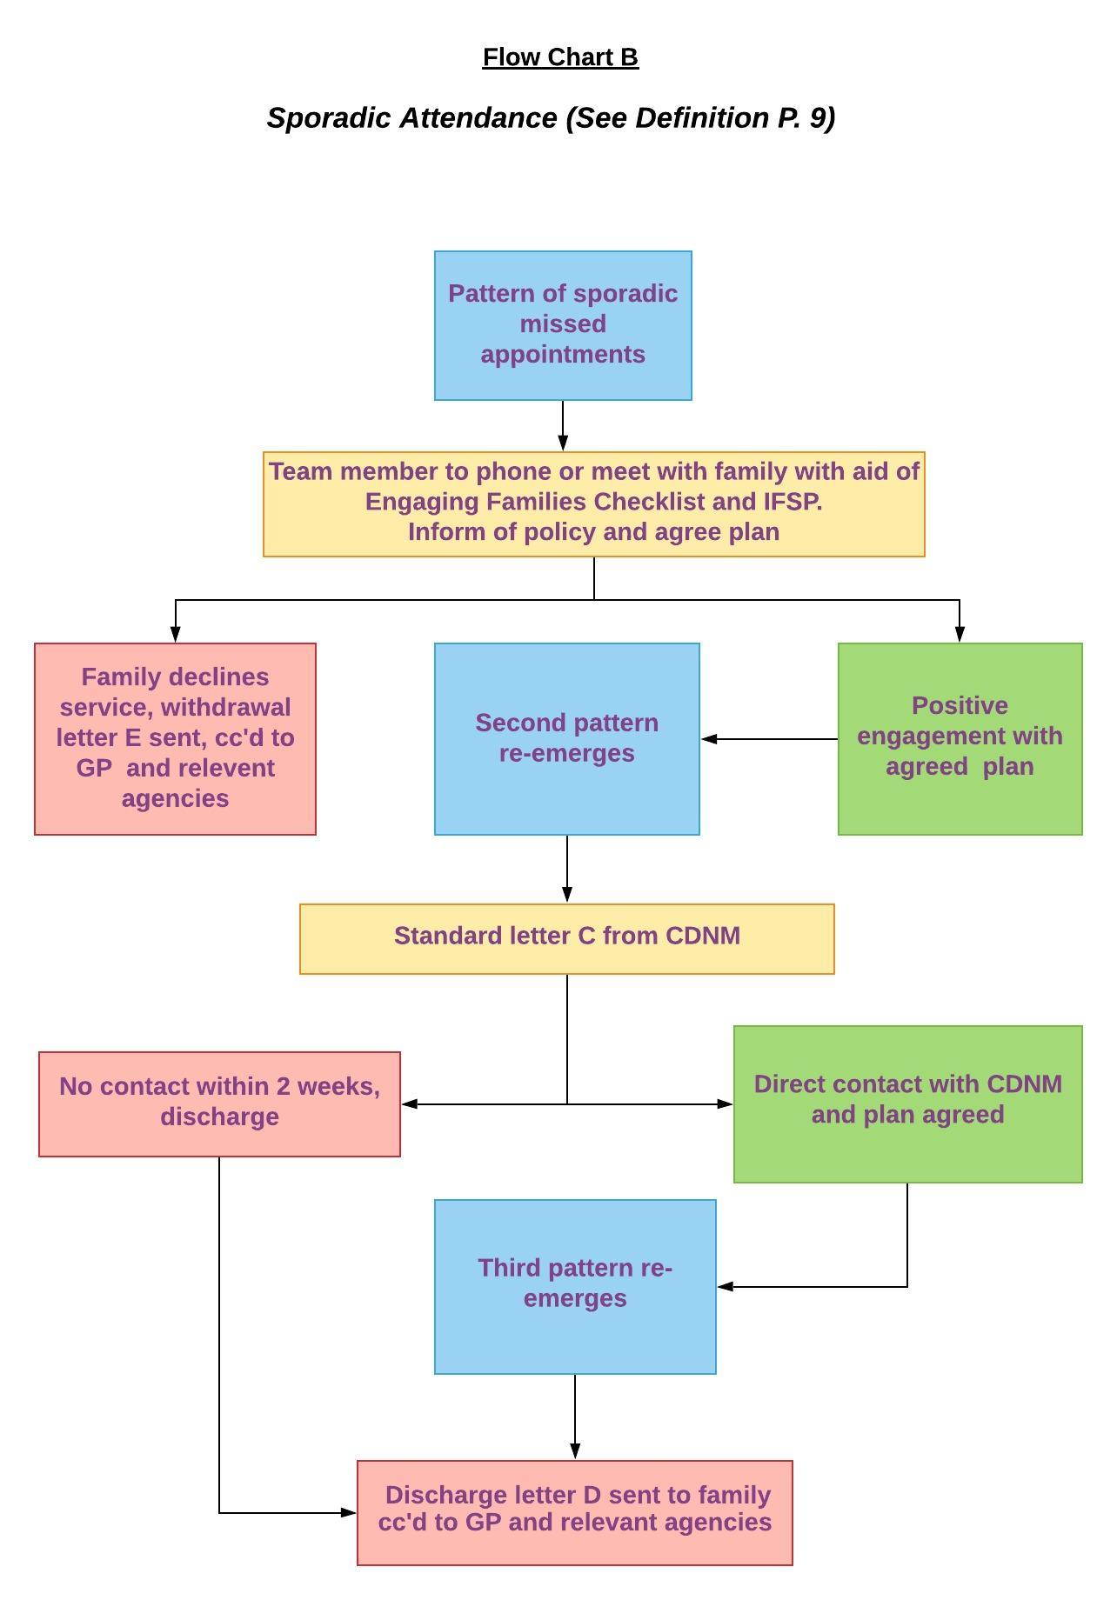Appendix 3 Standard Letters
Letter A – Second consecutive missed appointment
Letter B – Third consecutive missed appointment – family asked to contact
Letter C – Sporadic attendance – family asked to contact
Letter D – Discharge following no contact, fourth missed appointment or third pattern of sporadic non-attendance
Letter E – Discharge following family’s wish to withdraw from service

Standard letters should always be reviewed before being sent, to make sure they are appropriate and relevant for the individual situation.

LETTER A (Second consecutive missed appointment)
Name: Date:
Address:

Dear ________
Re.: (Child’s Name) D.o.B.: xx/xx/xxxx
We are concerned that your child is missing out on the supports that they need.
You missed an appointment for your child for ______ on _____ . This is the second appointment in a row that you have missed. We tried to contact you by phone to make another appointment.
We are offering you another appointment as follows:
Date: ___________ Time: __________
Venue: __________
Please contact us if you would like to change this.
When appointments are not attended, the National Policy for Children’s Disability Network Teams on Family Engagement and Attendance and is followed and your child may be discharged from the service.
I enclose a leaflet about our attendance policy.
Yours sincerely
_____________________
Copy: Child’s file
Cc:_____________

LETTER B (Third consecutive missed appointment)
Name: Date:
Address:

Dear _______,
Re.: (Child’s Name) D.o.B.: xx/xx/xxxx
We are concerned that your child is missing out on the supports that they need.
You missed an appointment for your child for ______ on _____ . This is the third appointment in a row that you have missed.
When appointments are not attended, the National Policy for Children’s Disability Network Teams on Family Engagement and Attendance is followed and your child may be discharged from the service. If there are concerns regarding your child’s welfare because of these missed appointments, we are obliged to advise Tusla the Child and Family Agency.
I enclose a leaflet about our attendance policy.
Please contact the team within 2 weeks to make another appointment, review plans or to discuss any difficulties you may have in relation to attending appointments. If you do not contact us within 2 weeks, your child will be discharged from this service.
Yours Sincerely,
__________________________________________
Children’s Disability Network Manager
Encl: Family Information Leaflet
Copy: Child’s file
Cc:_____________

LETTER C (Sporadic Attendance)
Name: Date:
Address
Dear _______,
Re.: (Child’s Name) D.o.B.: xx/xx/xxxx
You missed an appointment for your child for ______ on _____ . Your child’s team is concerned that there have been a number of appointments that you have not attended or cancelled.
We are concerned your child may be missing out on the supports that they need. Please contact us to discuss any difficulties you may have such as the timing of the appointments or transport issues.
When appointments are not attended, the National Policy for Children’s Disability Network Teams on Family Engagement and Attendance is followed and your child may be discharged from the service. If there are concerns regarding your child’s welfare because of these missed appointments, we are obliged to advise Tusla the Child and Family Agency.
I enclose a leaflet about our attendance policy.
Please contact us within the next two weeks to make another appointment, review plans or discuss any difficulties you have attending appointments.
Yours sincerely,
___________________
Children’s Disability Network Manager
Encl: Family Information Leaflet
Copy: Child’s file
Cc:_____________

LETTER D (Discharge letter)
Name: Date:
Address:

Dear _______,
Re.: (Child’s Name) D.o.B.: xx/xx/xxxx
We note that you have not made contact with us following our letters to you about missed appointments.
We are therefore assuming that you no longer require services from the Children’s Disability Network Team and ______ (child’s name) is being discharged from the service.
This letter is being copied to _______ (the original referral source/relevant services) and your GP for information purposes.
If there are concerns regarding your child’s welfare because of these missed appointments we are obliged to advise Tusla, the Child and Family Agency.
Your child can be referred to our service again in the future if your circumstances change.
Yours sincerely,
________________________________
Children’s Disability Network Manager
Copy: Child’s file
Cc:_____________

LETTER E (Family withdrawing from service)
Name: Date:
Address

Dear ________,
Re.: (Child’s Name) D.o.B.: xx/xx/xxxx

Following a number of missed appointments, a member of the team had a conversation with you on ______ (date).
We understand from this that you no longer wish ______ (child’s name) to access services with the Team.
______ (child’s name) has been discharged from the service. We will inform the referrer/relevant services of this discharge. If there are concerns regarding your child’s welfare we are obliged to advise Tusla, the Child and Family Agency.
If you have concerns in the future, your child can be referred to the team again.

Yours sincerely,
________________________
Children’s Disability Network Manager
Copy: Child’s file
Cc:_____________

See Progressing Towards Outcomes Focussed Family Centred Practice: An Operational Framework. HSE. 2020
Outcomes for Children and Their Families. Report on an Outcomes-Focused Performance Management and Accountability Framework for Early Intervention and School Age Disability Network Teams. HSE. 2013
10 Things You Can Do to Be Family-Centred. CanChild Center for Childhood Disability Research. Law, M., Rosenbaum, P., King, G., King, S., Burke-Gaffney, J., Moning-Szkut, T., Kertoy, M., Pollock, N., Viscardis, L., & Teplicky, R., 2003
National Policy on Prioritisation of Referrals to Children’s Disability Network Teams. HSE.2016
Phoenix, M., Jack, S.M., Rosenbaum, P.L. & Missiuna, C. (2019). Parents’ attendance, participation and engagement in children’s developmental rehabilitation services: part 1. Contextualizing the journal to child health and happiness. Disability and Rehabilitation (23, 1-10).
Children First: National Guidance for the Protection and Welfare of Children. Department of Children and Youth Affairs. 2017
ibid

