National Guidance for Children’s Disability Network Teams on Individual Family Support Plans

Document reference number | CDNT 03 | Document developed by | IFSP Guidance Working Group
Revision number | Version 3 | Document approved by | Head of Operations Disability Services
Approval date | 22.6.23 | Responsibility for implementation | Children’s Disability Network Managers
Revision date | June 2025 | Responsibility for review | HSE Community Operations – Disability Services

Contents

1. Context – Family centred practice | 2
2. Individual Family Supports Plan | 2
3. Elements of a plan | 5
4. Appendices  - Team checklist on IFSPs  - Sample forms to assist children and families  - Reflection on sample goals  - Useful resources | 9  11  22  25

1. Context - Family centred practice
All children develop and learn by taking part in daily life and activities. The child’s family and those who are with them every day are the most important people in their lives. Life happens every day at home, pre-school, school and with friends, not in a clinic. The purpose of a children’s disability team is to contribute their expertise to supporting children with disability and complex needs in everyday life.

Family-centred practices are defined as practices that listen to families. They provide family members with information to help them make decisions and choices. They include active family involvement in identifying goals and in accessing resources and supports, as well as the team being responsive and flexible towards each family’s aims and needs.

Family centred practice is a fundamental principle of the Children’s Disability Network Team (CDNT) model of service. An Individual Family Support Plan (IFSP) is the cornerstone of family centred practice.

2. Individual Family Support Plan

2.1 An IFSP is a plan made by the child (as appropriate to their age), their family and the CDNT in partnership. The plan brings together the child’s and family’s needs, priorities and desired outcomes with the team’s knowledge and expertise, in order to agree what they will focus on next. Everyone then knows who is doing what, where and when.

One of the core objectives in developing the plan is for members of the team to actively listen to the child and their family, gather information, develop an understanding of their values and culture and how the team can support them in a meaningful way. The plan can be updated at any time to reflect changes in priorities and goals, supports and strategies.
2.2 Children and young people as appropriate to their age and understanding should be included in all aspects of making their plan.

2.3 The plan does not necessarily require a formal meeting between the family and the whole team. It can be developed and revised by the family and one or two team members during a centre appointment, home visit, online meeting or phone conversation.

2.4 The plan should take account of:-
- The child’s or young person’s strengths as well as their difficulties
- The child’s or young person’s concerns and priorities
- The family’s concerns and priorities
- The family’s strengths and challenges
- The advice of the team based on their knowledge and expertise
- Goals agreed
- How the child, the family, the team and others will work towards these goals
- How achievement of the goals will be measured
- Timeframe for achievement of goals

2.5 In advance of developing a plan, the child or young person and their family are given information about the purpose and process, how the plan guides all supports offered and the importance of letting the team know about changes of priorities and goals over time. A leaflet for families is being developed with parent representatives and will be edited by NALA.

2.6 A plan with initial goals should be formed as soon as possible after services commence with the child and family. It remains live from that point on and amended as needed, such as when goals are achieved or priorities change. It is made available to the family in print or electronic form, whichever they prefer.

2.7 The number of children attending a CDNT who have a current IFSP is returned in national metrics. A plan is deemed to be current when it has had input within the past 12 months. This means that the plan is live, it has been revisited by family and team as needed and is the basis for interventions. It does not mean that a formal review meeting and new IFSP are required annually.

2.8 The Children’s Disability Network Team Information Management System (CDNTIMS) is an electronic healthcare record system being rolled out in a national programme, with all CDNTs estimated to have the system in place by the end of 2023. The system supports the planning process by orientating the team towards linking services to goals and includes the IFSP form template, which all teams will use.

2.9 The role of the family’s key contact is to provide specific support around the plan:
• Check in regularly with the family about the plan & current goals.
• Ensure the plan is updated as necessary
• Liaise with other team members as required to revisit the plan and goals

2.10 The CDNM should ensure there is a regular quality check by the team of a random sample of plans. This should be completed by the team together, jointly reflecting on their practice and identifying areas for improvement. (See checklist in appendices)

3. Elements of a plan
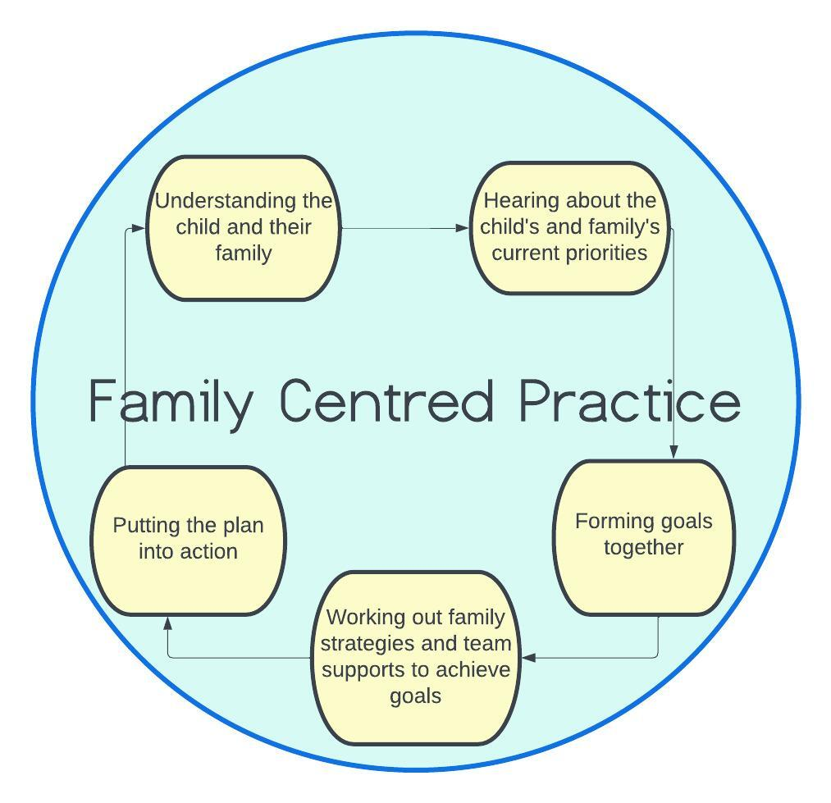

3.1 Understanding the child and family
The team actively listens to the child and family, gathers information and gains an understanding of their strengths, challenges and needs. They learn about the child and family, what’s happening in their everyday lives and what they would like help with. This also provides information to establish the baseline for a goal. (See Reflection on sample goals with baselines in the appendices.)

3.2 Priorities
These are the areas which the child and their family see as most important to them currently. For instance, it could be helping the child to participate in community activities, preparing to start school or move to secondary school.

The team brings their expertise and experience to inform and support the family.
Going through a typical day with children and families may be useful to help them identify their strengths and any particular challenges that arise for them.

Sample information forms are in the appendices of this guidance if teams would like to use or adapt them to give to families. They can help children, young people and their families think about all aspects of their lives and what’s important to them. It should be made clear to families that they are not obliged to complete these forms.

3.3 Goals
A goal is written collectively by the child, family and relevant team members. Each goal relates to the child’s function and participation in the context of everyday life for them and their family. The baseline for each goal is stated in terms of the child’s and family’s strengths as well as their difficulties.

The number of goals active at any one time has to be achievable and realistic for all concerned. Two to four goals is suggested as reasonable in most circumstances, but this is not a binding rule.

Goal setting within the plan should follow SMART guidelines. This means that goals should be:
- Specific (not vague or general)
- Measurable (how will we know that it’s achieved?)
- Achievable (for child, family and team)
- Relevant (does this goal relate to the child’s everyday life?)
- Time-bound (when do we expect to achieve this goal?)
It is important to note that the achievement of goals within a specific timeframe may be impacted by factors in the child’s and family’s lives or by a change in the team’s resources, for example an unexpected event within a family, a child having surgery or staff vacancies.

There will be times when it is not appropriate to develop SMART goals immediately. For example, having identified an area of the child’s life which is a priority, a team member may provide intervention and work with the family in order to develop the SMART goal as part of the ongoing process.

(See appendices for Reflection on sample goals and making them SMART.)
3.4 Supports and strategies

Team supports
What will members of the team do to support the goal? There could be one intervention or many, and provided by one member of the team or many. It may include individual, targeted and/or universal supports. Individual professional supports should link to one of the child’s functional or participatory goals. The plan should state clearly who, what, where and when the support will be provided.

Family Strategies
How are the family and others around the child every day, such as carers or teachers, going to help in meeting this goal? The team should provide the family from the outset with information, advice and guidance around strategies they can use.

As an example, if the goal is ‘Matthew will take part in weekly football practice at his local club in October’, team supports may be providing Matthew with appropriate orthotics and preparing for the activity through the development of visuals. The family strategies could be to take Matthew to football practice and use the supports in the setting of the football club.

(See also Reflection on sample goals, supports and strategies in the appendices)

3.5 Putting the plan into action
The plan and active goals are referred to in interactions with the family and when supports are offered, in order to make sure they are still what the child and family want to prioritise. Families need to be made aware that the plan is the basis on which they receive support from the team. They should contact the team if their priorities change or strategies are not working, such as by phoning their key contact or talking to a member of the team at an appointment.

If the family’s priorities change, the plan can be amended by the family’s key contact or by the member of the team who talked to the family about this. They must let the relevant members of the team know about the change. There is no need to re-draft the entire IFSP. Similarly, an existing goal which has not been achieved and is no longer a priority may, with the family’s and team’s agreement, be set aside. Other factors may lead to a change in the plan such as a goal being achieved.

Some services and supports may be needed which are not linked to current goals, for instance a regular review of equipment or consultation with a paediatrician. Supports may also be needed suddenly and unexpectedly because of a crisis. In the CDNTIMS these are noted as support events.

Appendices
1. Team checklist
2. Sample forms to assist children and families
3. Reflection on sample goals
4. Useful resources

1. Team checklist for a random sample of IFSPs

Is there evidence that the plan is active in the last 12 months e.g. the pathway in the plan is being followed?

Is the plan written from a strengths based perspective?

Is there evidence that the child’s or young person’s views have been taken into consideration in developing the plan and goals?
Do all the goals link clearly to a family priority?

Are the goals necessary and functional for the child’s and family’s life?

Are the goals clear and jargon free?

Are the goals team based and not discipline specific?

Are the goals in the active, not passive tense?

Do the goals emphasise the positive rather than the negative?

Do the goals state what skill and/or participation will look like when achieved?
Does the baseline refer to what the child and family can do?

Are the family strategies clearly linked to a goal and provide specific information?
Are the team supports clearly linked to a goal or part of a goal?

Is it clear who will do what, where and when?

Is there a target date for each goal to be achieved?

Is a key contact assigned to the family?

2. Sample forms to assist children and families

The following sample forms may be used or adapted by teams. They provide families with prompts and suggestions for them to consider what’s going well and what their current priorities and goals may be. The forms may be provided to children and families periodically, such as when they start attending the service, want to update their goals, are preparing for transitions or at any time when reflection would be useful. However, it is important to emphasise with parents that they are not obliged to complete them.

There are five sample forms:

- Birth to 5 years for parents and carers

- 6 to 11 years for parents and carers

- 6 to 11 years for children

- 12 to 18 years for parents and carers

- 12 for 18 years for young people

For parents and carers of a baby or child aged birth to five years
SAMPLE

These questions may help you and your family think through how your child is getting on and what’s important to you at the moment.

- What is going well with your child’s development?
________________________________________________________________________________________________________________________________________________________________________________________________________________________________________________________

- In what ways is your child beginning to learn to do things for themselves?

________________________________________________________________________________________________________________________________________________________________________________________________________________________________________________________

- How does your child make their needs know to you /to others?

________________________________________________________________________________________________________________________________________________________________________________________________________________________________________________________

- Are there areas of your child’s development that you have concerns about such as sleeping, eating, physical development or communication?
________________________________________________________________________________________________________________________________________________________________________________________________________________________________________________________

- Is there information or skills that would help you as parents bring on your child’s development and independence?

________________________________________________________________________________________________________________________________________________________________________________________________________________________________________________________

- Are there other family members/friends whom your child spends time with?
________________________________________________________________________________________________________________________________________________________________________________________________________________________________________________________

- Are there parent and child activities in your local area that you can join in with your child such as a parent and toddler group?
SAMPLE

________________________________________________________________________________________________________________________________________________________________________________________________________________________________________________________

- Would you like to have more opportunities to meet/spend time with other parents of children with and without special needs?
________________________________________________________________________________________________________________________________________________________________________________________________________________________________________________________

- Are you to able to answer questions other family members and /or your other children ask about your son or daughter?

________________________________________________________________________________________________________________________________________________________________________________________________________________________________________________________

- Depending on your child’s age are you beginning to think about/ plan for pre-school/school?

________________________________________________________________________________________________________________________________________________________________________________________________________________________________________________________

- If your child goes to pre-school, how is he or she getting on?

________________________________________________________________________________________________________________________________________________________________________________________________________________________________________________________

- Any other areas that are important for you and you would like to share?

________________________________________________________________________________________________________________________________________________________________________________________________________________________________________________________

For parents and carers of a child aged 6 to 11 years
SAMPLE

These questions may help you and your family think through how your child is getting on and what’s important at the moment.

Social & Recreation
How would you describe your child’s play and their interactions with others? What do they like to play and what kind of activities are they involved in outside school? Do they have a group of friends or a particular close friend?

____________________________________________________________________________________________________________________________________________________________________________________________________________________________________________________________________

Communication
How does your child let you know what they want or let you know about things that are important to them? How does your child listen and follow instructions?

__________________________________________________________________________________________________________________________________________________________________________________________________________________________________________________________

School Life
How are they getting on in school?
If they have recently started school how has the transition gone, if they are due to move to secondary school in the next year, do they talk about it?

____________________________________________________________________________________________________________________________________________________________________________________________________________________________________________________________________

Emotional Wellbeing
How would you describe their general mood and emotional well-being?

______________________________________________________________________________________________________________________________________________________________________________________________________________________________________________________________

Independent Living
How would you describe their daily living skills e.g. washing, dressing, toileting, eating and drinking. How can they be helped to further develop their independence? ____________________________________________________________________________________________________________________________________________________________________________________________________________________________________________________________________

Family Life
SAMPLE
Is there anything happening for your family that would be helpful for the team to know?
____________________________________________________________________________________________________________________________________________________________________________________________________________________________________________________________________

Anything else you think is important ____________________________________________________________________________________________________________________________________________________________________________________________________________________________________________________________________

What are your current priorities?

1. ___________________________________________________________

2. ___________________________________________________________

3. ___________________________________________________________

All About Me - For children aged from 6 to 11 years
SAMPLE

Communication

How I let people know what I want or to tell them something.

Playing and being with friends

Some of my favourite things to play and do are?

Things I like to do with friends.

Looking after myself

How I look after myself :
Dressing, washing, going to the toilet and eating and drinking

School

What helps me in school and things I like about school?

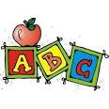
Things that would help me more in school?

Emotional Wellbeing and Behaviour

These are some of the things that make me feel happy or sad or annoyed.
SAMPLE

When I am feeling sad or annoyed these are some of the things that can help me to relax and feel happy

Things that are important to me that I would like the team and my family to help me with. | 1.  2.  3.

For parents and carers of a young person aged 12 to 18 years
SAMPLE

Have a think about each of the following parts of your young person’s life to see how they are becoming more independent and what else you could do.

Social & Recreation
How would you describe their social life and social skills? What kind of activities are they involved in outside school? Do they have a group of friends or a particular close friend?

_____________________________________________________________________________________________________________________________________________________________________________________________________________________

School Life
How are they getting on in school? If they are leaving secondary school in the next few years, do they talk about their plans for their future?
_____________________________________________________________________________________________________________________________________________________________________________________________________________________

Emotional Wellbeing
How would you describe their general mood and emotional well-being?
____________________________________________________________________________________________________________________________________________________________________________________________________________________________________________________________________________________________

Independent Living Skills
How do they look after themselves? How can they be helped to further develop their independence? _____________________________________________________________________________________________________________________________________________________________________________________________________________________

Health & Wellness
Do you think they know how to look after themselves and keep healthy?
_____________________________________________________________________________________________________________________________________________________________________________________________________________________

Family Life
SAMPLE
Is there anything happening for your family that would be helpful for the team to know?
_____________________________________________________________________________________________________________________________________________________________________________________________________________________

Anything else you think is important _____________________________________________________________________________________________________________________________________________________________________________________________________________________

What are your current priorities?

1. ___________________________________________________________

2. ___________________________________________________________

3. ___________________________________________________________

All about me - For young people aged 12 to 18 years
SAMPLE

Have a think about each of the following parts of your life to see how you are becoming more independent and what else you could do.

1. Social & Recreation

Spending time outside school
___________________________________________________________________________________________________________________________________________________________________________________________________

2. Independent Living Skills

Doing things for myself
Going out and about
_____________________________________________________________________________________________________________________________________________________________________________________________________________________

3. School

Schoolwork
Taking part in activities at school
Completing homework

_____________________________________________________________________________________________________________________________________________________________________________________________________________________

4. Health & Wellbeing

Knowing how to look after myself and keep healthy
What makes me feel good?
Do I have the information I need about my disability?
_____________________________________________________________________________________________________________________________________________________________________________________________________________________

5. Anything else you think is important _____________________________________________________________________________________________________________________________________________________________________________________________________
SAMPLE

6. Priorities

If you were to pick just a few, what would you most like to get better at?

1. ___________________________________________________________

2. ___________________________________________________________

3. ___________________________________________________________

3. Reflection on sample goals
Draft |  | Reflection | Possible revision
Goal
Conor will expand his diet to include one more food item. This may be plain pasta, plain pizza or non-toasted bread. Conor will be safe when eating and drinking. |  | This is two goals - to expand his diet and to be safe when eating and drinking. What will the goals look like when achieved? | Conor will expand his diet to include one more food item, which is pasta for his dinner at least once a week.
What is happening now? (baseline)
Conor continues to have a very limited diet.  He is sensitive to certain foods and will  refuse, regurgitate and gag on them. This makes going on holidays and to restaurants challenging for the family. Hospital has recommended swallow assessment. |  | It should be written from a strengths perspective e.g. Conor will eat 5 foods (named) but struggles when new foods are introduced and will gag, regurgitate etc. The swallow assessment relates to safety. | Conor currently eats mashed potato, chicken, yoghurt and rice. He struggles when other foods are introduced and refuses them or gags.
What will your family and others do to help achieve this goal? (family strategies)
Parents to complete food diary and to include with food play and exposure strategies. |  | How and for how long?  When, where and how will they do this? How will it fit into their current routines? How will it contribute to the achievement of the goal?  ‘ | We will complete a food diary for one month, to include notes of dinnertime each day, the food Conor was offered, any strategies used to encourage Conor to eat pasta and what he ate. The diary will help to identify strategies which work and track progress.
What will the team do to help achieve this goal? (team supports)
- OT to provide guidance and strategies for food play ideas.  - SLT to offer review at the team FEDS clinic to identify need for swallow assessment and guidance. |  | Is it going to be over the phone, in person, by post? Needs more contextual information. How will it contribute to the achievement of the goal?  What will this guidance look like? How will it contribute to the achievement of the goal? | The OT will give Conor’s family written guidance on strategies and food play ideas. She will phone the family once a week to check in and offer any advice and support needed.  The team will offer Conor’s parents a place on the Fun with Food programme in November in the centre.
Draft | Reflection |  | Possible revision
Goal
Amy will be supported to join in and maintain small group interactions of her interest | What do “supported” and maintain group interactions” mean? With adults, children? The more context the clearer it is to everyone how it will be achieved, what it will look like when achieved & how it will be measured. |  | Amy will engage in joint play for 30 minutes with two friends of her choosing in her own home.
What is happening now? (baseline)
Amy has great imagination and loves to engage in pretend play. She likes to play with her sisters. She tends to play alongside familiar peers. Amy shows a preference for having one play partner and tends to shy away from groups. She finds it difficult to maintain group interactions. | Needs to be more strengths based |  | Amy has great imagination and loves to engage in pretend play. Amy likes to play with her sisters. She tends to play alongside familiar peers. She prefers to play with one other person. Currently Amy will play in a group for up to 10 minutes.
What will your family and others do to help achieve this goal? (family strategies)
Parents to continue setting up fun and short play dates as able with 1-2 liked peers which includes preparation of context and Amy’s interest  Parents to attend Hanen Talkability programme. | Be specific around what Amy likes to do. Could pick a frequency and duration range for the play dates. Need to list some strategies for preparation.  When and where will the Hanen programme be? How will this contribute to the achievement of the goal?  What other strengths do Amy’s parents and herself have that can help to achieve the goal, ideally there should be more strategies. |  | We will set up short play dates once a week with 2 friends of her choosing. We will help Amy decide what she would like them to play at and prepare for any pretend play scenes e.g. a shop. We will support Amy to re-engage if she moves away from joint play. We will attend the Hanen Talkability programme in the centre in June. This programme helps children to carry on conversations (back and forth), tell stories, make friends and play.
What will the team do to help achieve this goal? (team supports)
SLT will facilitate Hanen Talkability programme | Are there any other team supports that team members could also provide e.g. some universal strategies around exploring Amy’s areas of interest? It should also be made clear when the team support has finished. |  | We will phone Amy’s parents every week for four weeks to offer support and advice and hear how the play dates have gone.  The SLT will facilitate the Hanen Talkability programme.

Draft | Reflection | Possible revision
Goal
It is really important for John to be able to get enough sleep at night | Needs to be specific about what is to be achieved | As our next step towards better sleep for John we will work towards him being able to stay in bed alone for 15 minutes after his bedtime story
What is happening now? (baseline)
John sleeps after 45 minutes if we stay in his room with him and help him stay settled. If we leave he stays in bed for a minute or two before getting out to play with toys on the floor in order to keep himself busy | Needs to be more strengths based. If they stay with him for 45 minutes does John then sleep through the night? | John usually sleeps through the night. He does not go to sleep without one of us staying with him. If we leave he stays in his bed for a minute or two.
What will your family and others do to help achieve this goal? (family strategies)
We will talk to John about what he’d like to do if he’s bored and not ready to sleep at bedtime.  We will check in on him & use rewards for steps towards success.  We will agree a night-time routine for everyone in the house to follow. | What are examples of activities for John if he’s not ready to sleep?  What is the reward system for John? | We will talk to John about what he’d like to do if he’s bored and not ready to sleep at bedtime, and focus on options that are pleasant, bed-based and low arousal. John likes to read & re-read some books which help him calm down, we will make sure he has access to these for bedtime reading. We will check in on him & use rewards for steps towards success. We will agree a night-time routine for everyone in the house to follow.
What will the team do to help achieve this goal? (team supports)
We will provide advice and guidance to John’s parents on bedtime routines. | Is the advice and guidance only about bedtime routine? What about ideas for the parents on bed-based activities and the reward system? Is the support going to be over the phone, in person, by post? | We will offer support on the bedtime reward system, arrange a call to discuss exercise & diet options during the day, and provide you with some resources on low-arousal bedtime routine and environments. After you’ve had a chance to read these, we will visit you & John at least once in the family home, to talk about night-time routines & see the bedroom.

4. Useful resources

- Progressing towards Outcomes focussed Family Centred Practice: an operational framework. HSE. 2020.
Link here: Progressing towards Outcomes-focussed Family-centred Practice

- Eurlyaid www.eurlyaid.eu

- Recommended Practices in Early Intervention: A Guide for Professionals
https://www.eurlyaid.eu/eciguidebook-englishversion/

- Early Childhood Technical Assistance Center https://ectacenter.org

- CanChild, McMaster University:
https://canchild.ca/en/resources/250-family-centred-service-sheets

https://canchild.ca/en/research-in-practice/f-words-in-childhood-disability

- H. Sukkar, C. J. Dunst, & J. Kirkby (Eds) Early childhood intervention: Working with families of young children with special needs. New York, NY, US: Routledge/Taylor & Francis Group. 2017

Reference to the ‘family’ in this guidance includes all members of the family (parents, foster parents, carers, siblings, grandparents etc.) and all variations in composition. ‘Child’ or ‘children’ includes children aged from birth to 18 years.
Progressing Towards Outcomes Focussed Family Centred Practice. HSE.2020
Policy Framework for Service Delivery of Children’s Disability NetworkTeams.HSE.2022
Interim Guidance for CDNTs on the Key Contact role. HSE. 2022

