**National Sharing Day – Disability Operations, Quality Improvement 2024**

**Submission form**

|  |  |
| --- | --- |
| C:\Users\khenderson\AppData\Local\Microsoft\Windows\Temporary Internet Files\Content.Word\Name6.png  Name of presenter: |  |
| Email address: |  |
| C:\Users\khenderson\AppData\Local\Microsoft\Windows\Temporary Internet Files\Content.IE5\CGTSF16A\256px-Phone_Shiny_Icon.svg[1].png  Contact number: |  |
| Name of presentation: |  |
| Name of service/group: |  |

The National Sharing Day will be on Thursday 26th September at 11am.

It will take place at the Printworks, Dublin Castle



****

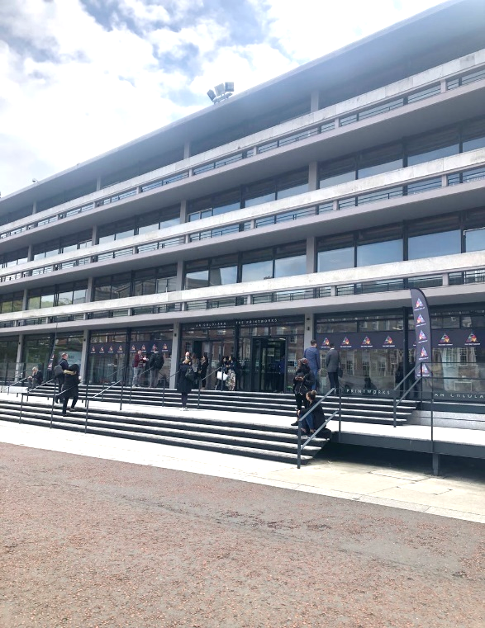

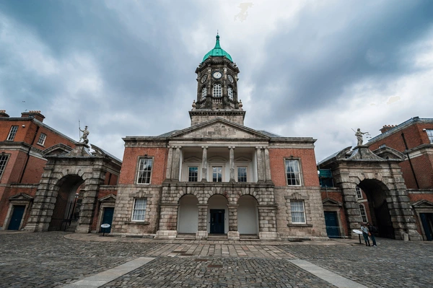

|  |  |  |
| --- | --- | --- |
| C:\Users\khenderson\AppData\Local\Microsoft\Windows\Temporary Internet Files\Content.Word\Alice Points.png  **Choose 1 topic**  **C:\Users\khenderson\AppData\Local\Microsoft\Windows\Temporary Internet Files\Content.IE5\MSG53THK\1024px-Pointing_hand_cursor_vector.svg[1].png**ý |  | How you decide about your money. |
|  | How you decide about where you live. |
|  | How you decide on hobbies or lifestyle |
|  | How you decide on your future. |

|  |  |  |
| --- | --- | --- |
| C:\Users\khenderson\AppData\Local\Microsoft\Windows\Temporary Internet Files\Content.Word\Alice Points.png  **Choose 1 type of presentation**  **C:\Users\khenderson\AppData\Local\Microsoft\Windows\Temporary Internet Files\Content.IE5\MSG53THK\1024px-Pointing_hand_cursor_vector.svg[1].png**ý | Speakup1Levi Laptop1200px-Microsoft_Office_PowerPoint_(2018–present) | A live presentation |
| Meeting 7 | Record a presentation video |
| DramaArtist | Song, dance, painting or drama. |
|  | A poster |



Tell us what you want to talk about in your presentation. Type it in this box. Make sure it is less than 500 words.



Do you have any questions? Do you need any support to take part in the National Sharing Day?

|  |  |
| --- | --- |
| C:\Users\khenderson\AppData\Local\Microsoft\Windows\Temporary Internet Files\Content.Word\Email.png | Email this form to [disabilitiesqi@hse.ie](mailto:disabilitiesqi@hse.ie)  You can email Nicole your questions also at [Nicole.Lam@hse.ie](mailto:Nicole.Lam@hse.ie) |
|  |  |
| Time 05-00 | Email your form before the 17 May 2024 |