

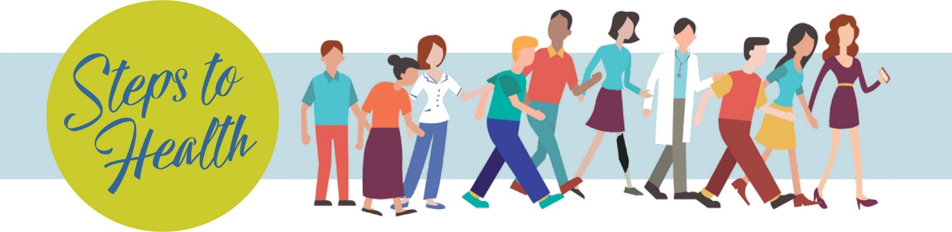

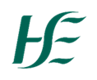

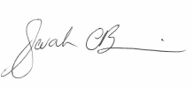

# certificate of COMPLETION

Sarah O’Brien

National Lead

Healthy Eating & Active Living Programme

awarded to

for completing the HSE Steps to Health Challenge 2024

Awarded on __________ 2024