CoVid Prep Intensive Care Orientation Manual for Nurses redeployed to Critical Care

This Orientation Manual belongs to:

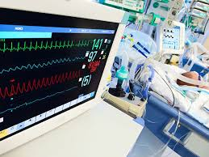

Online educational resource can be accessed: https://rise.articulate.com/share/BDSZkwB-l50YUj2c9K6bWldCMQx4zYVC
Please go to for up to date Healthcare workers guidance: https://www.hpsc.ie/a-z/respiratory/coronavirus/novelcoronavirus/guidance/guidanceforhealthcareworkers/
Table of Contents | Page No.
Welcome to the Intensive Care Unit | 2
Unit Philosophy | 2
Induction Checklist | 3
Escalation and emergency plan for Covid 19 | 5
Critical Care Nursing Team and Contact Details | 7
What is Covid 19? | 8
Levels of Critical Care | 9
IPCC guidelines for Critical care (follow local guidelines and have PPE training) | 10
Ordering blood products and the blood tracking system | 10
Resuscitation Trolley | 10
Intubation/Lines/Cannulation/Catheterisation trolley | 10
ICU training checklist | 11
Bed space safety checks | 12
Shift Routine | 13
Schedule of Line/Device/Equipment and Dressing Changes | 15
Schedule of Peripheral and CVC administration set change | 17
Physical Assessment | 17
Arterial Blood Gas (ABG) values | 23
C – Circulation (Cardiovascular system) | 24
Cardiac Arrest Rhythms | 25
Other common rhythm abnormalities | 26
CVP insertion for multiple IV infusions | 27
Care of the central line in accordance with local policy | 28
Blood pressure monitoring | 29
Care of the arterial line in accordance with hospital policy | 31
D – Disability (Neurological system) | 32
E – Exposure (Integumentary system) | 33
Pressure area care | 33
Mouth care | 34
Eye care | 34
Renal system | 35
Gastrointestinal system | 36
Psychological care | 37

Welcome to the Intensive Care unit
These are unprecedented times and we all in Critical Care thank you for your support and for agreeing to work alongside us. This guide is meant as a simple reorientation/ orientation around Critical Care. As this pandemic evolves we will work together to ensure your ability matches what is required so that we all as a team can deliver Critical Care to the best of our capacity, capability and resources.
You will be assisting in the care for patients with a variety of health problems including ventilated patients, patients with multiple infusions and monitored with various equipment. Online resourcing for reorientation/ orientation is available at: https://rise.articulate.com/share/BDSZkwB-l50YUj2c9K6bWldCMQx4zYVC.
However daunting the intensive care unit seems to be please remember that you are part of a team and that we are here to help you at all times.
We will endeavour to allocate you a primary preceptor and a secondary preceptor on each shift, although this might not always be possible.
At a point during this crisis, it may become necessary to deliver care through an Intensive Care Nurse Led, Critical Care delivery team. This will mean that an Intensive Care Nurse will coordinate the care of a number of patients, so that all care is delivered in an aggregated fashion as required for each patient.
Unit Philosophy

Many ICU’s have their specific unit philosophy. This is an example of what your units philosophy might look like.

The staff of the Intensive Care Unit aim to provide skilled, compassionate, holistic and evidence-based healthcare to meet the needs of the critically ill patient and their families; while respecting the values and beliefs of all patients in our care.

Our philosophy is to recognise the uniqueness of individuals in our care. Respect their perspective, feelings and beliefs, and acknowledging their right to confidentiality, privacy and dignity. Staff are supported to develop new skills in an environment where teaching, learning, professional development and research are actively encouraged.
Please insert your own Units philosophy here as you deem appropriate

The following list contains skills that you may need to receive training on to help smooth your transition into ICU
Skill | Support Nurse Date & Sign
Swipe access to ICU and swipe access requirements in ICU
Labs access
General orientation of the unit
Know how to Access Policies, guidelines & procedures
Unit specific Documentation processes (computer or flow sheets)
How to set up a Bed Space for admission
How to perform bed space safety checks
Preceptor allocated
How to don PPE equipment
How to perform endotracheal suctioning, both open & closed
How to take an ABG; How to use the Blood Gas Analyser
How to zero the Arterial line and CVP line transducer
How to check infusion pumps, check labelled infusion lines, how to increase or decrease infusion rates
How to prepare intravenous infusions.; particularly inotropes; How the double pumping process works on your unit
Your role as a team member when performing a safe and effective patient proning procedure (as per specific unit guideline)
How to assess the critically ill patient for pain, sedation and delirium
Cardiac arrest related to COVID
Location of Staff roster
Please add other unit specific skills training here

Your preceptor/support nurse will orientate you to the location of the following
Remember to orientate yourself daily to these

- Crash Trolley

- Arterial Blood Gas Machine

- Store Room

- PPE trolley

- IV Medication and dilution/ concentrations

- Dialysis Machines & Equipment

- Infusion Pumps

- Central Line/ Art Line/ Vas Cath Insertion Trolleys

- Transport Trolley

- Catherisation Trolley

- Intubation Trolley (Emergency/ Difficult airway)

Escalation and emergency plan for Covid 19
These are some of the general activities that you may be required to do. There will always be an ICU staff nurse to support and advise you.
We would ask that you become familiar with the following tasks to act as runners initially as support for ICU staff under their direct supervision
- Bed Space safety checks e.g. Check: O2 flow meters; suction; Ambu-bag; C-Circuits; Humidified O2; Oral –pharyngeal airway present.
- Patient comfort measure: for example, assisting with patient repositioning, hygiene needs, such as helping with a bed bath, and bed sheet change as required. Pressure area assessment on every turn; mouth care / eye care 4hrly; Assess mouth for pressure from ties and ETT.
- (Closed) Suctioning of patient via ETT as required. Education will be given
- Proning procedure.
- Turning patients, 4hrly standard for all ICU pts. Increase frequency if required dictated by pts skin integrity, pts not to be nursed flat; sit up at least 30° head or if possible can tolerate higher)
- Assisting line insertion i.e. Arterial / CVL (transducer lines changed as per local guidelines)
- Taking bloods from Arterial line ABG/FBC etc… ICU nurse will inform staff of when bloods to be taken
- Recording vital signs and fluid input & output
- Monitor and alert ICU staff to any patient concerns such as: signs of deterioration in BP/ HR/ Sats /urinary output (minimum urinary output of 0.5ml/kg/hr); Ventilator/ Infusion pump alerts
- Closely monitor pts for risk of self extubation or pulling out lines, sedated patients can wake unexpectedly!!!
- Second checker for IV antibiotics / infusions etc
- Draw up required IV Infusion medication
- Administration of blood products/ IV antibiotics/ NG feeding
- Changing of infusion syringes if required
- Support Patients Family and others
The care of a critically ill patient is Multi-Disciplinary, however, it may become a requirement during this pandemic that Critically ill patients are given Nursing care within an Intensive Care Nurse Led Critical Care delivery team. The recommendation for delivery of safe care is a Nurse Patient ratio 1:1. This team might look like and roles might be:
ICU Nurse leading team
- Will take handover and co-ordinate the daily care of 2 patients with 2 Non ICU Nurses
- Do full daily assessment on their patients, alongside their Non ICU Nurse colleague
- Set all alarm limits for all equipment Monitors/ ventilators/ etc

Non ICU Nurse in 1:1 care
- Recording observations. Urinary & Drains output, ventilator readings, temps etc
- Be our eyes and ears for alarms, alert ICU staff to falling BP/ HR/ Sats/urinary output (minimum urinary output of 0.5ml/kg/hr) if ventilator alarm on ventilator sound alert ICU staff.
- Watch pts in case patients they try to pull out ETT or lines, sedated patients can wake unexpectedly!!!
All care should be aggregated across teams within the ICU, meaning that at times when Proning, turning, washes are being done, then all other relevant care should take place as well.
ICU CNM / ICU SN as nurse in charge (not in numbers) will be checker of staff donning on and off of gowns & PPE
On behalf of nursing management and all the ICU staff, we thank you sincerely for your support in this difficult time.

Critical Care Nursing Team & contact details; please populate the following

Critical Care ADON:
CNM 3:
CNM 2 ICU:
Clinical Facilitator:
HCA:
Porters:
Dietitian:
Senior critical care physio:
The Physio team review patients twice daily focusing on, respiratory support and mobility/limb rehab.
Critical Care Registrars & Bleep Numbers

Critical care Consultants:

Important NUMBERS
Cardiac Arrest Dial:
Fire Dial:
Pharmacy:
Lab/ Blood Bank:
Security Emergency Dial:
FIRE SAFETY
Fire alert is via phone dial and inform switchboard operation of fire location.
Break-glass fire alarms are located on the wall at and at
Fire extinguishers are located in the unit – one and one
The fire plan is on the wall at

What is CoVid 19??
Resembles viral pneumonia and can be mild to severe.
- 80% of patients present with mild illness
- 14% present with severe illness
- 5% present with critical illness.
Early reports suggest that illness severity is associated with older age and the presence of underlying health conditions. Some patients may be minimally symptomatic or asymptomatic. (BMJ Best Practice)
Co-morbidities associated with increased risk
- Age > 60 years
- Cardiovascular disease
- Hypertension
- Diabetes
- Chronic respiratory disease
- Cancer
- Immunocompromised
CLINICAL SYNDROMES ASSOCIATED WITH COVID-19
Severe pneumonia
Adolescent or adult:
Fever or suspected respiratory infection, plus one of:
Respiratory rate >30 breaths/min
Severe respiratory distress,
or SpO2 <90% on room air .
The diagnosis is clinical; chest imaging can exclude complications

Levels of Critical Care

The levels of care required are defined by the patient’s clinical condition and his/her level of need for critical care.
The Joint Faculty of Intensive

Critical Care Medicine of Ireland (JFICMI) (2011) created definitions to support Irish practice. These definitions of levels of critical care are outlined in the table below:

Acute Care | Level 0 | Hospital ward clinical management
 | Level 1 | Higher level of observation e.g. PACU
Critical Care | Level 2 | Active management by critical care team to treat and  support critically ill patients with primary single organ  failure
 | Level 3 | Active management by critical care team to treat and  support critically ill patients with two or more organ  failures
 | Level 3s | Level 3 with regional/national service

IPCC guidelines for Critical Care (follow local guidelines and have PPE training)
Technique for Donning and Doffing of PPE
Donning Doffing
- Perform Hand hygiene

- Put on Gown and hat

- Put on FFP3 mask
Fit Check Mask
Place mask over nose, mouth and chin
Fit flexible nose piece over nose bridge
Secure on head with elastic
Adjust to fit
Inhale- mask should collapse
Exhale- check for leakage around face

- Put on Eye Protection goggles or face shield

- Put on gloves
In the patients’ room
- Remove Gloves
- Perform Hand hygiene
- emove Goggles –avoid touching the front
- Remove Gown -avoid touching the front of the apron/gown
- Perform Hand hygiene
In ante room or directly outside patients' room- Ensure door is closed
- Remove Mask
Grasp and lift ties from behind your head and pull off respirator away from your face.
Avoid touching the front of the respirator and use ties to discard.
2. Perform Hand hygiene

Ordering blood products and the blood tracking System?
Familiarise yourself with Blood product ordering and fast track requirements

RESUSCITATION TROLLEY
Adult and Paediatric versions are . Daily check of resus trolley and transport trolley is assigned to a rotation of nurses and check must be signed off in log book.

INTUBATION/LINES/CANNULATION/CATHETERISATION TROLLEY
The contents in each drawer must be checked daily against the list in each drawer and items replaced after each use.

ICU TRAINING Checklist
Course | Complete | Comments
PPE
Equipment
Orientation to the unit
Bed Space set up and List for same
ICU Bedside trolley list
Bed Space Safety check
Admissions list/ requirements
IV Medication:
Sedation
Inotropes
Muscle Relaxants
Analgaesia
Anti Virals
Micro
Proning
Closed Suctioning System
Cardiac Arrest related to CoVid
Infusion Pumps
Line Checks, labelling & Double pumping
Arterial Blood Gas Monitoring and care of the Arterial Line
End of Life care
Principles of Ventilators & troubleshooting
NIV

General daily activities
The following text outlines an example of events occurring during a 12 hour day. However, every unit is unique. Don’t worry; you will soon learn the routine of your particular ICU
BED SPACE SAFETY CHECKS
- Ensure patient armband applied, accurate and legible
- Do not leave patient unobserved
- Be aware of need to maintain a clean uncluttered bedside/unit environment
- In the event of equipment failure call for help
- Remove equipment for decontamination when no longer required
- Aware of need to maintain bedside stock
- Ensure vacant bed spaces ready for new admissions at all times
- Aware of location, contents and purpose of emergency & intubation trolleys equipment
- Check monitor, pump and ventilator alarms are activated and equipment is plugged in and fully charged
Airway
- Check oxygen and air point connections
- Check c- circuit intact, connected and ready for use with face mask available (with face mask available and PEEP valve in place for patients on high PEEP settings)
- Inflate bag to check for leaks/damage
- Ensure suction assembled and working effectively
- Ensure correct size of open suction catheters available (ETT size minus 2) X 2
Yanker sucker x 2 and bottle of sterile water
- Check ETT tube, what is the measurement of the tape at the patient's lips (and compare with the previous measurement).
- Check that the ETT tape is secure
- Trace the ventilator tubing from the patient to the ventilator
- Check the alarm limits on the ventilator, cardiac monitor, infusions are on and amended to the specific needs of the patient ( you may need to help with this).
IV lines & infusions:
- Check that you have emergency IV access
- Zero the Arterial line and CVP transducer
- Check the insertion site of all IV lines for signs of infections. Trace all IV infusion lines from the patent to the infusion pump. Now check what drug is infusing and if the label on the IV line matches the sticker on the syringe, next check the corresponding prescription. Repeat for all infusions.
- Check lines are secured; dressings are in date
- Check all lines on fluid and drug administration sets and infusions are labelled & dated as per line bundles
- NOTE any infusions that are nearly empty and report this/prepare replacement medication. NOTE: Always have a replacement syringe available for inotropes & vasopressors & drugs with short half-life e.g. propofol, remifentanil to avoid infusion run out
- Check all fluids and infusions rate/volume/dose/additives/expiratory date/connections are secure
- Check and change transducer, pressure bags/systems as per hospital policy
- Check peripheral IV lines against care VPS bundle
- Be aware If double pumping of inotropes is set up
- Check and change transducer, pressure bags/systems as per hospital policy
- Log broken/ malfunctioning equipment to biomedical engineer via Biomed icon on computer desktop. A log number is generated and this is then recorded into biomed & maintenance book on the unit desk

SHIFT ROUTINE: Please complete as per your unit if required. This is meant as an easy guide for your redeployed staff
Shift Start – the nurse in charge will allocate you your duties after the unit handover from the night staff.
Patients are allocated by day shift team leader to nurses for the day according to patient’s acuity and staff numbers. Generally ventilated or unstable patients will be 1:1. The ratio for High Dependency (level 2) patients will be 1:2 depending on staff numbers
Individual bedside handover is given
08.30 - Bedside safety checks per above list
Introduce yourself to the patient and orientate them to time and place
Perform a Head to toe Patient assessment and document as per your unit
Note any infusions running low and prepare critical infusions in advance
If required, ensure double pumping of inotropes is set up
09.00 - Anaesthetic and primary medical team rounds – Give report to teams and flag any particular concerns. Use systematic head to toe report style. Ascertain treatment goals and parameters and document same
Assist the radiographer to position the Chest Xray plate (two people sit patient forward, and the plate is placed at the patients back – keep ETT safe, during this procedure)
Chest x-ray as ordered and review with critical care nurse/ medical team
09.40 – Morning tea breaks begin

SHIFT ROUTINE Continued
10.00-1200 Administer prescribed medications, seek review of the patient's chest x-ray and blood results (report any changes from yesterday’s results)
Continue to attend to patient comfort measures, pain, sedation, and delirium assessments, reassurance, perform mouth car. Always explain procedures to the patent. Administer analgesia, change your patient's position in the bed, and assess pressure areas
Physiotherapist generally reviews and treats patients in the morning. They may seek your assistance to mobilise your patient.
Check microbiology results. Notify team medical and anaesthetic teams of new findings - immediate consultation with microbiologist may be required
Mobilise patients out of bed as appropriate
Refer patient to multidisciplinary team members via bleep system as appropriate e.g. SALT, TVN, Occupational Therapist.
Physiotherapist will review and treat all patients in morning and afternoon and will assist with getting patients out of bed
12.00 - Continue to attend to patient comfort measures, assessment of vital signs, infusions, administration of medication, document your care.
12.30 - Lunches start
Dietician will review each patient daily and enteral feeding and TPN is prescribed. Additional medication chart prescription is required for TPN and medical doctor must do so
14.30 - Continue to attend to patient comfort measures, pain, sedation, and delirium assessments, reassurance, perform mouth care. Always explain procedures to the patent. Administer analgesia, change your patient's position in the bed, and assess pressure areas, monitor vital signs continuously and document hrly along with fluid balance
15.15 – Afternoon tea breaks begin
1600 -2000 - Continue to attend to patient comfort measures, pain, sedation, and delirium assessments, reassurance, perform mouth car. Always explain procedures to the patent. Administer analgesia, change your patient's position in the bed, and assess pressure areas
20.30 – General, brief handover from the previous shift's nurse is given at each bedside. Notable events, expected admissions, safety issues are highlighted by team leader to the group
Patients are allocated by team leader and bedside handover is given to night shift nurse
SCHEDULE OF LINE/ DEVICE/ EQUIPMENT AND DRESSING CHANGES

Respiratory
Equipment | Write how often they need to be changed (unit specific) Example below
Ambu BMV | On patient discharge
Aeroneb Solo Nebuliser connectors on Ventilator Circuits | 14 days with ventilator circuit change
Airvo Circuits and attached Aerogen Solo Nebuliser connector | 7 days – apply date sticker
Closed suction set | 72 hrs – apply sticker - date changed
C circuit | 14 days with vent circuit change
ETT / Trachy tapes | 12- 24 hrs or sooner if soiled  Tape change/tube adjustments must be done with 2 nurses present
Sterile Water Bottle for clearing yankeur & suction tubing | 24 hrs
Suction tubing | 24hrs
Suction liner | When canister ¾ full. Dispose in yellow rigid biohazard waste bin in sluice room
Tracheostomy dressings | 24 hrs or sooner if soiled
Tracheostomy inner cannula | 12 – 24 hrs depending on secretions
Tracheostomy Tubes (portex, blue line) | 30 days
Ventilator Humidified Circuits | 14 days - apply date sticker to humidifier chamber
Ventilator Bacterial Filter | 24 hrs – write date changed on filter
Ventilator Expiratory Cassette | On discharge – Put in CSSD Container for decontamination
EtC0₂ piece | 14 days with circuit change. Place in CSSD container for decontamination.
Yankeur | 12 hrs & prn
Cardiovascular
Administration Sets –Medication Infusion and Transducer Sets | See table below
CVC and Arterial lines  - Per care bundle | Review requirement for line daily per care bundle.  Consider change @ 10days or sooner if temperature spike or entry site has signs of inflammation or infection  Insertion date recorded in care bundle chart and front of 24hr care plan
Central line and Arterial line dressings  - Per care bundle | 7 days with CHG dressing or sooner if soiled/wet/peeling off (Sterile procedure) Apply dressing sticker or write date date of change on dressing  Use ANTT procedure with dressing pack
ECG Dots | 24 hrs
Epidural Line | Not changed
Peripheral IV cannula | 96hrs or if VIP >2 - write date of change on dressing and record in care bundle
Mouth Care/ Patient Care
Chlorhexidine mouthwash | When bottle is empty / patient discharged
ETT Tapes | 12- 24 hrs or sooner if soiled  Tape change /tube adjustments must be done with 2 nurses present
Wash bowls | Dispose of on discharge
GIT
NG Tubes | 30days
NG Feed giving Sets | 24 hrs – Label date changed
Sterile water bottles for suction / NG | 24 hrs – write date changed on bottle
Styrofoam cups for NG aspirate and medicine dilution | Dispose after each use
Urinary catheter bags | 7 days – Label with date changed
Urinary catheters - silicone | 30 days
Urinary catheters – silastic | As per local guidelines

SCHEDULE OF PERIPHERAL AND CVC ADMINISTRATION SET CHANGE
Administration Type | Administration Set | Set Change Frequency Example below
Primary and Secondary Continuous Infusions  (Infusions NOT containing blood, blood products or intravenous fat emulsions)  Transducer sets | Primary Set  And  Secondary ‘piggyback’ sets | If infusate is administered continuously via primary  or secondary administration set, including add-on  devices, change set(s) no more frequently than at  96 hr intervals.  3 way taps and microclave bung replace at 96hrs at time of administration set change
Primary Intermittent  Infusions (Infusions NOT containing blood, blood products or Intravenous fat emulsions) | Primary Set  And Secondary ‘piggyback’ sets | Discard after each disconnection  Replace set every 24 hours if not disconnected.
TPN/PN and 10% & 20% glucose solutions  Insulin Infusion | Primary Set | Replace every 24 hours and/or with each new container/syringe.
Propofol | Primary Set | Replace every 6 – 12hrs, when the bottle changed.
Blood Product Administration Set | Blood Product Administration Set with Integrated Filter | As per local guidelines
NOTE: The above table applies to administration sets. All syringes and infusion bags containing medications must be changed every 24hrs

Physical Assessment of a Critically ill patient. Performed by all Critical Care Nurses at the start of every shift

Head | Inspect:  - Alertness  - colour, Cyanosis and pallor in lips and oral mucosa signalling hypoxia  - wounds, and abnormalities  - Height of Head Of Bed, aim >30 degrees  - IJ CVL – VIP score, ports, dates of lines  - ETT position, note cm at lips, position and check cuff pressure  - NG – external length
Neuro | Assess:  - GCS  - Pupillary reaction  - Limb strength and coordination  - RASS  - Pain – CPOT  - Sedative medication  Additional:  - Spinal Care  - Specific Neurological symptom management
Thorax/ Respiratory  Inspect  Palpate  Auscultate | Remove clothing, HOB 30®, note ventilation/02 support/ ETT/ Trachy  RASS = 0/ Self ventilating – assess pain and deep breathing capabilities  Inspect:  - Trachea - midline  - AP diameter  - Rate, rhythm, depth and effort of breathing  - Use of accessory muscles  - Deformities or asymmetry  - Skin condition & under the skin devices  - Chest Drains etc.  Palpate:  Place palms of hands on the chest and at the bases  - Note respiratory expansion, decreased, flail chest  - Abnormalities  - Vibrations (secretions)  Use pads of fingers to preform specific palpation to identify:  - Tender areas  - Abnormalities; surgical emphysema, devices  Auscultate in a ladder technique:  Listen in each area for one full breath cycle (inspiration/expiration)  1 = Apex of the lung, above the clavicle  1 – 4 = Midclavicular line  5 & 6 = Base of lungs, under the arm pit (mid axillary line)  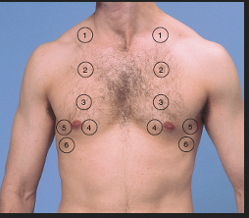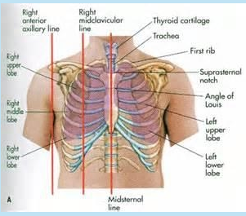
Thorax/ Respiratory | Characteristics of Normal Breath Sounds  Sound Duration Intensity Pitch Normal locations  Vesicular Inspired longer then expired Soft low Most lung parenchyma  Broncho- Vesicular Inspired = expired Intermediate Intermediate 1st – 2nd interspace. Main Bronchus bifurcates  Bronchial Expired longer then inspired Loud Relatively high Manubrium Bronchioles  Tracheal Inspired and expired equal Very loud Relatively high Trachea  Adventitious or Added Breath Sounds  Sound Continuous/ Intermittent Pitch Inspiration/ expiration Quality  Wheeze Continuous High Both Whistling/ hissing/ shrills  Rhonchi Continuous Low Both Snoring  Stridor Continuous Very High Mostly inspired/ Both Squeaking  Fine Crackles Intermittent High Brief Both Soft  Coarse Crackles Intermittent Loud Low Brief Both Noisy  Plural friction Continuous Low Both Non musical
Abdomen  Inspect  Auscultate  Palpate | Current condition; Identify from handover/ patient:  - Current bowel habit – Colour/ Consistency  - Oral/Enteral/PN intake  - NG – Aspirations Vs Free drainage; check position on CXR  - GI Surgical intervention  - Urinary system, urine output – Colour/Pain/Infection  - IDC/SP/ Ileal -conduit  - Abdo Pain/ where? / back pain/ were?  - Ileostomy/ Colostomy/ rectal tube/ bowel management device  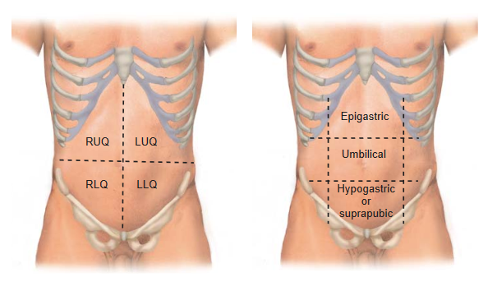  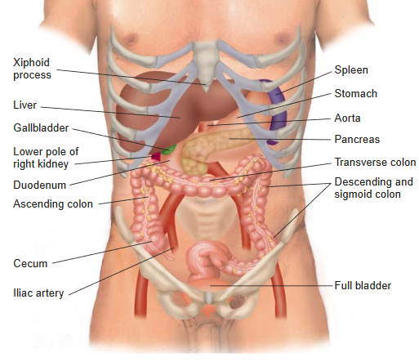  Expose patients abdomen, maintaining dignity at all times.  Inspect:  - Skin  - Contour, shape, distention  - Umbilical – hernias deformities  - Stoma/drains/wounds  Auscultate all four quadrants:  - Bowel Sounds  Change Seen with  Increased Diarrhoea Early intestine obstruction  Decreased Absent bowel sounds Ileus Peritonitis  High-Pitched Tinkling sounds Intestinal fluid Air under tension in dilated loops of bowel  High- Pitched Rushing bowel sounds with cramping Intestinal obstruction  Palpate all quadrants:  One handed light palpation with the pads of your fingers  - Distention/Soft/Rigid  - Tenderness /guarding  - Masses/ abnormalities
Cardiac | Assess:  - BP, Compare NIV to Arterial  - Inotrope infusions  - Heart rate and rhythm  - Temperature – peripheries to central with back of hand  - Peripheral capillary refill  - Nail bed, colour, shape  - Peripheral oedema  - Peripheral pulses, signs of PVD/PAD  - Volume assessment  - DVT Bundle adherence

Arterial Blood Gas Values
pH - Measures Hydrogen ions (acids) in arterial blood
PaCO₂ - Measures partial pressure carbon dioxide (an acid) in arterial blood
HCO₃ – Measures bicarbonate with acts as a buffer of acids to maintain normal pH
Base Excess – Is a measure of the surplus amount of alkali (base) in the blood
PaO₂ - Measures partial pressure of oxygen in arterial blood
Ranges: 10 – 13.5kPa – Normal
8 – 10kPa – Mild hypoxia
6 – 8kPa – Moderate hypoxia
< 5kPa – Severe hypoxia
SaO2 – Measures percentage of haemoglobin saturated with oxygen

Normal ABG Values
pH | 7.35 -7.45
PaCO₂ | 4.5 – 6.10 kPa
PaO₂ | 12.0 – 15.0 kPa
HCO₃ | 22 – 26 mmo/L
BE- | -2 to + 2 mmo/L
SaO₂ | 94% – 100%

- PH is regulated by the kidneys and lungs.
- The body’s metabolic processes always produce ‘Acids’. The breakdown of fats and sugars for energy generates carbon dioxide and the metabolism of protein produces metabolic acids. Both increase the body’s H+ concentration.
- To maintain a normal pH balance ‘acids’ need to be removed from the body. The body's buffering system regulates this process.
- Acids produced by the body's metabolic processes are removed by our lungs, kidneys and chemical buffers which mop up acids such as bicarbonate, haemoglobin and phosphate.

C – CIRCULATION (Cardiovascular system)
Review Patient history and presenting complaint including medications

Inspection
- skin colour - e.g. pale, cyanosis (peripheral or central), grey
- petechiae (blood spots), bruising, bleeding or serous ooze from puncture sites,
- mottling of skin or limbs
- feet/limb swelling
- signs of dyspnoea
- level of consciousness, confusion, agitation
- presence of chest tightness or pain and assessment of same
- Non-invasive and invasive monitoring parameters - B/P, arterial waveform characteristics, cardiac output monitoring parameters, CVP
- Serum biochemical and hematological tests
- JVP / neck vein distension
- Chest X-ray
- Other diagnostic tests e.g. ECHO
- ECG - 12 lead analysis Heart Rate, Rhythm, ectopics, PR, QT intervals, ST segment elevation/depression, P wave abnormalities, pathological Q waves, inverted T waves

Palpation
- Skin temperature
- Clammy
- Pulse – rate full volume/thready/bounding/ regular/irregular
- PALPATE FOR A PULSE NO MATTER WHAT IS DISPLAYED ON ECG SCREEN
- Capillary refill time
- Skin turgor /signs of hypervolemia/ hypo perfusion
- Pulses present and equal at radial, brachial, femoral and pedal sites
Auscultation
- Heart sounds

Cardiovascular monitoring:
- ECG - monitoring via 3 or 5 lead monitoring is routine for all ICU patients. Additional leads are added to produce 12 lead ECG daily as patient condition indicates.
- Arterial pressure monitoring
- Central Venous pressure monitoring
- Continuous Cardiac Output monitoring (PICCO monitoring) if required

Cardiac Arrest Rhythms
Asystole
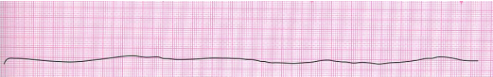
P wave asystole 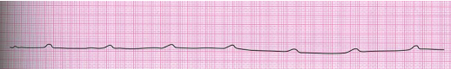
Pulseless Electrical Activity (PEA) (electrical activity without a pulse)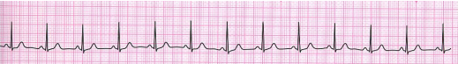
Agonal Rhythm (seen in the dying patient, unsuccessful resuscitation)
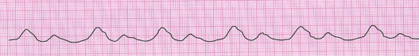
Ventricular Tachycardia (Shockable Rhythm)
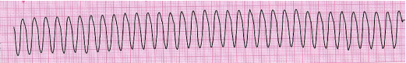
Course Ventricular Fibrillation (Shockable Rhythm)
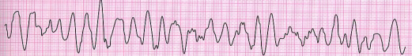
Fine Ventricular Fibrillation (Shockable Rhythm)
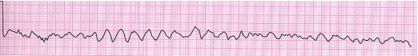

Other common rhythm abnormalities
Atrial Fibrillation
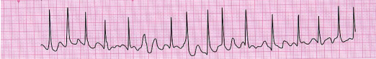
Atrial Flutter
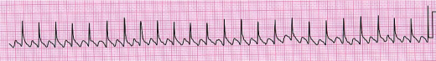
1st Degree Atrioventricular Block
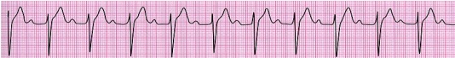
Mobiz type 1 or Wenckebach Block
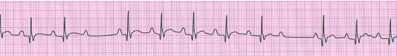
Mobiz type 2 Atrioventricular Block
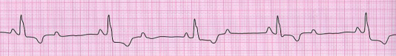
Third Degree or Complete Atrioventricular Block
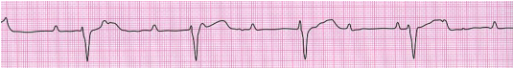
Premature Ventricular Beat (Ectopic)
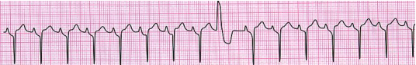
CVP insertion for Multiple IV Infusions
CVC insertion is indicated in patients who:
- are critically ill and require monitoring to guide fluid administration
- require administration of drugs such as inotropes and vasopressors which should be given into a central rather than peripheral vein.
- Have poor peripheral access and require the administration of long-term antibiotics and/or parenteral nutrition
Care of the central line is done in accordance with hospital policy - main points are:
- The nurse assists with setup and insertion of the CVC in the ICU.
- It is the nurses responsibility to ensure line is maintained securely and safely according to the hospital policy
- to ensure that the opportunity for blood stream infection is minimized standard precautions must be followed and any manipulation of the line is in accordance with hospital policy.
- Care should be taken when flushing the CVP/ arterial line infusion set, ensuring all taps are closed, the catheter is flushed adequately to prevent thrombosis and the catheter insertion site is monitored for signs of infection.
- Overall, arterial line placement and CVC placement are considered safe procedures, however complications and problems can occur.
- Correct CVC line placement is confirmed by CXR and must not be used until confirmed by anaesthetic registrar.
- Continuous monitoring and assessment for CVP trace via monitor and transducer ensures patency maintained.
- Site must be kept visible, kept secure (sutured), dressed. CVP waveform is produced via monitor and is assessed and measurement taken regularly (see figure below).
- Phlebostatic axis (4th intercostal space, mid-axilla line) is the anatomical position of transduced level for measurement recording.
- Measurements must be done supine, but not necessarily in flat head of bed position. Because VAP guideline means that patients head of bed is kept at least 30º, this position is perfect for CVP measurements once transducer is levelled to phlebostatic axis. References for this are as follows:
‘It is a generally accepted rule that the CVP can be measured with the patient at 45 degrees head-up elevation’ Bernsten and Handy (2019) Oh’s Intensive Care Manual
‘ A backrest position of less than or equal to 60 degrees with the patient's back flat against the surface of the bed won't compromise the accuracy of the reading’. Iversen, C, Understanding the phlebostatic axis; Nursing Made Incredibly Easy! : September-October 2011 - Volume 9 - Issue 5 - p 56
‘Supine with head of bed up between 0 and 60 degrees. Allow patient to stabilise for 5 to 15 min after a position change’. Morton and Fontaine (2018) Critical Care Nursing A holistic Approach

Complications of CVC insertion are:
- pneumothorax (highest for SCV)
- failure to locate vein
- accidental arterial puncture
- haemothorax
- haematoma
- arrhythmia
- thoracic duct injury
- guide wire embolus
- air embolus
- haemopericardium and tamponade
- catheter blockage
- infection
- catheter fracture
- vascular erosion
- vessel stenosis
- thrombosis
- osteomyelitis of clavicle

Blood pressure monitoring
Non-invasive
- tends to under-read at high pressures and over-read at low pressures
- less accurate during arrhythmias
- non-continuous
- less suitable for haemodynamically unstable patients
- cuff width most important determinant of the accuracy of the pressure reading. Should be 40% of mid-circumference of limb (the length should be twice the width). Cuffs which are too narrow tend to overestimate BP while those which are too wide tend to underestimate
- complications include: ulnar nerve injury (usually associated with cuff being placed too low on upper arm), oedema of the limb, petechiae and bruising, friction blisters, failure to cycle and drip failure

Arterial / Invasive
- Critically ill patients require arterial lines to:
- monitor blood pressure (BP) trends and is indicated in patients receiving vasoactive infusions / inotropes or those with fluctuating, unstable blood pressures
- titrate drug therapies
- obtain blood samples for arterial blood gases and laboratory studies

- To ensure that a patient receives optimal treatment, it is crucial that staff are aware of factors that affect the safety and accuracy of arterial monitoring
- To ensure that the opportunity for blood stream infection is minimized standard precautions must be followed and any manipulation of the line is in accordance with hospital policy.
- An arterial catheter is inserted into the radial, brachial, femoral, or dorsalis pedis artery.
- The radial artery is the preferred site because of accessibility. The catheter is attached to a fluid-filled pressure transducer system incorporating a flush system, which continuously infuses a 0.9% sodium chlorides solution under pressure (300 mmHg) to maintain patency of the catheter.
- An attached transducer senses arterial pressure and converts the pressure signal to a waveform on the bedside monitor.
- The waveform reflects pressure generated by the left ventricle during systole. The monitor also displays numerical pressure values.

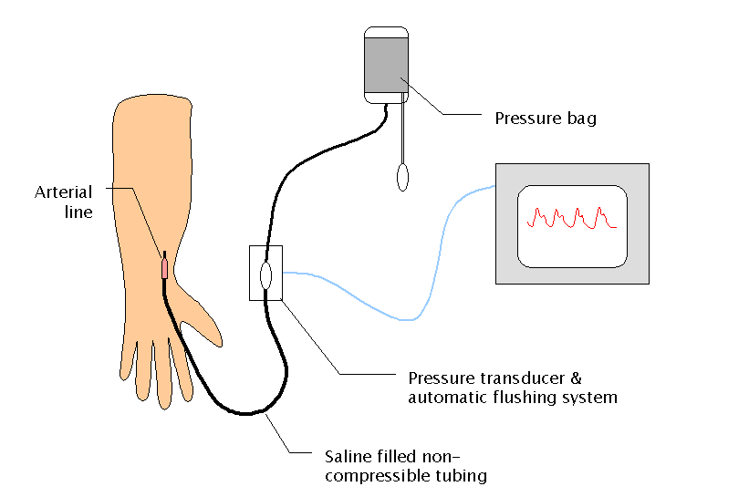
Invasive blood pressure monitoring system consists of:
- arterial line
- saline filled non-compressible tubing
- pressure transducer which converts the pressure waveform into an electrical signal
- this pressure waveform is displayed on the bedside monitor
- pressurised saline @ 300mmHg for flushing
Sources of error:
- Failure of any one of the components in system
- Transducer position
- Pressure displayed is pressure relative to position of transducer
- In order to reflect blood pressure accurately transducer should be at phlebostatic axis - 4th intercostal space, mid axillary line (level of heart)
- Over-reading will occur if transducer too low and under-reading if transducer too high
- Transducer must be zeroed to atmospheric pressure
- Damping. Important to have appropriate amount of damping in the system. Inadequate damping will result in excessive resonance in the system and an overestimate of systolic pressure and an underestimate of diastolic pressure. The opposite occurs with overdamping. In both cases the mean arterial pressure is the most accurate. An underdamped trace is often characterized by a high initial spike in the waveform.

Care of the arterial line is per hospital policy – main points are:
- NO DRUG OR FLUID CAN BE GIVEN INTO THE ARTERIAL LINE – ONLY SALINE FLUSH FROM TRANSDUCER SYSTEM IS USED
- Calibration/re-zeroing should be performed at the beginning of each shift

- The transducer height level to phlebostatic axis (4th intercostal space & mid-axillary point) should be checked at regular intervals and following each position change of the patient ot bed height

- Ensure all connections are tight
- Maintain entry site visibility at all times as dislodgement, disconnection, leaks in system will lead to significant bleeding
- Monitor limb regularly for signs of hypoperfusion, thrombosis, peripheral ischaemia (dusky colour, cool/coldness) as arterial cannulation occludes part of the blood supply to distal area and tissue ischaemia and necrosis can be caused
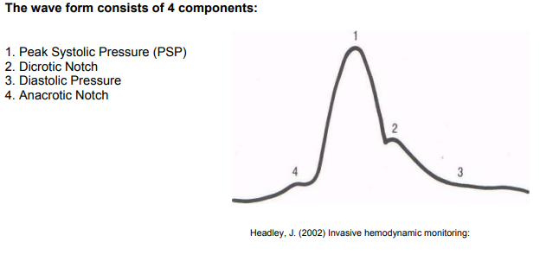

D. DISABILITY (Neurological system)
Neurological assessment involves use of GCS tool and is done regularly throughout the shift and hourly in patients with head injuries, intracranial bleeding, stroke, seizures or unstable level of consciousness as a consequence of critical illness.
It is important that you know what sedation your patient is on and that a plan is made for the weaning of the patient off that sedation
Blood glucose monitoring in patients with decreased level of consciousness (LOC). Liver dysfunction is important to detect hypoglycaemia effecting LOC
Seizure duration, type and medications required to stop seizure are recorded.
Changes in LOC require urgent attention and urgent CT brain is often indicated
Sedation scoring tool is Richmond Agitation and Sedation Score (RASS)
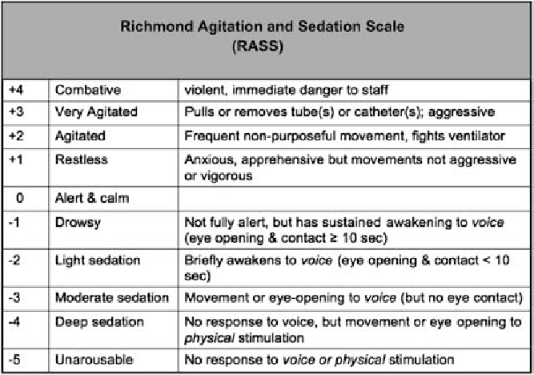
It is used to assess sedation levels and guide goal achievement in sedation levels.
When Proned, Pupil Checks are essential based on patient need
Pain score 0 -10 is sought from patients regularly throughout the shift and CPOT scoring system is used in intubated or non-verbal patients.
Pain assessment and analgesia selection is done in consultation with anaesthetic team. Commonly used analgesics are:
- epidural infusions and top –ups (Dermatone assessment required)
- iv / enteral paracetamol
- morphine, remifentanyl infusions
- intermittent IV morphine/oxynorm bolus
- PCA
- oral morphine preparations
- regional blocks (Dermatone assessment required)

E. EXPOSURE (Integumentary system)
Skin assessment can give important information relating to patient general health condition and some features are critical to forming diagnosis in acutely ill patients e.g. meningococcal rash development. Critically ill patients are at increased risk of pressure ulcer development due to immobility, poor tissue perfusion, oedema in those with shock and on vasoconstricting inotropes. A pressure ulcer can quickly lead to serious complications. Extension of bruising, petechiae, rashes are important to recognise and signs of internal bleeding may be detected.
Temperature control is altered in many critically ill patients and continuous temperature measurement may be required. Warming blanket can be used in hypothermia and cooling measures taken in febrile patients.
Pressure area care
- Critically ill patients are at special risk of pressure injuries due to immobility, poor tissue perfusion, oedema, vasoactive drugs, device induced (e.g. ETT, NIV mask), febrile and dermatological conditions associated with critical illness. The rosk of developing a pressure injury should be assessed daily using a validated tool (Waterlow/ Braden scoring tool)
- Patients must be repositioned 3 to 4 hourly for both pressure area/skin care and as a function for their respiratory care (postural drainage/oedema mobilisation/ VAP prevention).
- More frequent repositioning of entire body or vulnerable areas / limbs, may be required.
- Kinetic therapy (rotation bed) is used for patients with ARDS.
- Vulnerable areas are protected with pressure relieving devices
- Tissue injuries are scored per pressure ulcer and both your shift lead and tissue viability nurse should be informed
- Pressure injuries must be reported in national incident reporting form on computer desktop and CNM 2 informed to forward to risk manager.

Mouth care

This is an important aspect of patient care in the ICU for both patient comfort, mucosal function maintenance and in the prevention of ventilator associated pneumonia (VAP).
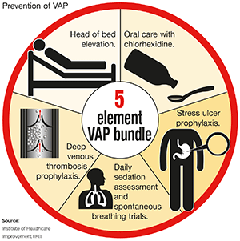
Chlorhexidine 2% mouthwash for example or gel is used 4-6hrly and regular oral hygiene is done. Tooth/gum/tongue brushing is done daily even in edentulous patients.
Vaseline is applied to lips especially under the ETT. Oral candititis is common and anti-fungal mouth drops are commonly used to treat this.
Thorough inspection of lips for injury caused by ETT must be done regularly throughout a shift and tube adjustment is done prn, with 2 nurses in attendance for safety.

Eye care
Unconscious or sedated patients are at risk of corneal drying because of reduced muscle tone resulting in only partial closure of eyes.
Please follow local guidelines for eyecare, particularly relating to proned patients

RENAL SYSTEM
Many critically ill patients develop acute kidney injury (AKI).
AKI is a clinical syndrome denoted by an abrupt decline (over hours, days to a few weeks in glomerular filtration rate sufficient to decrease the elimination of nitrogenous waste products (urea and creatinine) and other uraemic toxins.
Assess for the presence of the following signs and symptoms:
- Change in urine volume
- Oliguria (< 400 ml/24 hours - target is 0.5 to 1ml/kg/hr urine output)
- Nonoliguria (excess, dilute urine)
- Anuria (no urine output or <100 ml/24 hours)
- Abnormal Dipstick Test Results
- Haematuria (grossly bloody)
- Pyuria (cloudy)

Careful assessment and monitoring of renal function involves:
- Hourly urine output monitoring, Fluid balance recording
- Daily or twice daily urea and electrolyte measurement
- Acidosis assessment through regular ABG testing
Key points in caring for the patient with AKI are:
- Tissue perfusion to renal level is achieved through adequate fluid and electrolyte management
- Fluid Overload management
- Mean arterial pressure (usually MAP > 70) and avoidance of renal toxic drugs.
- Metabolic acidosis management
- Hyperkalaemia management
- Nutritional management

GASTROINTESTINAL SYSTEM
Gut failure in ICU patients is often suspected by the lack of normal bowel sounds, regurgitation, vomiting, high gastric drainage volumes (>500mL/day), diarrhoea, abdominal distension or GI bleeding.
With abdominal assessment, you inspect first, then auscultate, percuss, and palpate. This order is different from the rest of the body systems, for which you inspect, then percuss, palpate, and auscultate. The difference is based on the fact that physical handling of peritoneal contents may alter the frequency of bowel sounds.

Patients and are reviewed by dietician daily Monday to Friday and feed type is selected and prescribed. This prescription is filed in nursing notes folder.
Enteral feeding is commenced as soon as possible in the critically ill if oral feeding is not possible. Parenteral feeding (TPN) is commenced if enteral feeding is not possible.
NGT placement should be checked and verified in correct position daily via CXR. Aspiration is done before administration of any water flushes, medications of feed and 4hrly after this.
Glycaemic control is often an issue in the critically ill patient and glucose is measured at least 6hrly and more frequently in patients on insulin infusions. Sliding scale regimen is used and is prescribed in drug chart. A DKA protocol is also used if indicated. Refer to local policy for guidance.

PSYCHOLOGICAL CARE
Intensive care patients are very vulnerable given the acuity of illness. Other factors such as sleep deprivation, immobility, inability to communicate effectively or at all, device attachment, drug treatments can all have a significant impact on psychological wellbeing.
Many patients develop delirium. CAM ICU is the delirium detection tool used in ICU and information on scoring same is in end of bed folder and in 24hr patient care plan.
Psychological care of the loved ones / family is central to patient care.

