Enhanced Customer Services to General Practitioners

Dear Doctor

You will recall that Professor Brendan Drumm launched a number of new initiatives in May 2006 around enhanced customer services that were made available to General Practitioners by the Primary Care Reimbursement Service.

These initiatives aimed to streamline the processes involved in making claims, provide for early payments, and offer more client and payment information to all GP’s. The technology also facilitates closer involvement in keeping your patient lists up-to-date.

We are happy to announce a further key enhancement to these services in the form of additional online information on prescribing practices with drilldown and download facilities.

I attach some details of these additional information services along with a brief information notice on the other services available, i.e. those launched in 2006, for any of those GP’s that may not have availed of these facilities yet, and would like to do so now.

If you have already registered for the current services you can access the new information straight away. You do not need to take any further action.

We would encourage any GP’s that have not already registered to register for all of these services now. Registration is free and all of the online information is made available to you free of charge. We will be making further online services available in the coming months and will communicate details of these to you later on in the summer.

Yours faithfully

____________________
Patrick Burke
Assistant National Director
Finance Shared Services, PCRS

New Service

Prescribing Analysis Reports

As a result of the reimbursement function fulfilled by PCRS a wealth of prescribing data is accumulated. The information extracted from this data can assist the HSE, GPs and other professional bodies to understand prescribing patterns in Ireland.

Over the years we have supplied prescribing analysis to GPs. A number of months ago further reporting was added to the online GP Application Suite, now used by over 1,500 GPs. The focus of those reports was on the prescribing of Benzodiazepine and Controlled Drugs.

We have now added additional detailed prescribing analysis reporting facilities to the online GP Application Suite. These analyses are high quality and delivered directly to GP desktops securely.

They include:

- The cost of prescribing analysed by top-level ATC with historical analysis commencing August 2005. Presented in pie chart and table forms with mouse over sensitive chart segments

- The cost of prescribing within those top-level categories, e.g. the sub-categories within cardiovascular system, again with historical analysis commencing August 2005. Presented in pie chart and table forms with mouse over sensitive chart segments.

- Charted history of the cost of prescribing by top level ATC from August 2005 to the most recent month available. Presented in bar chart and table form with mouse over sensitive bars.

- The prescribing cost of your top twenty patients

- A detailed analysis on these top 20 patients showing the products that makes up the cost

- The ability to view this detailed analysis for every patient on your GPs panel.

- Charted history of the cost of prescribing to each patient on your GPs panel from August 2005. Presented in bar chart and table form.

Please note that you will need to have Broadband to use some of these features, as the amount of data required to produce them for you is significant. We are continuing to work to improve response times.

It is our view that this is a new starting point in detailed prescribing analysis, and we will continue to develop these features to best support GPs in the future.

Sample screenshots are attached on the following pages.

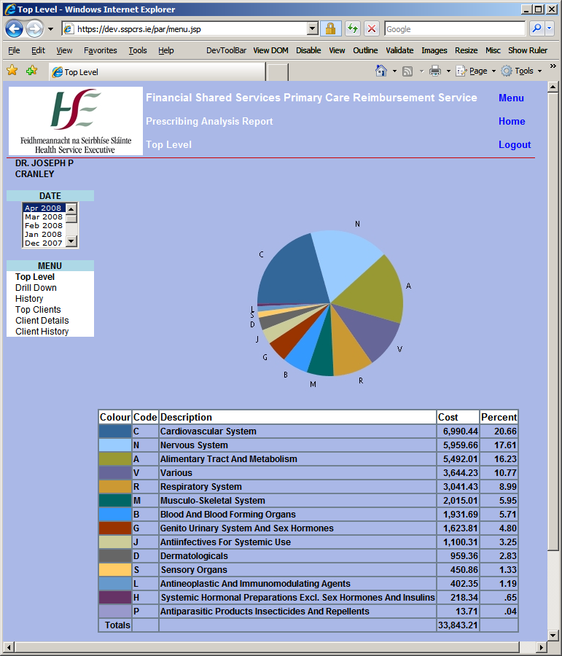

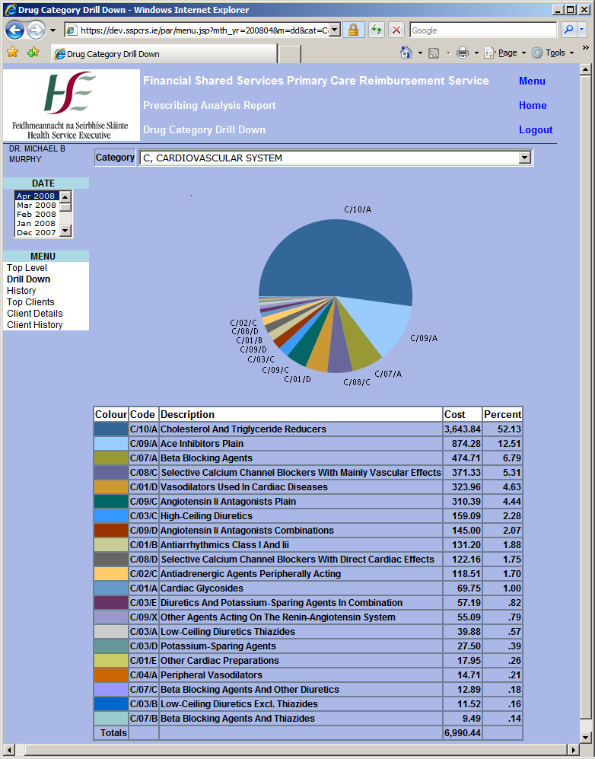

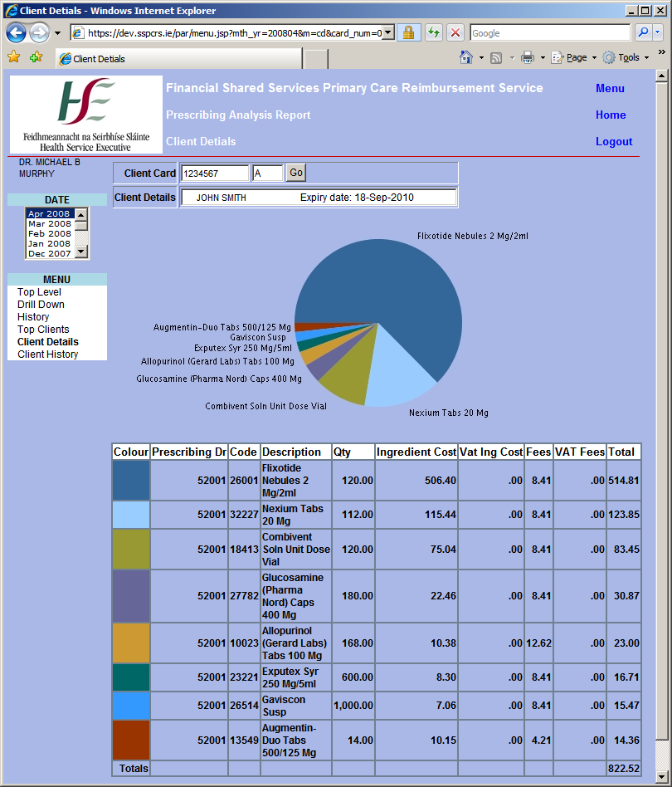

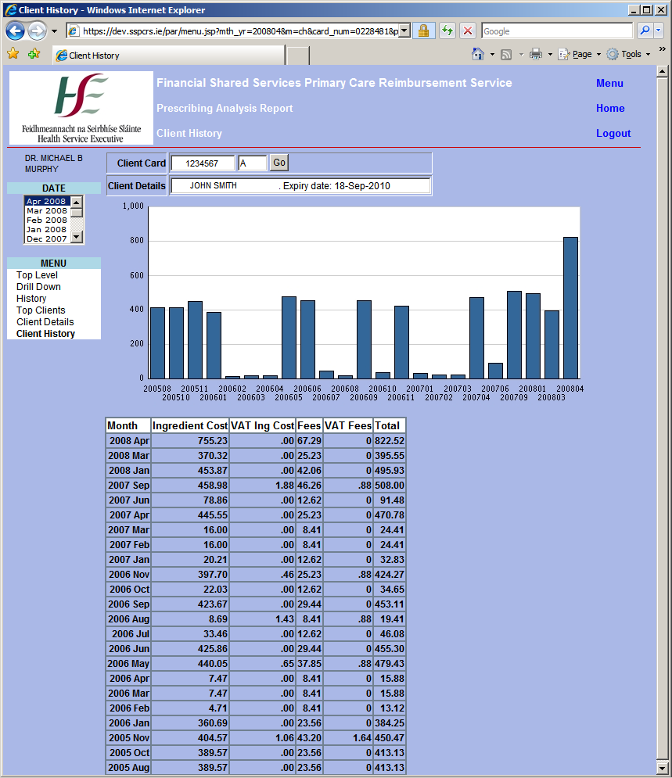

If you have not already registered

Register now for access

To the complete

Online GP Application Suite

A single Menu with the following facilities

Full details of all clients on your panel

Downloadable, printable, searchable panel listing with archive

Downloadable, printable, searchable itemised listings with archive

Online claim entry

Online claim review

Early pay – provide service this month, get paid 14th next month

Adjustment capture, i.e. self-service corrections/adjustments for births and deaths etc.

Confirm clients medical card eligibility at the point of service

Manage your subscription to the Drugs and

Therapeutics Bulletin

Prescribing Analysis Reports

For further information
Call 01-8647145 / 6

